**Data Manipulation with Pandas**

1. In the previous chapter, we dove into detail on NumPy and its ndarray object, which provides efficient storage and manipulation of dense typed arrays in Python.
2. Here we’ll build on this knowledge by looking in detail at the data structures provided by the Pandas library. Pandas is a newer package built on top of NumPy, and provides an efficient implementation of a DataFrame.
3. DataFrames are essentially multidimensional arrays with attached row and column labels, and often with heterogeneous types and/or missing data. As well as offering a convenient storage interface for labeled data, Pandas implements a number of powerful data operations familiar to users of both database frameworks and spreadsheet programs.
4. As we saw, NumPy’s ndarray data structure provides essential features for the type of clean, well-organized data typically seen in numerical computing tasks.

🡪While it serves this purpose very well, its limitations become clear when we need more flexibility (attaching labels to data, working with missing data, etc.) and when attempting operations that do not map well to element-wise broadcasting (groupings, pivots, etc.), each of which is an important piece of analyzing the less structured data available in many forms in the world around us.

🡪Pandas, and in particular its Series and DataFrame objects, builds on the NumPy array structure and provides efficient access to these sorts of “data munging” tasks that occupy much of a data scientist’s time.

1. In this chapter, we will focus on the mechanics of using Series, DataFrame, and related structures effectively.

🡪As we generally import Numpy under the alias np, we will import pandas under the alias pd:

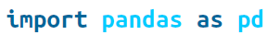

1. Introduction to pandas object

🡪At the very basic level, Pandas objects can be thought of as enhanced versions of NumPy structured arrays in which the rows and columns are identified with labels rather than simple integer indices.

🡪As we will see during the course of this chapter, Pandas provides a host of useful tools, methods, and functionality on top of the basic data structures, but nearly everything that follows will require an understanding of what these structures are. 🡪Thus, before we go any further, let’s introduce these three fundamental Pandas data structures: the Series, DataFrame, and Index.

🡪We will start our code with the standard Numpy and pandas import:

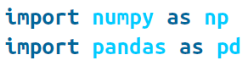

1. The Pandas Series Object

🡪**A Pandas Series is a one-dimensional array of indexed data**. It can be created from a list or array as follows:

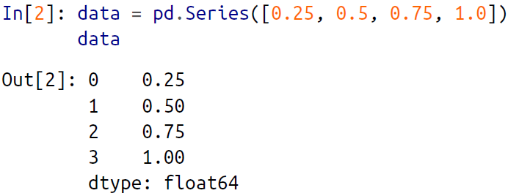

🡪As we see in the preceding output, the Series wraps both a sequence of values and a sequence of indices, which we can access with the values and index attributes. The values are simply a familiar NumPy array:

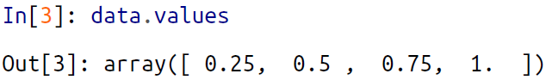

🡪The index is an array-like object of type pd.Index, which we’ll discuss in more detail

momentarily:

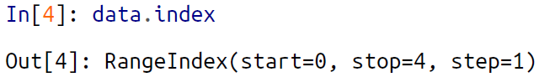

🡪Like with a NumPy array, data can be accessed by the associated index via the familiar Python square-bracket notation:

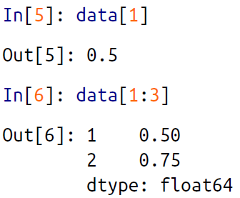

🡪As we will see, though, the Pandas Series is much more general and flexible than the

one-dimensional NumPy array that it emulates.

🡺Series as generalized NumPy array

🡪From what we’ve seen so far, it may look like the Series object is basically interchangeable with a one-dimensional NumPy array.

🡪**The essential difference is the presence of the index: while the NumPy array has an *implicitly defined* integer index used to access the values, the Pandas Series has an *explicitly defined* index associated with the values.**

🡪**This explicit index definition gives the Series object additional capabilities. For example, the index need not be an integer, but can consist of values of any desired type**. For example, if we wish, we can use strings as an index:

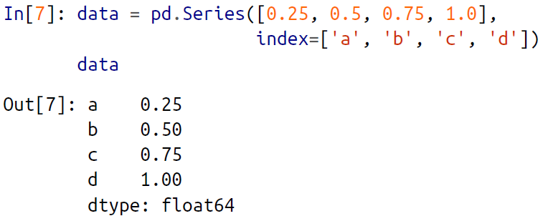

🡪And the item access works as expected:

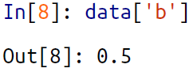

🡪We can even use noncontiguous or nonsequential indices:

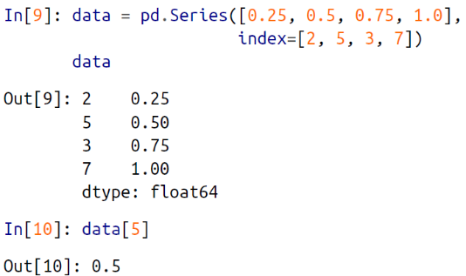

**🡺Series as specialized dictionary**

🡪In this way, you can think of a Pandas Series a bit like a specialization of a Python dictionary.

🡪A dictionary is a structure that maps arbitrary keys to a set of arbitrary values, and a Series is a structure that maps typed keys to a set of typed values.

🡪This typing is important: just as the type-specific compiled code behind a NumPy array makes it more efficient than a Python list for certain operations, the type information of a Pandas Series makes it much more efficient than Python dictionaries for certain operations.  
**🡪We can make the Series-as-dictionary analogy even more clear by constructing a Series object directly from a Python dictionary:**

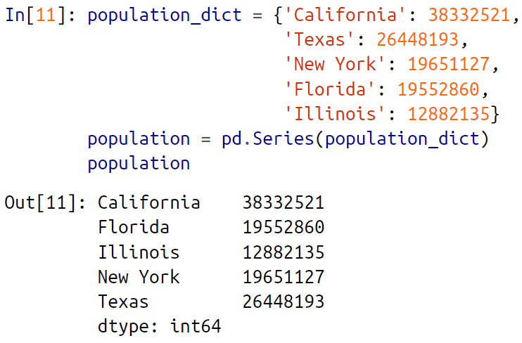

🡪By default, a Series will be created where the index is drawn from the sorted keys. From here, typical dictionary-style item access can be performed:

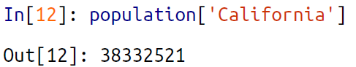

🡪Unlike a dictionary, though, the Series also supports array-style operations such as slicing:

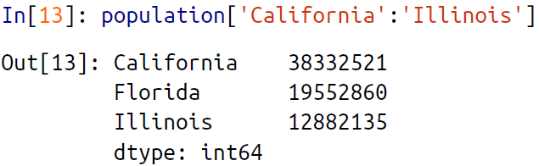

**🡺Constructing Series objects**

🡪We’ve already seen a few ways of constructing a Pandas Series from scratch; all of them are some version of the following:



🡪where index is an optional argument, and data can be one of many entities.

🡪For example, data can be a list or NumPy array, in which case index defaults to an integer sequence:

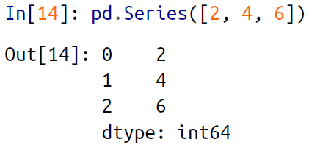

🡪data can be a scalar, which is repeated to fill the specified index:

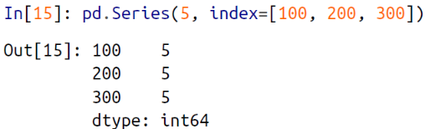

🡪data can be a dictionary, in which index defaults to the sorted dictionary keys:

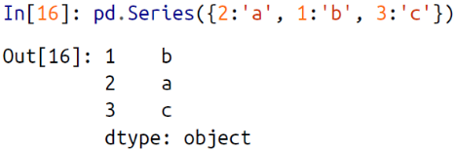

🡪In each case, the index can be explicitly set if a different result is preferred:

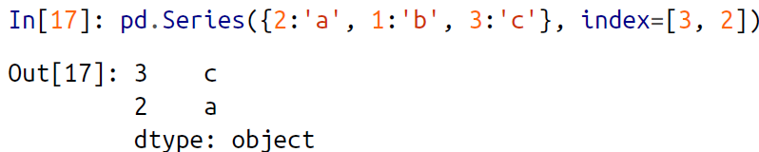

🡪Notice that in this case, the series is populated only with the explicitly identified keys.

1. The Panda DataFrame Object

🡪The next fundamental structure in Pandas is the DataFrame. Like the Series object

discussed in the previous section, **the DataFrame can be thought of either as a generalization of a NumPy array, or as a specialization of a Python dictionary**. We’ll nowtake a look at each of these perspectives.

🡺**DataFrame as a generalized Numpy array**

🡪If a Series is an analog of a one-dimensional array with flexible indices, a DataFrame is an analog of a two-dimensional array with both flexible row indices and flexible column names.

🡪Just as you might think of a two-dimensional array as an ordered sequence of aligned one-dimensional columns, you can think of a DataFrame as a sequence of aligned Series objects.

🡪Here, by “aligned” we mean that they share the same index.

🡪To demonstrate this, let’s first construct a new Series listing the area of each of the five states:

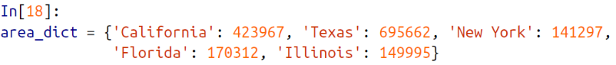

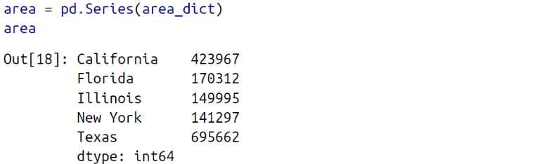

🡪Now that we have this along with the population Series from before, we can use a dictionary to construct a single two-dimensional object containing this information:

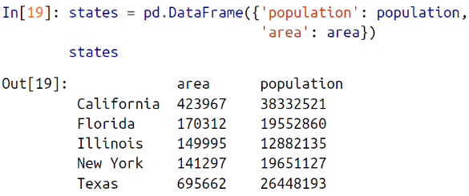

🡪Like the Series object, the DataFrame has an index attribute that gives access to the index labels:

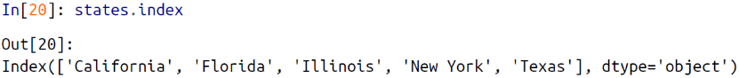

🡪Additionally, the DataFrame has a columns attribute, which is an Index object holding the column labels:

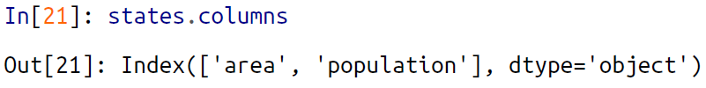

🡪Thus the DataFrame can be thought of as a generalization of a two-dimensional NumPy array, where both the rows and columns have a generalized index for accessing the data.

🡺DataFrame as specialized dictionary

🡪Similarly, we can also think of a DataFrame as a specialization of a dictionary. Where a dictionary maps a key to a value, a DataFrame maps a column name to a Series of column data. For example, asking for the 'area' attribute returns the Series object containing the areas we saw earlier:

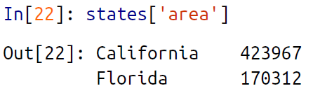

🡪Notice the potential point of confusion here: in a two-dimensional NumPy array, **data[0] will return the first *row***. For a **DataFrame, data['col0'] will return the first** ***column***. Because of this, it is probably better to think about DataFrames as generalized dictionaries rather than generalized arrays, though both ways of looking at the situation can be useful.

🡺Constructing DataFrame objects

🡪A Pandas DataFrame can be constructed in a variety of ways. Here we’ll give several examples.

🡪From a single Series object. A DataFrame is a collection of Series objects, and a single column DataFrame can be constructed from a single Series:

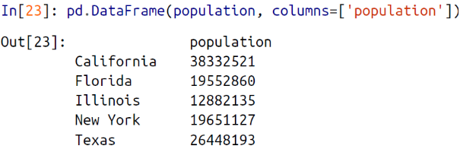

🡪From a list of dicts. Any list of dictionaries can be made into a DataFrame. We’ll use a simple list comprehension to create some data:

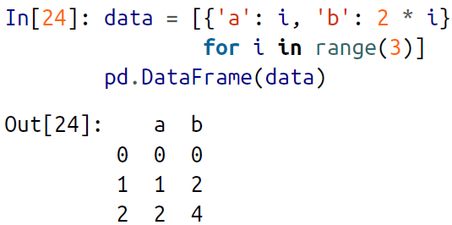

🡪Even if some keys in the dictionary are missing, Pandas will fill them in with NaN (i.e., “not a number”) values:

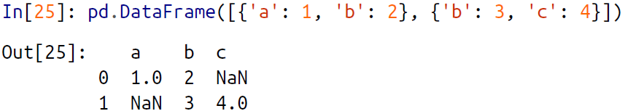

🡪From a dictionary of Series objects. As we saw before, a DataFrame can be constructed from a dictionary of Series objects as well:

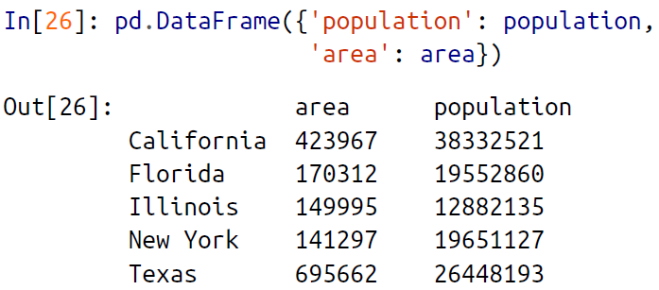

🡪From a two-dimensional NumPy array. Given a two-dimensional array of data, we can create a DataFrame with any specified column and index names. If omitted, an integer index will be used for each:

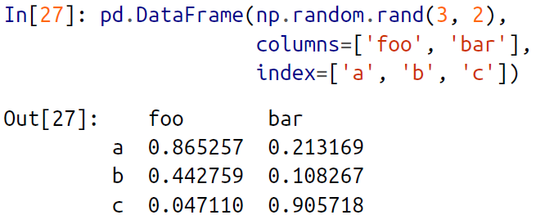

1. The Pandas Index Object

🡪We have seen here that both the Series and DataFrame objects contain an explicit

*index* that lets you reference and modify data.

🡪This Index object is an interesting structure in itself, and it can be thought of either as an *immutable array* or as an *ordered set* (technically a multiset, as Index objects may contain repeated values).

*🡪*Those views have some interesting consequences in the operations available on Index objects. As a simple example, let’s construct an Index from a list of integers:

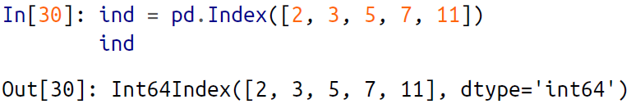

**🡺Index as immutable array**

🡪The Index object in many ways operates like an array. For example, we can use standard Python indexing notation to retrieve values or slices:

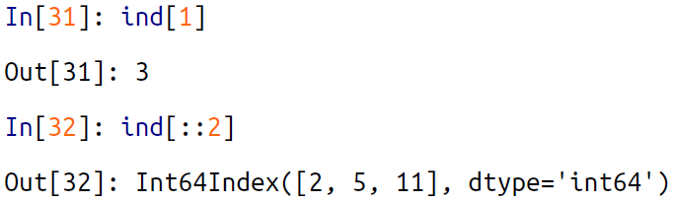

🡪Index objects also have many of the attributes familiar from NumPy arrays:

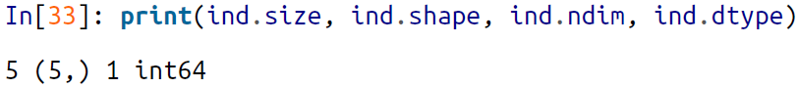

🡪One difference between Index objects and NumPy arrays is that indices are immutable—that is, they cannot be modified via the normal means:

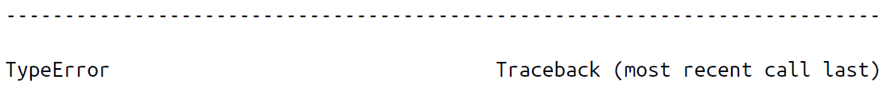

🡪This immutability makes it safer to share indices between multiple DataFrames and arrays, without the potential for side effects from inadvertent index modification.

**🡺Index as ordered set**

🡪Pandas objects are designed to facilitate operations such as joins across datasets, which depend on many aspects of set arithmetic. The Index object follows many of the conventions used by Python’s built-in set data structure, so that unions, intersections, differences, and other combinations can be computed in a familiar way:

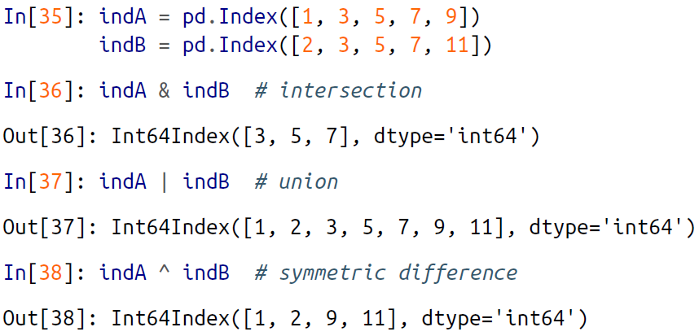

🡪These operations may also be accessed via object methods—for example, indA.inter section(indB).

1. Data Indexing and selection

🡪Here we’ll look at similar means of accessing and modifying values in Pandas Series and DataFrame objects.If you have used the NumPy patterns, the corresponding patterns in Pandas will feel very familiar, though there are a few quirks to be aware of.

🡪We’ll start with the simple case of the one-dimensional Series object, and then move

on to the more complicated two-dimensional DataFrame object.

**🡺Data Selection in Series**

🡪As we saw in the previous section, a Series object acts in many ways like a one dimensional NumPy array, and in many ways like a standard Python dictionary. If we keep these two overlapping analogies in mind, it will help us to understand the patterns of data indexing and selection in these arrays.

🡺**Series as dictionary**

🡪Like a dictionary, the Series object provides a mapping from a collection of keys to a collection of values:

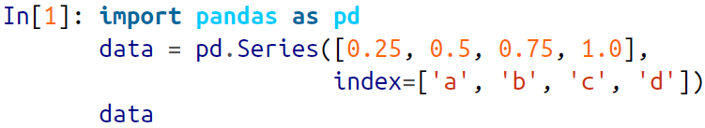

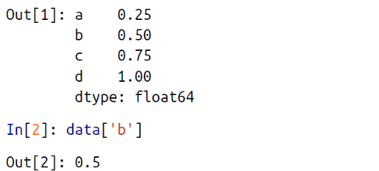

🡪We can also use dictionary-like Python expressions and methods to examine the keys/indices and values:

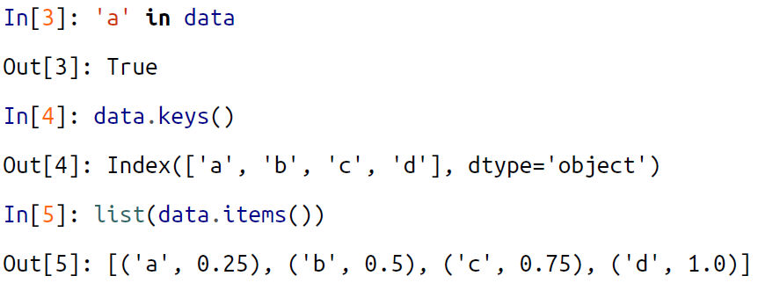

🡪Series objects can even be modified with a dictionary-like syntax. Just as you can extend a dictionary by assigning to a new key, you can extend a Series by assigning to a new index value:

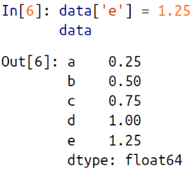

🡪This easy mutability of the objects is a convenient feature: under the hood, Pandas is making decisions about memory layout and data copying that might need to take place; the user generally does not need to worry about these issues.

**🡺Indexers: loc, iloc, and ix**

🡪These slicing and indexing conventions can be a source of confusion. For example, if your Series has an explicit integer index, an indexing operation such as data[1] will use the explicit indices, while a slicing operation like data[1:3] will use the implicit Python-style index.

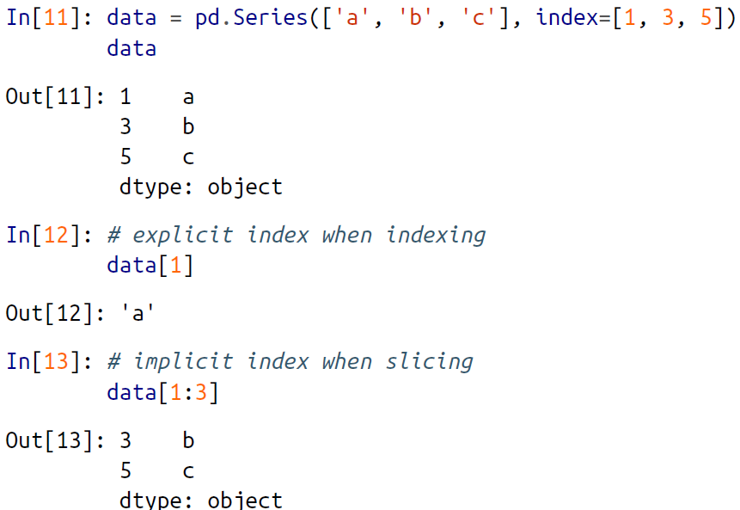

🡪Because of this potential confusion in the case of integer indexes, Pandas provides some special *indexer* attributes that explicitly expose certain indexing schemes. These are not functional methods, but attributes that expose a particular slicing interface to the data in the Series.

**🡪(I.M.P.)First, the loc attribute allows indexing and slicing that always references the explicit index:**

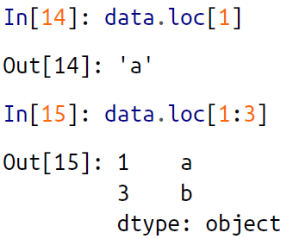

**🡪(I.M.P.)The iloc attribute allows indexing and slicing that always references the implicit Python-style index:**

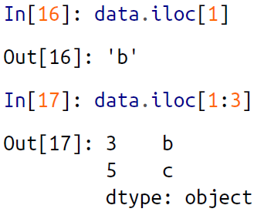

🡪A third indexing attribute, ix, is a hybrid of the two, and for Series objects is equivalent to standard []-based indexing. The purpose of the ix indexer will become more apparent in the context of DataFrame objects, which we will discuss in a moment.

🡪**One guiding principle of Python code is that “explicit is better than implicit.**” The explicit nature of loc and iloc make them very **useful in maintaining clean and readable** **code; especially in the case of integer indexes, I recommend using these both to** **make code easier to read and understand**, and to prevent subtle bugs due to the mixed indexing/slicing convention.

1. **Data Selection in DataFrame**

🡪 Recall that a DataFrame acts in many ways like a two-dimensional or structured array, and in other ways like a dictionary of Series structures sharing the same index. These analogies can be helpful to keep in mind as we explore data selection within

this structure.

**🡺DataFrame as a dictionary**

🡪 The first analogy we will consider is the DataFrame as a dictionary of related Series objects. Let’s return to our example of areas and populations of states:

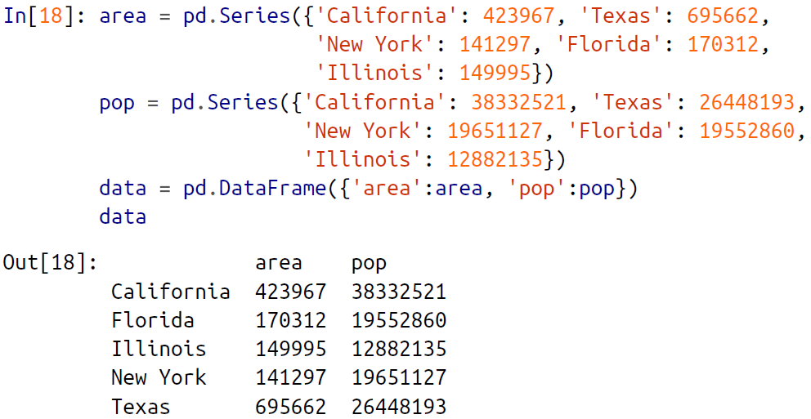

🡪 The individual Series that make up the columns of the DataFrame can be accessed via dictionary-style indexing of the column name:

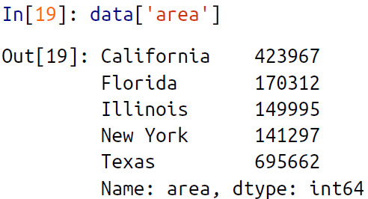

🡪 Equivalently, we can use attribute-style access with column names that are strings:

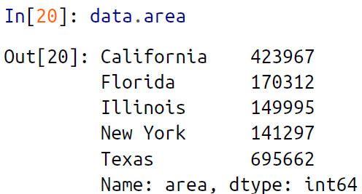

🡪 This attribute-style column access actually accesses the exact same object as the dictionary-style access:

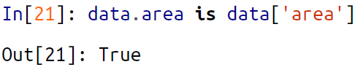

🡪 Though this is a useful shorthand, keep in mind that it does not work for all cases! For example, if the column names are not strings, or if the column names conflict with methods of the DataFrame, this attribute-style access is not possible. For example, the DataFrame has a pop() method, so data.pop will point to this rather than the "pop" column:

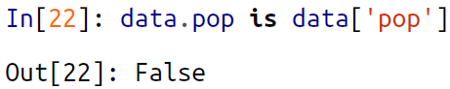

🡪 In particular, you should avoid the temptation to try column assignment via attribute (i.e., use data['pop'] = z rather than data.pop = z).

🡪 Like with the Series objects discussed earlier, this dictionary-style syntax can also be used to modify the object, in this case to add a new column:

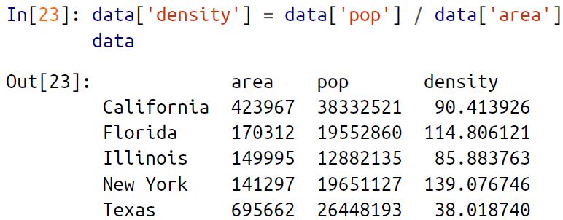

**🡺DataFrame as two-dimensional array**

🡪 As mentioned previously, we can also view the DataFrame as an enhanced two dimensional array. We can examine the raw underlying data array using the values attribute:

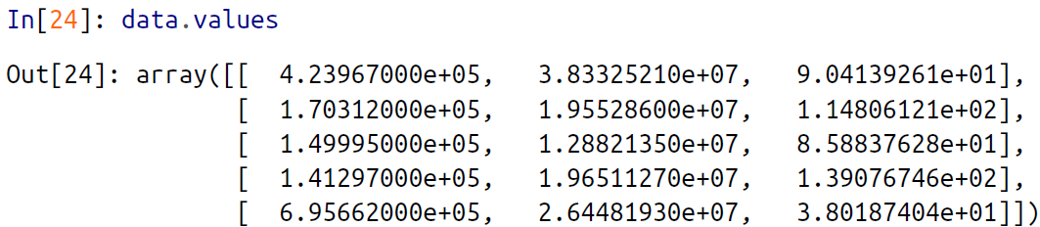

🡪 With this picture in mind, we can do many familiar array-like observations on the DataFrame itself. For example, we can transpose the full DataFrame to swap rows and columns:

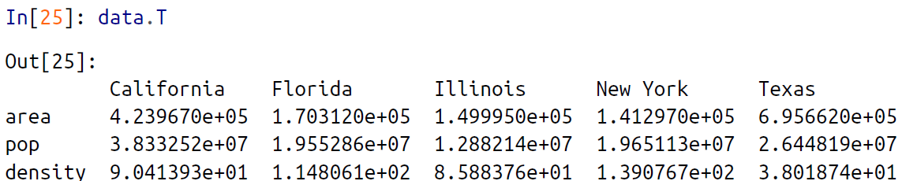

🡪 When it comes to indexing of DataFrame objects, however, it is clear that the

dictionary-style indexing of columns precludes our ability to simply treat it as a NumPy array. In particular, passing a single index to an array accesses a row:



🡪 And passing a single “index” to a DataFrame accesses a column:

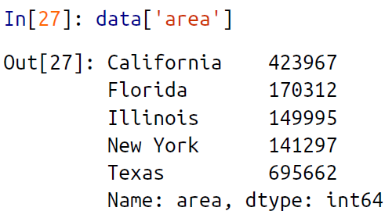

🡪 Thus for array-style indexing, we need another convention. Here Pandas again uses the loc, iloc, and ix indexers mentioned earlier. Using the iloc indexer, we can index the underlying array as if it is a simple NumPy array (using the implicit Python-style index), but the DataFrame index and column labels are maintained in the result:

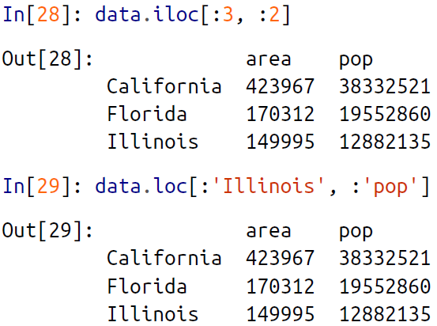

🡪 The ix indexer allows a hybrid of these two approaches:

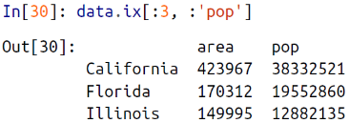

🡪 Any of the familiar NumPy-style data access patterns can be used within these indexers. For example, in the loc indexer we can combine masking and fancy indexing as in the following:

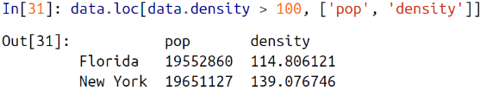

🡪 Any of these indexing conventions may also be used to set or modify values; this is done in the standard way that you might be accustomed to from working with NumPy:

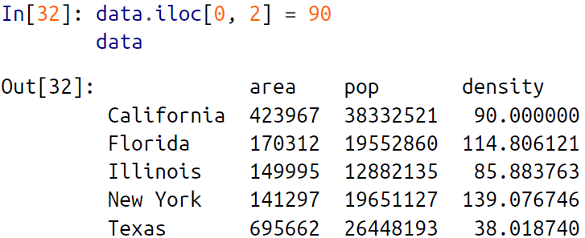

**🡺Additional indexing conventions**

🡪 There are a couple extra indexing conventions that might seem at odds with the preceding discussion, but nevertheless can be very useful in practice. First, while *indexing* refers to columns, *slicing* refers to rows:

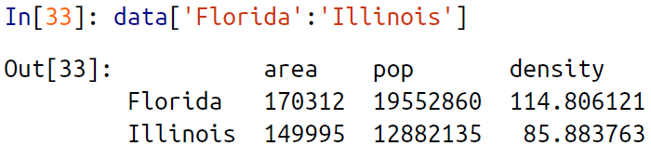

🡪 Such slices can also refer to rows by number rather than by index:

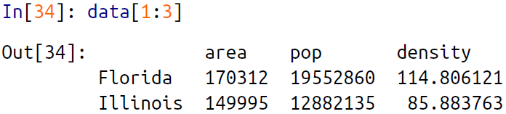

🡪 Similarly, direct masking operations are also interpreted row-wise rather than column-wise:

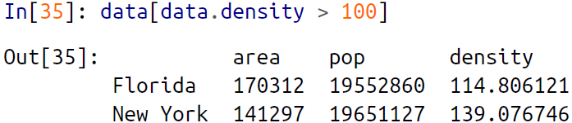

1. Operating on Data in pandas

**🡪** One of the essential pieces of NumPy is the ability to perform quick element-wise operations, both with basic arithmetic (addition, subtraction, multiplication, etc.) and with more sophisticated operations (trigonometric functions, exponential and logarithmic functions, etc.). Pandas inherits much of this functionality from NumPy, and the ufuncs

🡪 Pandas includes a couple useful twists, however: for unary operations like negation and trigonometric functions, these ufuncs will *preserve index and column labels* in the output, and for binary operations such as addition and multiplication, Pandas will automatically *align indices* when passing the objects to the ufunc.

🡪This means that keeping the context of data and combining data from different sources—both potentially error-prone tasks with raw NumPy arrays—become essentially foolproof ones with Pandas.

**🡺Ufuncs: Index Preservation**

🡪 Because Pandas is designed to work with NumPy, any NumPy ufunc will work on Pandas Series and DataFrame objects. Let’s start by defining a simple Series and DataFrame on which to demonstrate this:

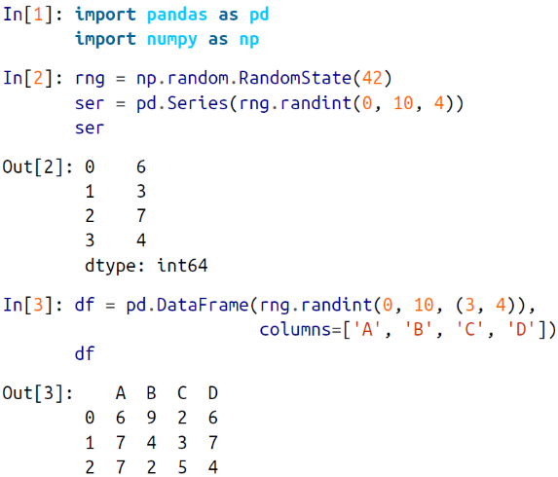

🡪 If we apply a NumPy ufunc on either of these objects, the result will be another Pandas object *with the indices preserved:*

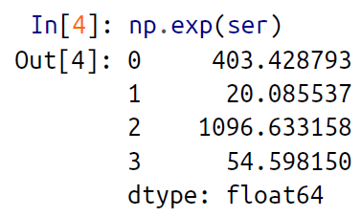

**🡪** Or, for a slightly more complex calculation:

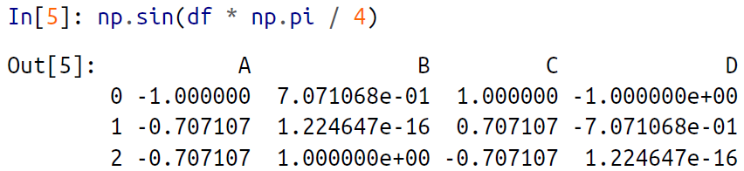

**🡺UnFuncs: Index Alignment**

**🡪** For binary operations on two Series or DataFrame objects, Pandas will align indices in the process of performing the operation.

**🡺Index alignment in series**

🡪As an example, suppose we are combining two different data sources, and find only the top three US states by *area* and the top three US states by *population*:

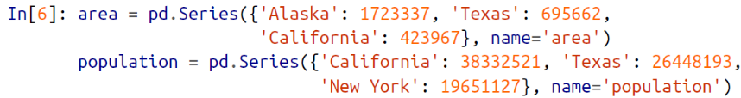

🡪Let’s see what happens when we divide these to compute the population density:

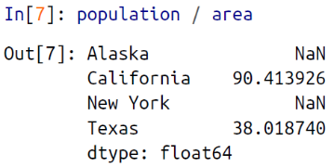

🡪The resulting array contains the *union* of indices of the two input arrays, which we could determine using standard Python set arithmetic on these indices:



🡪Any item for which one or the other does not have an entry is marked with NaN, or “Not a Number,” which is how Pandas marks missing data. This index matching is imple‐mented this way for any of Python’s built-in arithmetic expressions; any missing values are filled in with NaN by default:

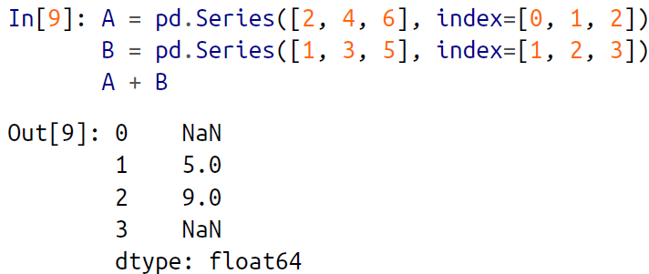

🡪If using NaN values is not the desired behavior, we can modify the fill value using appropriate object methods in place of the operators. For example, calling A.add(B) is equivalent to calling A + B, but allows optional explicit specification of the fill value for any elements in A or B that might be missing:

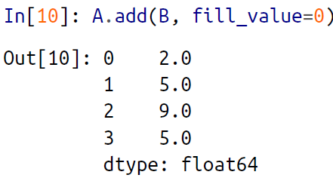

**🡺Indexing alignment in DataFrame**

🡪A similar type of alignment takes place for *both* columns and indices when you are performing operations on DataFrames:

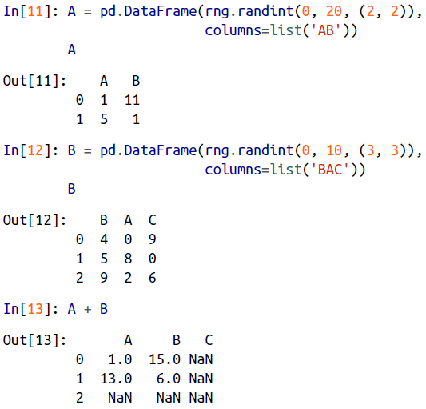

🡪Notice that indices are aligned correctly irrespective of their order in the two objects, and indices in the result are sorted. As was the case with Series, we can use the associated object’s arithmetic method and pass any desired fill_value to be used in place of missing entries. Here we’ll fill with the mean of all values in A (which we compute by first stacking the rows of A):

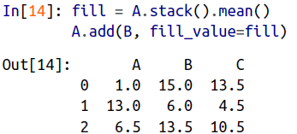

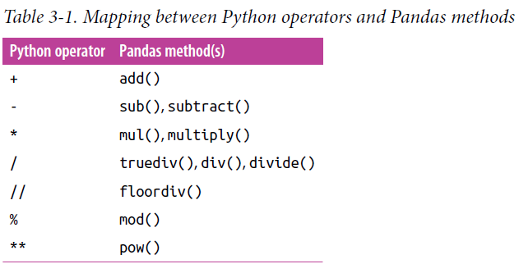

1. **Ufuncs: Operations Between DataFrame and Series**

🡪When you are performing operations between a DataFrame and a Series, the index

and column alignment is similarly maintained. Operations between a DataFrame and

a Series are similar to operations between a two-dimensional and one-dimensional

NumPy array. Consider one common operation, where we find the difference of a

two-dimensional array and one of its rows:

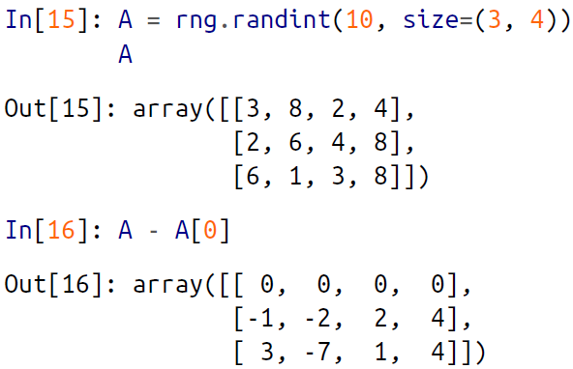

🡪According to NumPy’s broadcasting rules, subtraction between a two-dimensional array and one of its rows is applied row-wise.

🡪In Pandas, the convention similarly operates row-wise by default:

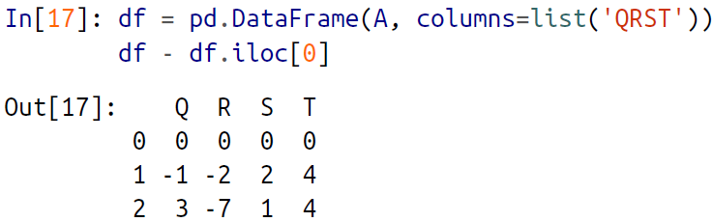

🡪If you would instead like to operate column-wise, you can use the object methods

mentioned earlier, while specifying the axis keyword:

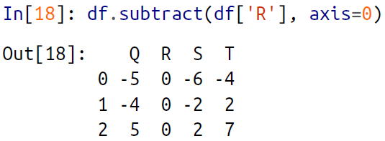

🡪Note that these DataFrame/Series operations, like the operations discussed before,

will automatically align indices between the two elements:

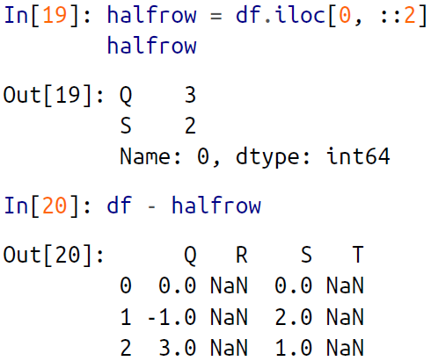

🡪This preservation and alignment of indices and columns means that operations on

data in Pandas will always maintain the data context, which prevents the types of silly errors that might come up when you are working with heterogeneous and/or misaligned data in raw NumPy arrays.

1. Handling Missing Data

🡪The difference between data found in many tutorials and data in the real world is that real-world data is rarely clean and homogeneous. In particular, many interesting

datasets will have some amount of data missing. To make matters even more complicated, different data sources may indicate missing data in different ways.

🡪In this section, we will discuss some general considerations for missing data, discuss how Pandas chooses to represent it, and demonstrate some built-in Pandas tools for handling missing data in Python. Here and throughout the book, we’ll refer to missing data in general as *null*, *NaN*, or *NA* values.

**🡺Trade-Offs in Missing Data Conventions**

🡪A number of schemes have been developed to indicate the presence of missing data in a table or DataFrame. Generally, they revolve around one of two strategies: using a *mask* that globally indicates missing values, or choosing a *sentinel value* that indicates a missing entry.

🡪In the masking approach, the mask might be an entirely separate Boolean array, or it may involve appropriation of one bit in the data representation to locally indicate the null status of a value.

🡪In the sentinel approach, the sentinel value could be some data-specific convention, such as indicating a missing integer value with –9999 or some rare bit pattern, or it could be a more global convention, such as indicating a missing floating-point value with NaN (Not a Number), a special value which is part of the IEEE floating-point specification.

🡪None of these approaches is without trade-offs: use of a separate mask array requires allocation of an additional Boolean array, which adds overhead in both storage and computation. A sentinel value reduces the range of valid values that can be represented, and may require extra (often non-optimized) logic in CPU and GPU arithmetic. Common special values like NaN are not available for all data types.

🡪As in most cases where no universally optimal choice exists, different languages and systems use different conventions.

🡪For example, the R language uses reserved bit patterns within each data type as sentinel values indicating missing data, while the SciDB system uses an extra byte attached to every cell to indicate a NA state.

**🡺Missing Data In Pandas**

🡪The way in which Pandas handles missing values is constrained by its reliance on the NumPy package, which does not have a built-in notion of NA values for nonfloating- point data types.

🡪With these constraints in mind, Pandas chose to use sentinels for missing data, and further chose to use two already-existing Python null values: the special floatingpoint NaN value, and the Python None object. This choice has some side effects, as we will see, but in practice ends up being a good compromise in most cases of interest.

**🡺None: Pythonic missing data**

🡪The first sentinel value used by Pandas is None, a Python singleton object that is often used for missing data in Python code. Because None is a Python object, it cannot be used in any arbitrary NumPy/Pandas array, but only in arrays with data type 'object' (i.e., arrays of Python objects):

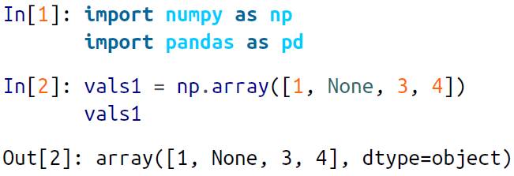

🡪This dtype=object means that the best common type representation NumPy could infer for the contents of the array is that they are Python objects. While this kind of object array is useful for some purposes, any operations on the data will be done at the Python level, with much more overhead than the typically fast operations seen for arrays with native types:

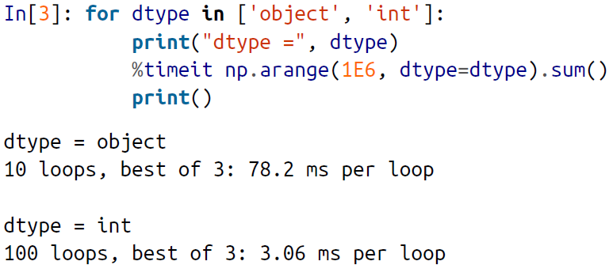

🡪The use of Python objects in an array also means that if you perform aggregations like sum() or min() across an array with a None value, you will generally get an error:

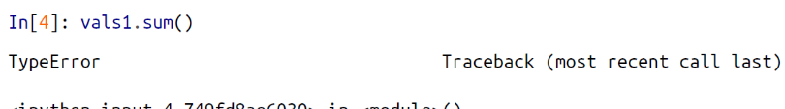

🡪This reflects the fact that addition between an integer and None is undefined.

**🡺NaN: Missing numerical data**

🡪The other missing data representation, NaN (acronym for *Not a Number*), is different; it is a special floating-point value recognized by all systems that use the standard IEEE floating-point representation:

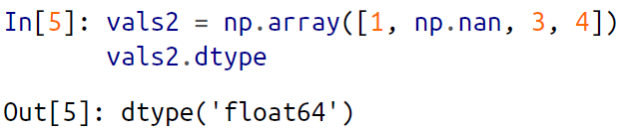

**🡪Notice that NumPy chose a native floating-point type for this array: this means that unlike the object array from before, this array supports fast operations pushed into compiled code.**

**🡪You should be aware that NaN is a bit like a data virus—it infects any**

**other object it touches. Regardless of the operation, the result of arithmetic with NaN will be another NaN:**

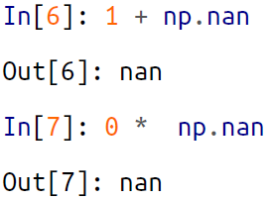

🡪Note that this means that aggregates over the values are well defined (i.e., they don’t result in an error) but not always useful:

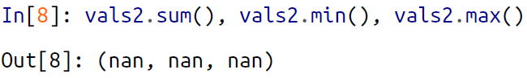

🡪NumPy does provide some special aggregations that will ignore these missing values:

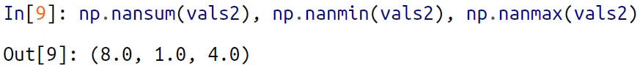

🡪Keep in mind that NaN is specifically a floating-point value; there is no equivalent NaN value for integers, strings, or other types.

**🡺NAN and None in Pandas**

🡪NaN and None both have their place, and Pandas is built to handle the two of them nearly interchangeably, converting between them where appropriate:

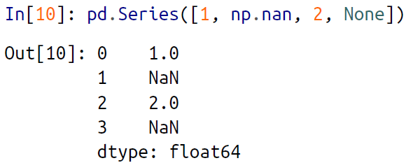

🡪Notice that in addition to casting the integer array to floating point, Pandas automatically converts the None to a NaN value.

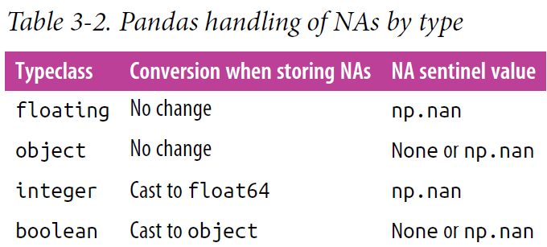

🡪Keep in mind that in Pandas, string data is always stored with an object dtype.

**🡺Operating On Null Values**

🡪As we have seen, Pandas treats None and NaN as essentially interchangeable for indicating missing or null values. To facilitate this convention, there are several useful methods for detecting, removing, and replacing null values in Pandas data structures. They are:

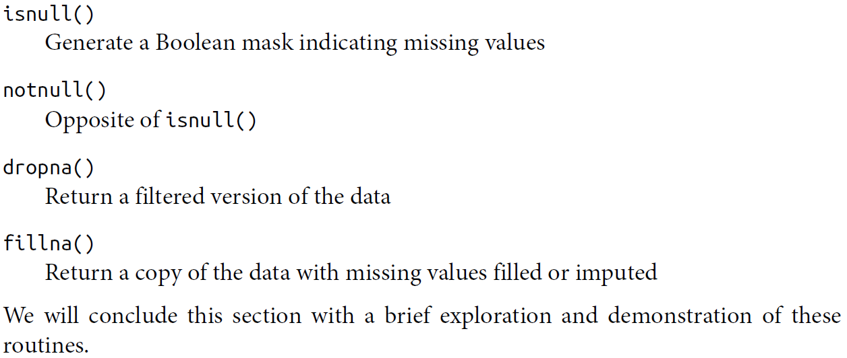

**🡺Detecting null values**

🡪Pandas data structures have two useful methods for detecting null data: isnull() and notnull(). Either one will return a Boolean mask over the data. For example:

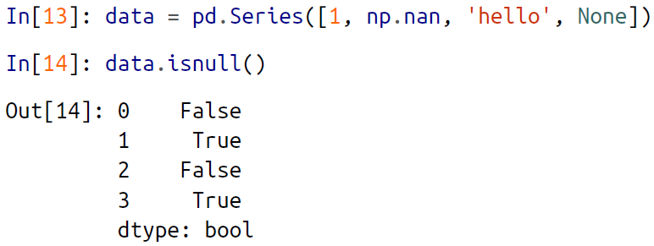

🡪As mentioned in Data Indexing and Selection, Boolean masks can be used directly as a Series or DataFrame index:

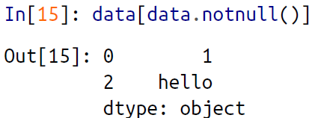

🡪The isnull() and notnull() methods produce similar Boolean results for Data

Frames.

🡺Dropping null values

🡪In addition to the masking used before, there are the convenience methods, dropna() (which removes NA values) and fillna() (which fills in NA values). For a Series, the result is straightforward:

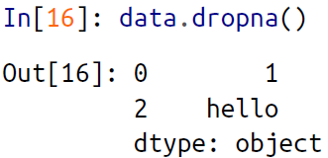

🡪For a DataFrame, there are more options. Consider the following DataFrame:

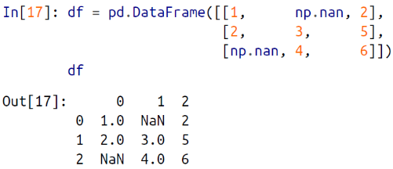

🡪We cannot drop single values from a DataFrame; we can only drop full rows or full columns. Depending on the application, you might want one or the other, so dropna() gives a number of options for a DataFrame.

🡪**By default, dropna() will drop all rows in which *any* null value is present:**

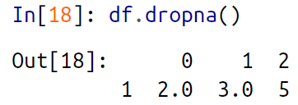

🡪Alternatively, you can drop NA values along a different axis; axis=1 drops all columns containing a null value:

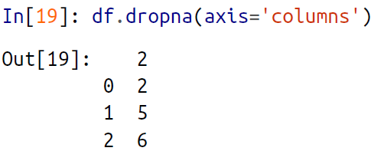

🡪But this drops some good data as well; you might rather be interested in dropping rows or columns with *all* NA values, or a majority of NA values. This can be specified through the how or thresh parameters, which allow fine control of the number of nulls to allow through.

🡪The default is how='any', such that any row or column (depending on the axis keyword) containing a null value will be dropped. You can also specify how='all', which will only drop rows/columns that are *all* null values:

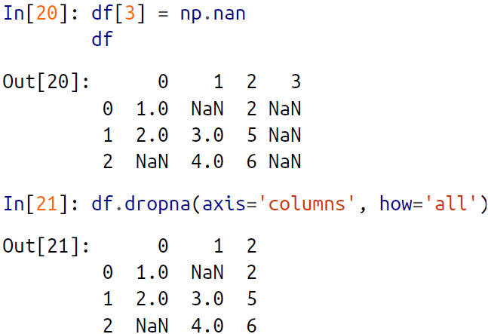

🡪For finer-grained control, the thresh parameter lets you specify a minimum number of non-null values for the row/column to be kept:

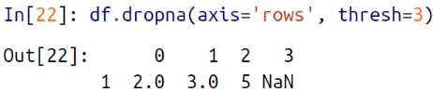

🡪Here the first and last row have been dropped, because they contain only two nonnull values.

**🡺(I.M.P.)Filling null values**

🡪Sometimes rather than dropping NA values, you’d rather replace them with a valid value. This value might be a single number like zero, or it might be some sort of imputation or interpolation from the good values. You could do this in-place using the isnull() method as a mask, but because it is such a common operation Pandas provides the fillna() method, which returns a copy of the array with the null values replaced.

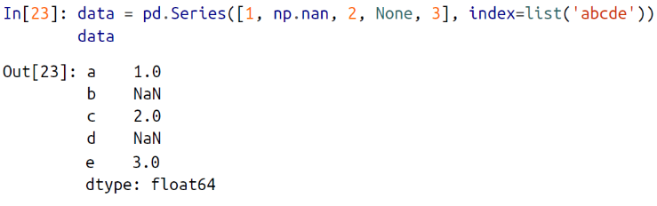

🡪We can fill NA entries with a single value, such as zero:

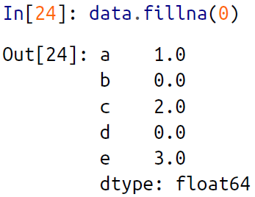

🡪We can specify a forward-fill to propagate the previous value forward:

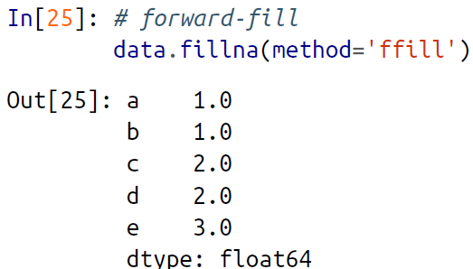

🡪Or we can specify a back-fill to propagate the next values backward:

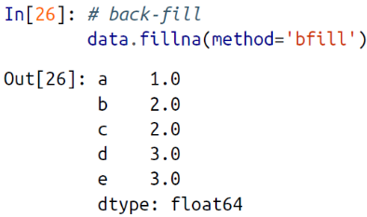

🡪For DataFrames, the options are similar, but we can also specify an axis along which the fills take place:

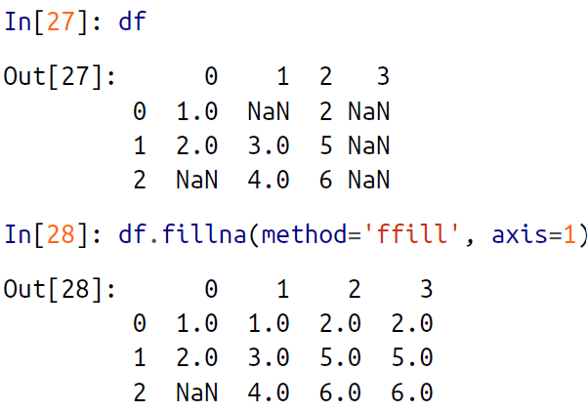

🡪Notice that if a previous value is not available during a forward fill, the NA value remains.

1. Hierarchical Indexing

🡪Up to this point we’ve been focused primarily on one-dimensional and twodimensional data, stored in Pandas Series and DataFrame objects, respectively. Often it is useful to go beyond this and store higher-dimensional data—that is, data indexed by more than one or two keys. While Pandas does provide Panel and Panel4D objects that natively handle three-dimensional and four-dimensional data, a far more common pattern in practice is to make use of *hierarchical* *indexing* (also known as *multi-indexing*) to incorporate multiple index *levels* within a single index. In this way, higher-dimensional data can be compactly represented within the familiar one-dimensional Series and two-dimensional DataFrame objects.

🡪In this section, we’ll explore the direct creation of MultiIndex objects; considerations

around indexing, slicing, and computing statistics across multiply indexed data; and

useful routines for converting between simple and hierarchically indexed representations of your data.

🡪We begin with standard imports:

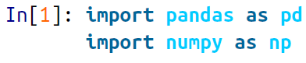

**🡺A Multiply Indexed Series**

🡪Let’s start by considering how we might represent two-dimensional data within a one-dimensional Series. For concreteness, we will consider a series of data where each point has a character and numerical key.

🡪Suppose you would like to track data about states from two different years. Using the Pandas tools we’ve already covered, you might be tempted to simply use Python tuples as keys:

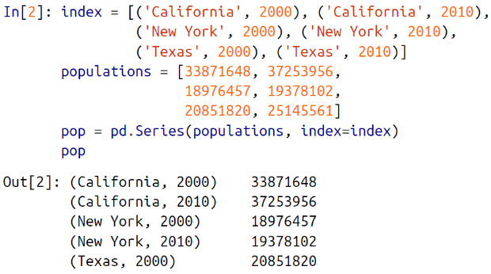

🡪With this indexing scheme, you can straightforwardly index or slice the series based on this multiple index:

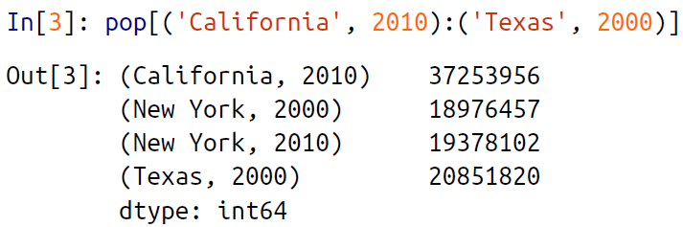

🡪But the convenience ends there. For example, if you need to select all values from 2010, you’ll need to do some messy (and potentially slow) munging to make it happen:

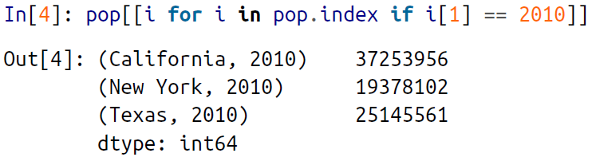

🡪This produces the desired result, but is not as clean (or as efficient for large datasets) as the slicing syntax we’ve grown to love in Pandas.

**🡺The better way: Pandas MultiIndex**

🡪Fortunately, Pandas provides a better way. Our tuple-based indexing is essentially a rudimentary multi-index, and the Pandas MultiIndex type gives us the type of operations we wish to have. We can create a multi-index from the tuples as follows:

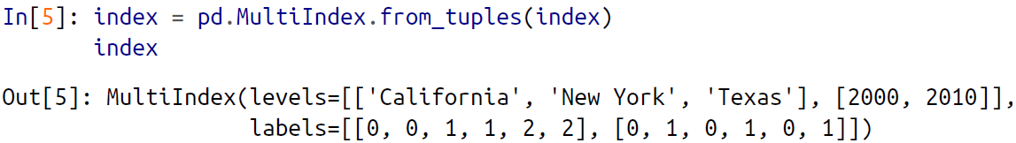

🡪Notice that the MultiIndex contains multiple *levels* of indexing—in this case, the state names and the years, as well as multiple *labels* for each data point which encode these levels.

🡪If we reindex our series with this MultiIndex, we see the hierarchical representation of the data:

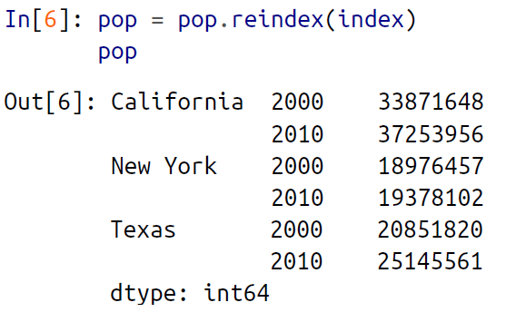

🡪Here the first two columns of the Series representation show the multiple index values, while the third column shows the data. Notice that some entries are missing in the first column: in this multi-index representation, any blank entry indicates the same value as the line above it.

🡪Now to access all data for which the second index is 2010, we can simply use the Pandas slicing notation:

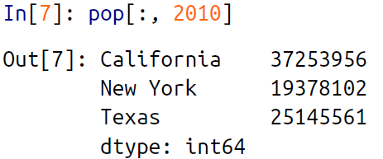

🡪The result is a singly indexed array with just the keys we’re interested in. This syntax is much more convenient (and the operation is much more efficient!) than the homespun tuple-based multi-indexing solution that we started with. We’ll now further discuss this sort of indexing operation on hierarchically indexed data.

**🡺MultiIndex as extra dimension**

🡪You might notice something else here: we could easily have stored the same data using a simple DataFrame with index and column labels. In fact, Pandas is built with this equivalence in mind. The unstack() method will quickly convert a multiply indexed Series into a conventionally indexed DataFrame:

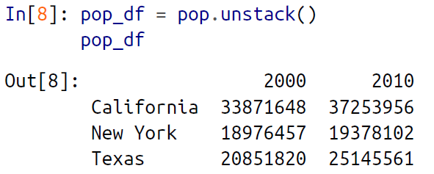

🡪Naturally, the stack() method provides the opposite operation:

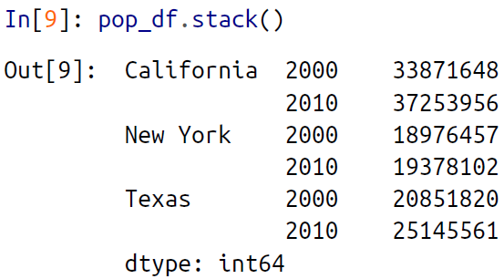

🡪Seeing this, you might wonder why would we would bother with hierarchical indexing at all. The reason is simple: just as we were able to use multi indexing to represent two-dimensional data within a one-dimensional Series, we can also use it to represent data of three or more dimensions in a Series or DataFrame. Each extra level in a multi-index represents an extra dimension of data; taking advantage of this property gives us much more flexibility in the types of data we can represent. Concretely, we might want to add another column of demographic data for each state at each year (say, population under 18); with a MultiIndex this is as easy as adding another column to the DataFrame:

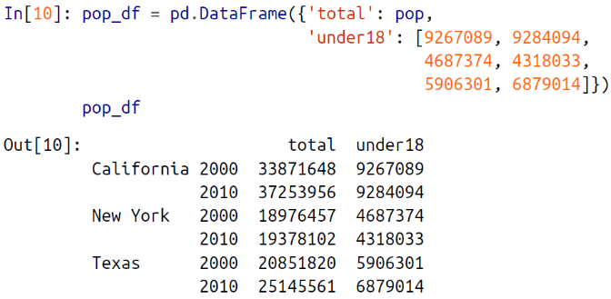

🡪In addition, all the ufuncs and other functionality discussed in “Operating on Data in Pandas” work with hierarchical indices as well. Here we compute the

fraction of people under 18 by year, given the above data:

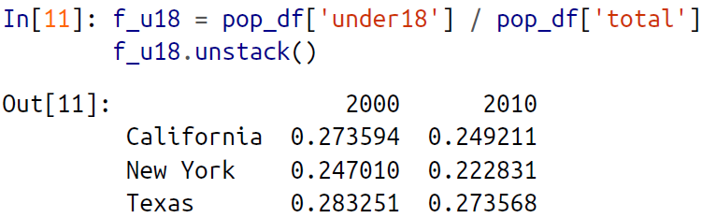

🡪This allows us to easily and quickly manipulate and explore even high-dimensional data.

**🡺Methods Of MultiIndex Creation**

🡪The most straightforward way to construct a multiply indexed Series or DataFrame is to simply pass a list of two or more index arrays to the constructor. For example:

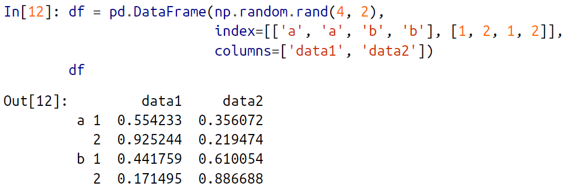

🡪The work of creating the MultiIndex is done in the background.

🡪Similarly, if you pass a dictionary with appropriate tuples as keys, Pandas will automatically recognize this and use a MultiIndex by default:

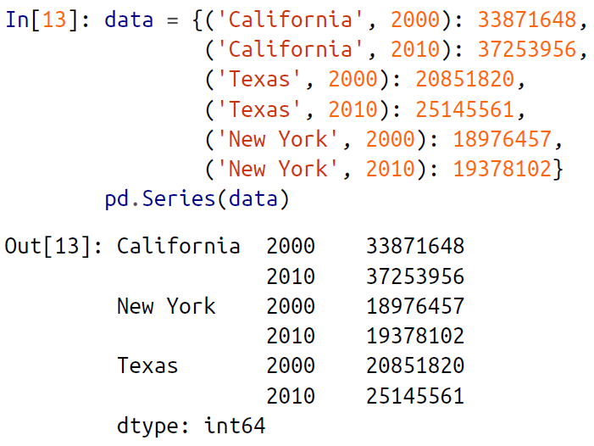

🡪Nevertheless, it is sometimes useful to explicitly create a MultiIndex; we’ll see a couple of these methods here.

**🡺Explicit MultiIndex constructors**

🡪For more flexibility in how the index is constructed, you can instead use the class method constructors available in the pd.MultiIndex. For example, as we did before, you can construct the MultiIndex from a simple list of arrays, giving the index values within each level:

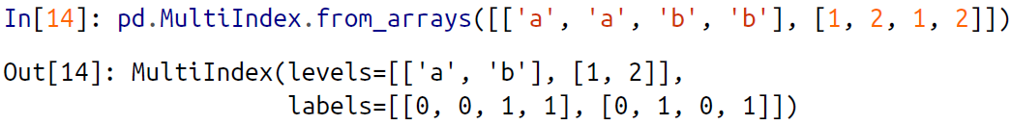

🡪You can construct it from a list of tuples, giving the multiple index values of each point:

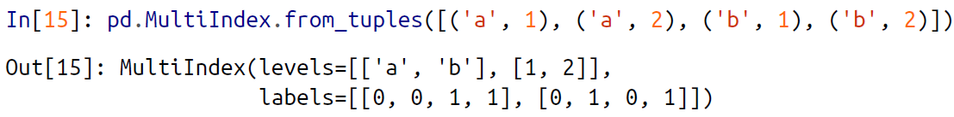

🡪You can even construct it from a Cartesian product of single indices:

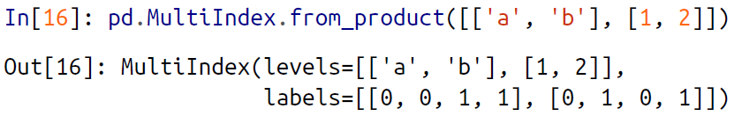

🡪Similarly, you can construct the MultiIndex directly using its internal encoding by passing levels (a list of lists containing available index values for each level) and labels (a list of lists that reference these labels):

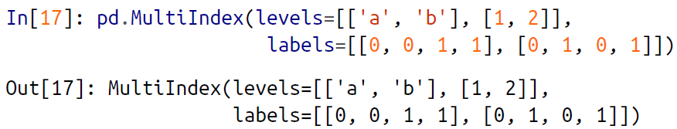

🡪You can pass any of these objects as the index argument when creating a Series or DataFrame, or to the reindex method of an existing Series or DataFrame.

**🡺MultiIndex level names**

🡪Sometimes it is convenient to name the levels of the MultiIndex. You can accomplish this by passing the names argument to any of the above MultiIndex constructors, or by setting the names attribute of the index after the fact:

🡪Sometimes it is convenient to name the levels of the MultiIndex. You can accomplish this by passing the names argument to any of the above MultiIndex constructors, or by setting the names attribute of the index after the fact:

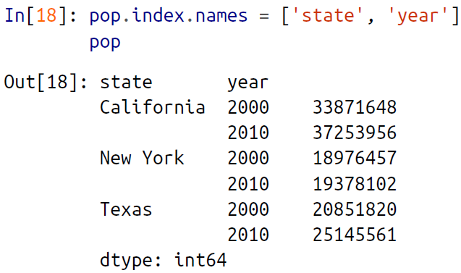

🡪With more involved datasets, this can be a useful way to keep track of the meaning of various index values.

**🡺MultiIndex for columns**

🡪In a DataFrame, the rows and columns are completely symmetric, and just as the rows can have multiple levels of indices, the columns can have multiple levels as well. Consider the following, which is a mock-up of some (somewhat realistic) medical data:

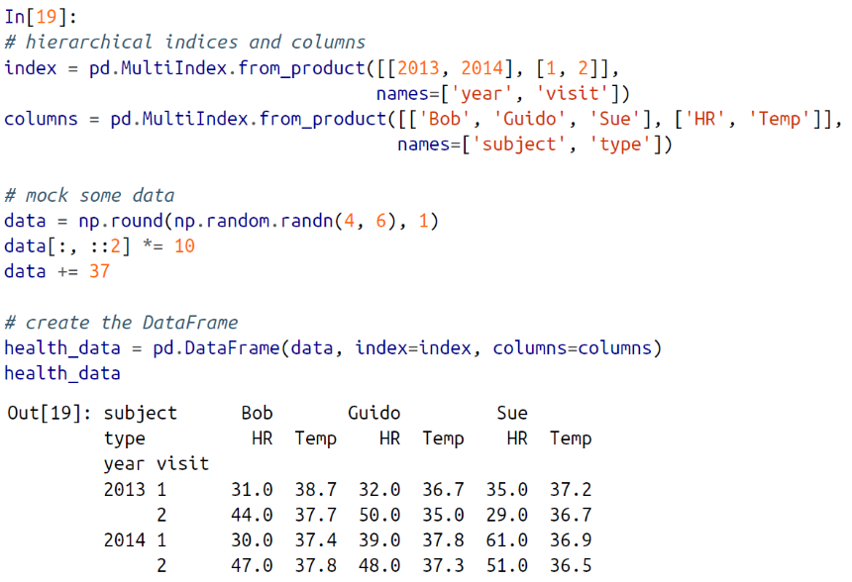

🡪Here we see where the multi-indexing for both rows and columns can come in *very* handy. This is fundamentally four-dimensional data, where the dimensions are thesubject, the measurement type, the year, and the visit number. With this in place wecan, for example, index the top-level column by the person’s name and get a full DataFrame containing just that person’s information:

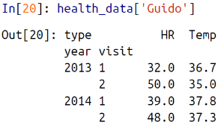

🡪For complicated records containing multiple labeled measurements across multiple times for many subjects (people, countries, cities, etc.), use of hierarchical rows and columns can be extremely convenient!

**🡺Indexing and Slicing a MultiIndex**

🡪Indexing and slicing on a MultiIndex is designed to be intuitive, and it helps if you think about the indices as added dimensions. We’ll first look at indexing multiply indexed Series, and then multiply indexed DataFrames.

**🡺Multiply Indexed Series**

🡪Consider the multiply indexed Series of state populations we saw earlier:

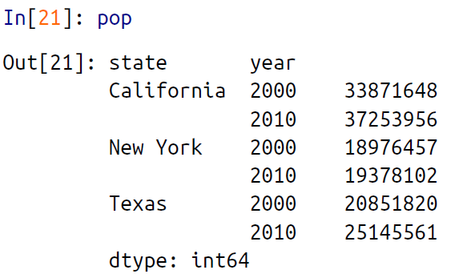

🡪We can access single elements by indexing with multiple terms:

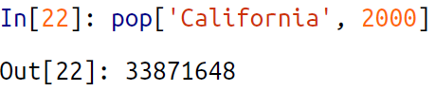

🡪The MultiIndex also supports *partial indexing*, or indexing just one of the levels in the index. The result is another Series, with the lower-level indices maintained:

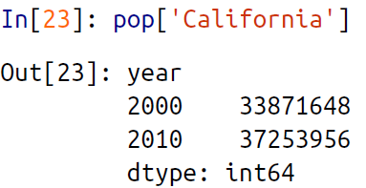

🡪Partial slicing is available as well, as long as the MultiIndex is sorted

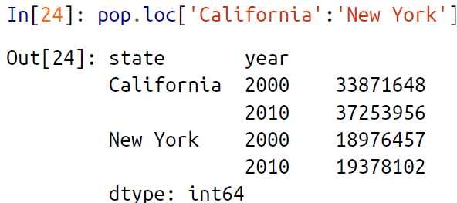

🡪With sorted indices, we can perform partial indexing on lower levels by passing an empty slice in the first index:

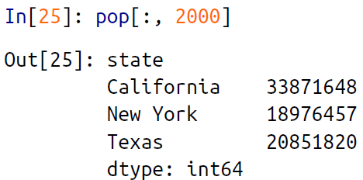

🡪Other types of indexing and selection (discussed in “Data Indexing and Selection”) work as well; for example, selection based on Boolean masks:

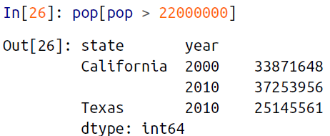

🡪Selection based on fancy indexing also works:

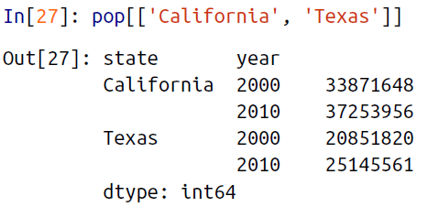

**🡺Multiply indexed DataFrames**

🡪A multiply indexed DataFrame behaves in a similar manner. Consider our toy medical DataFrame from before:

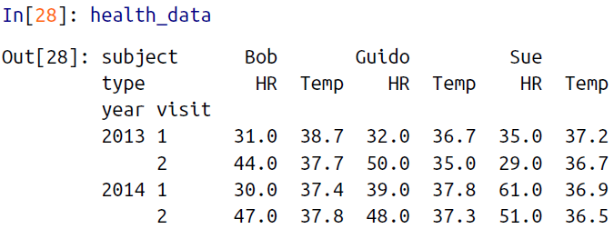

🡪Remember that columns are primary in a DataFrame, and the syntax used for multiply indexed Series applies to the columns. For example, we can recover Guido’s heart rate data with a simple operation:

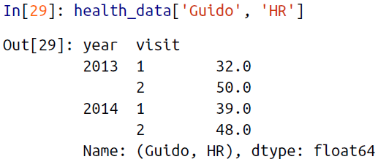

🡪Also, as with the single-index case, we can use the loc, iloc, and ix indexers introduced in “Data Indexing and Selection”. For example:

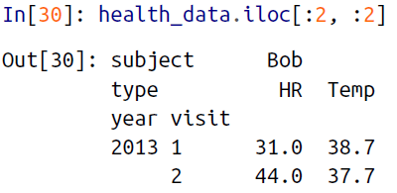

🡪These indexers provide an array-like view of the underlying two-dimensional data, but each individual index in loc or iloc can be passed a tuple of multiple indices. For example:

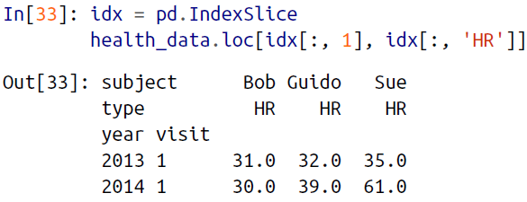

🡪There are so many ways to interact with data in multiply indexed Series and Data Frames, and as with many tools in this book the best way to become familiar with them is to try them out!

**🡺Rearranging Multi-Indices**

🡪We saw a brief example of this in the stack() and unstack() methods, but there are many more ways to finely control the rearrangement of data between hierarchical indices and columns, and we’ll explore them here.

**🡺Sorted and unsorted indices**

🡪Earlier, we briefly mentioned a caveat, but we should emphasize it more here. *Many of the* MultiIndex *slicing operations will fail if the index is not sorted.* Let’s take a look atthis here.

🡪We’ll start by creating some simple multiply indexed data where the indices are *not lexographically sorted* :

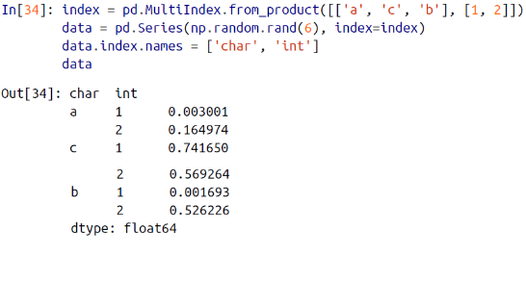

🡪If we try to take a partial slice of this index, it will result in an error:

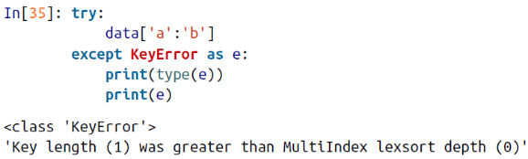

🡪Although it is not entirely clear from the error message, this is the result of the Multi Index not being sorted. For various reasons, partial slices and other similar operations require the levels in the MultiIndex to be in sorted (i.e., lexographical) order. Pandas provides a number of convenience routines to perform this type of sorting; examples are the sort_index() and sortlevel() methods of the DataFrame. We’ll use the simplest, sort_index(), here:

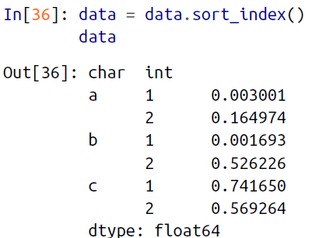

🡪With the index sorted in this way, partial slicing will work as expected:

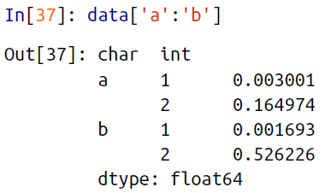

**🡺Stacking and unstacking indices**

🡪As we saw briefly before, it is possible to convert a dataset from a stacked multi-index to a simple two-dimensional representation, optionally specifying the level to use:

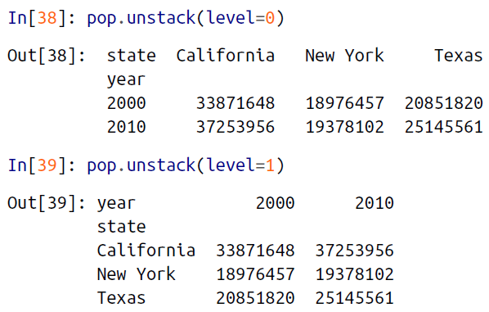

🡪The opposite of unstack() is stack(), which here can be used to recover the original series:

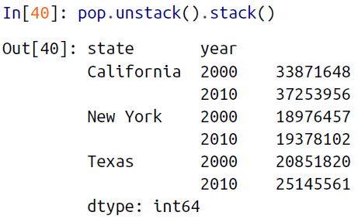

**🡺Index setting and resetting**

🡪Another way to rearrange hierarchical data is to turn the index labels into columns; this can be accomplished with the reset_index method. Calling this on the population dictionary will result in a DataFrame with a *state* and *year* column holding the information that was formerly in the index. For clarity, we can optionally specify the name of the data for the column representation:

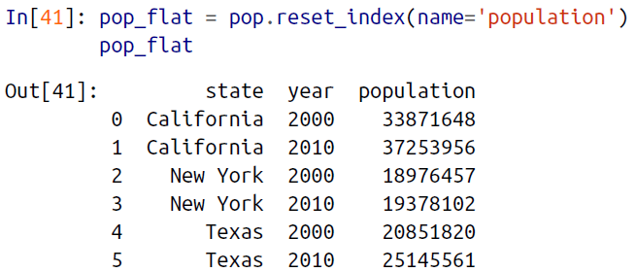

🡪Often when you are working with data in the real world, the raw input data looks like this and it’s useful to build a MultiIndex from the column values. This can be done with the set_index method of the DataFrame, which returns a multiply indexed Data Frame:

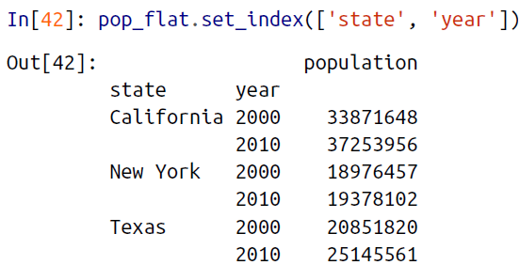

**🡺Data Aggregations on Multi-Indices**

🡪We’ve previously seen that Pandas has built-in data aggregation methods, such as mean(), sum(), and max(). For hierarchically indexed data, these can be passed a level parameter that controls which subset of the data the aggregate is computed on. For example, let’s return to our health data:

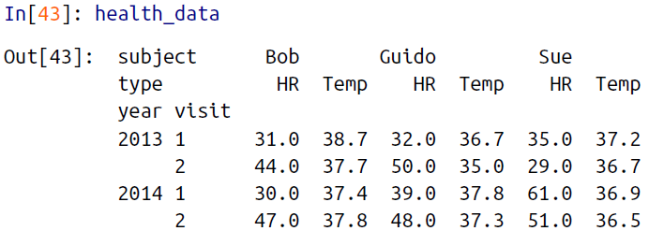

🡪Perhaps we’d like to average out the measurements in the two visits each year. We can do this by naming the index level we’d like to explore, in this case the year:

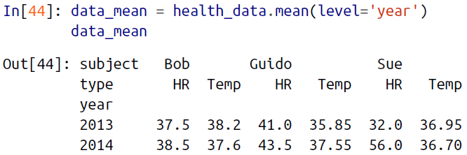

🡪By further making use of the axis keyword, we can take the mean among levels on the columns as well:

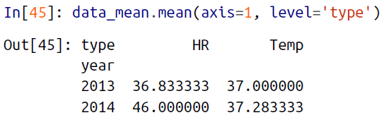

🡪Thus in two lines, we’ve been able to find the average heart rate and temperature measured among all subjects in all visits each year. This syntax is actually a shortcut to the GroupBy functionality. While this is a toy example, many real-world datasets have similar hierarchical structure.

1. Panel Data

🡪Pandas has a few other fundamental data structures that we have not yet discussed,

namely the pd.Panel and pd.Panel4D objects. These can be thought of, respectively,

as three-dimensional and four-dimensional generalizations of the (one-dimensional)

Series and (two-dimensional) DataFrame structures. Once you are familiar with

indexing and manipulation of data in a Series and DataFrame, Panel and Panel4D

are relatively straightforward to use.

1. Combining Datasets: Concat and Append

🡪Some of the most interesting studies of data come from combining different data

sources. These operations can involve anything from very straightforward concatenation of two different datasets, to more complicated database-style joins and merges that correctly handle any overlaps between the datasets. Series and DataFrames are built with this type of operation in mind, and Pandas includes functions and methods that make this sort of data wrangling fast and straightforward.

🡪Here we’ll take a look at simple concatenation of Series and DataFrames with the

pd.concat function; later we’ll dive into more sophisticated in-memory merges and

joins implemented in Pandas.

🡪For convenience, we’ll define this function, which creates a DataFrame of a particular

form that will be useful below:

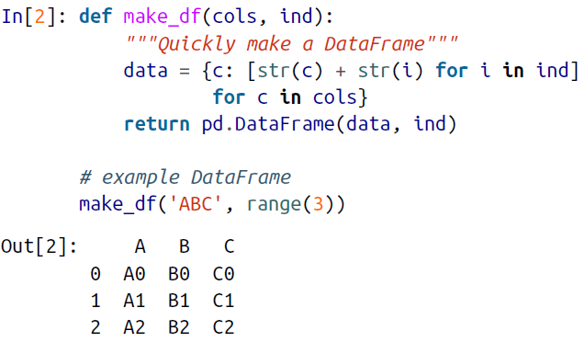

**🡺Recall: Concatenation Of Numpy Arrays**

🡪Concatenation of Series and DataFrame objects is very similar to concatenation of NumPy arrays, which can be done via the np.concatenate function. Recall that with it, you can combine the contents of two or more arrays into a single array:

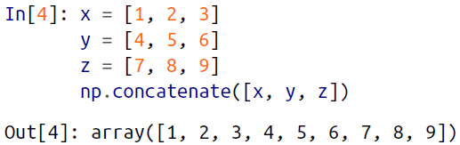

🡪The first argument is a list or tuple of arrays to concatenate. Additionally, it takes an axis keyword that allows you to specify the axis along which the result will be concatenated:

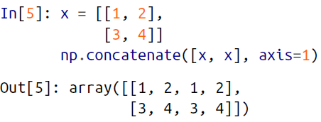

**🡺Simple Concatenation with pd.concat**

🡪Pandas has a function, pd.concat(), which has a similar syntax to np.concatenate but contains a number of options that we’ll discuss momentarily:

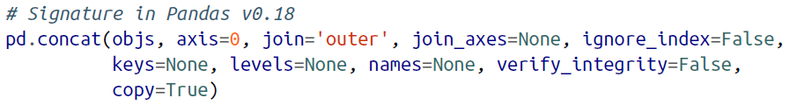

🡪pd.concat() can be used for a simple concatenation of Series or DataFrame objects, just as np.concatenate() can be used for simple concatenations of arrays:

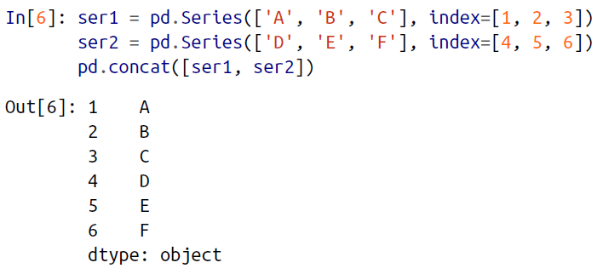

🡪It also works to concatenate higher-dimensional objects, such as DataFrames:

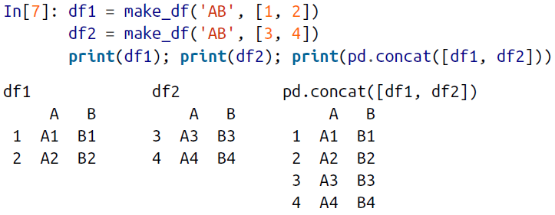

🡪By default, the concatenation takes place row-wise within the DataFrame (i.e.,axis=0). Like np.concatenate, pd.concat allows specification of an axis along which concatenation will take place. Consider the following example:

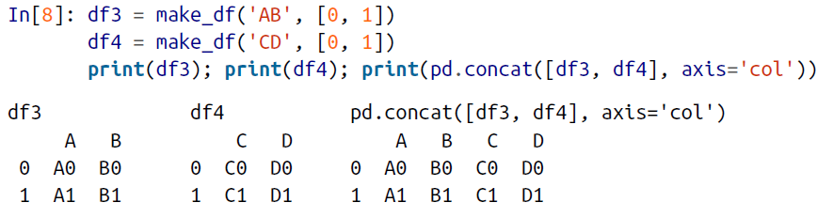

🡪We could have equivalently specified axis=1; here we’ve used the more intuitive axis='col'.

**🡺Duplicate indices**

🡪One important difference between np.concatenate and pd.concat is **that Pandas concatenation *preserves indices*, even if the result will have duplicate indices!** Consider this simple example:

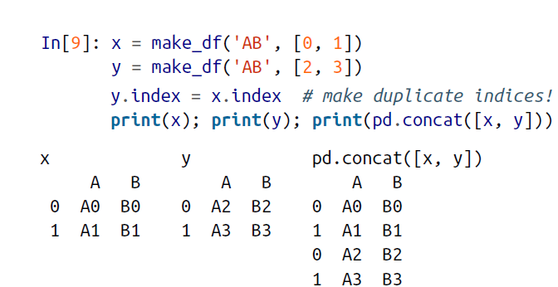

🡪Notice the repeated indices in the result. While this is valid within DataFrames, the outcome is often undesirable. pd.concat() gives us a few ways to handle it.

🡪Catching the repeats as an error. If you’d like to simply verify that the indices in the result of pd.concat() do not overlap, you can specify the verify_integrity flag.

With this set to True, the concatenation will raise an exception if there are duplicate indices. Here is an example, where for clarity we’ll catch and print the error message:

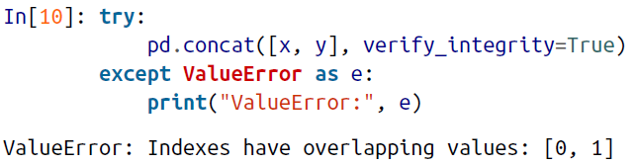

🡪Ignoring the index. Sometimes the index itself does not matter, and you would prefer it to simply be ignored. You can specify this option using the ignore_index flag. With this set to True, the concatenation will create a new integer index for the resulting Series:

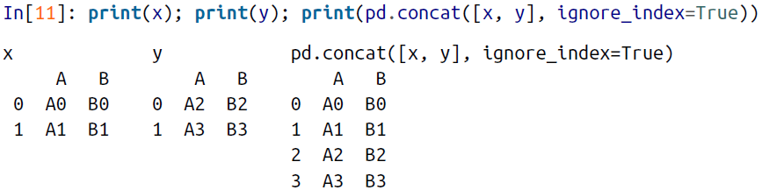

🡪Adding MultiIndex keys. Another alternative is to use the keys option to specify a label for the data sources; the result will be a hierarchically indexed series containing the data:

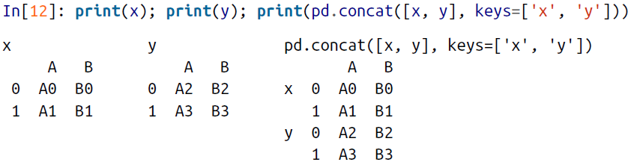

**🡺Concatenation with joins**

🡪In the simple examples we just looked at, we were mainly concatenating DataFrames with shared column names. In practice, data from different sources might have different sets of column names, and pd.concat offers several options in this case. Consider the concatenation of the following two DataFrames, which have some (but not all!) columns in common:

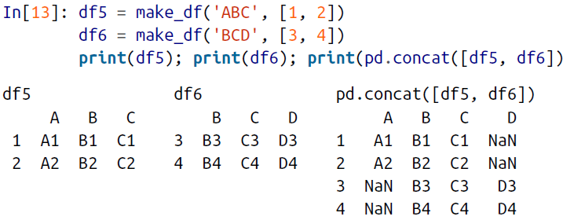

🡪By default, the entries for which no data is available are filled with NA values. To change this, we can specify one of several options for the join and join_axes parameters of the concatenate function. By default, the join is a union of the input columns (join='outer'), but we can change this to an intersection of the columns using join='inner':

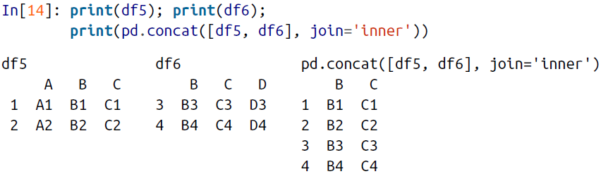

🡪Another option is to directly specify the index of the remaining colums using the join_axes argument, which takes a list of index objects. Here we’ll specify that the returned columns should be the same as those of the first input:

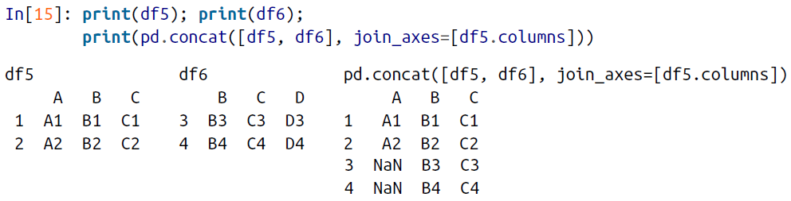

🡪The combination of options of the pd.concat function allows a wide range of possible behaviors when you are joining two datasets; keep these in mind as you use these tools for your own data.

🡺The append() method

🡪Because direct array concatenation is so common, Series and DataFrame objects have an append method that can accomplish the same thing in fewer keystrokes. For example, rather than calling pd.concat([df1, df2]), you can simply call df1.append(df2):

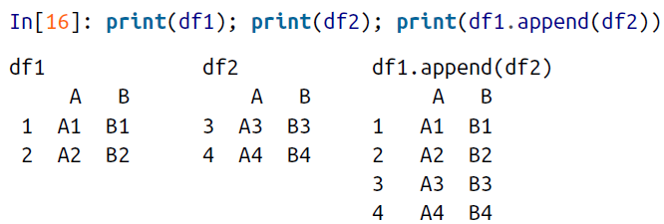

🡪Keep in mind that unlike the append() and extend() methods of Python lists, the **append() method in Pandas does not modify the original object—instead, it creates a** **new object with the combined data**. It also is **not a very efficient method**, because it involves creation of a new index *and* data buffer. **Thus, if you plan to do multiple** **append operations, it is generally better to build a list of DataFrames and pass them all** **at once to the concat() function.**

1. Combining Datasets: Merge and join

🡪One essential feature offered by Pandas is its high-performance, in-memory join and merge operations. If you have ever worked with databases, you should be familiar

with this type of data interaction. The main interface for this is the pd.merge function, and we’ll see a few examples of how this can work in practice.

**🡺Relational Algebra**

🡪The behavior implemented in pd.merge() is a subset of what is known as *relational algebra*, which is a formal set of rules for manipulating relational data, and forms theconceptual foundation of operations available in most databases. The strength of the relational algebra approach is that it proposes several primitive operations, whichbecome the building blocks of more complicated operations on any dataset. With thislexicon of fundamental operations implemented efficiently in a database or other program,a wide range of fairly complicated composite operations can be performed.

🡪Pandas implements several of these fundamental building blocks in the pd.merge() function and the related join() method of Series and DataFrames. As we will see, these let you efficiently link data from different sources.

**🡺Categories Of Joins**

🡪The pd.merge() function implements a number of types of joins: the *one-to-one*, *many-to-one*, and *many-to-many* joins. All three types of joins are accessed via an identical call to the pd.merge() interface; the type of join performed depends on the form of the input data. Here we will show simple examples of the three types of merges, and discuss detailed options further below.

**🡺One-to-One Joins**

🡪Perhaps the simplest type of merge expression is the one-to-one join, which is in many ways very similar to the column-wise concatenation, As a concrete example, consider the following two DataFrames, which contain information on several employees in a company:

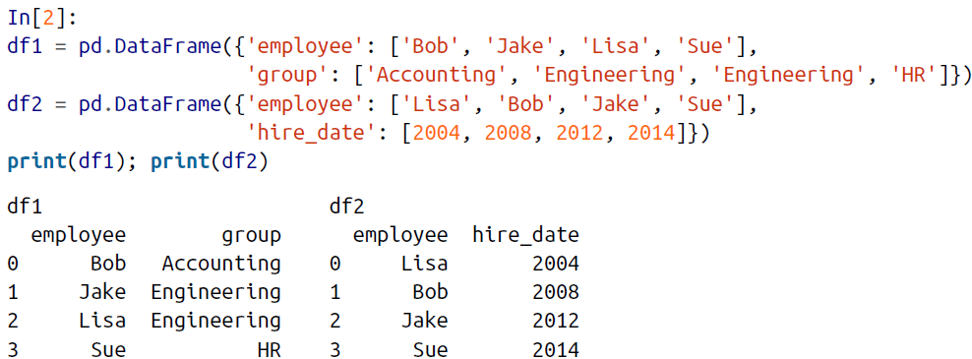

🡪To combine this information into a single DataFrame, we can use the pd.merge() function:

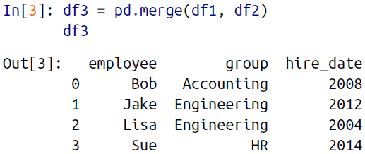

🡪The pd.merge() function recognizes that each DataFrame has an “employee” column, and automatically joins using this column as a key. The result of the merge is a new DataFrame that combines the information from the two inputs. Notice that the order of entries in each column is not necessarily maintained: in this case, the order of the “employee” column differs between df1 and df2, and the pd.merge() function correctly accounts for this. Additionally, keep in mind that the merge in general discards the index, except in the special case of merges by index

**🡺Many-to-one joins**

🡪Many-to-one joins are joins in which one of the two key columns contains duplicate entries. For the many-to-one case, the resulting DataFrame will preserve those duplicate entries as appropriate. Consider the following example of a many-to-one join:

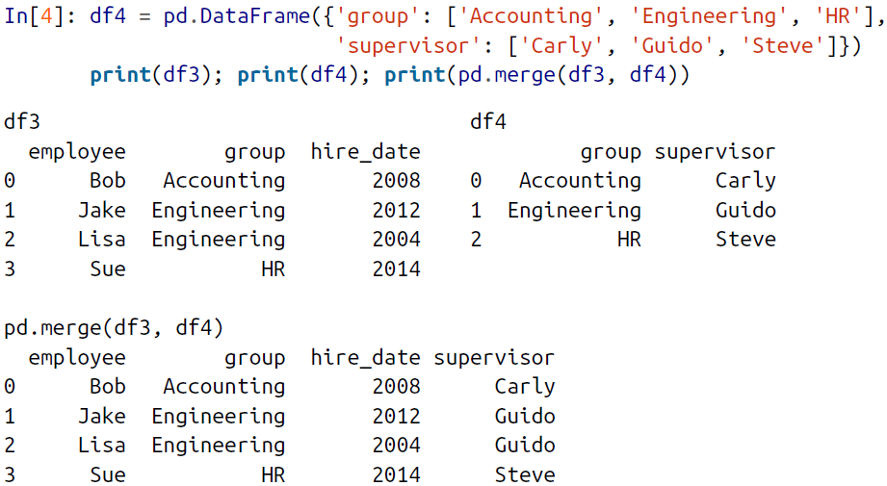

🡪The resulting DataFrame has an additional column with the “supervisor” information, where the information is repeated in one or more locations as required by the inputs.

**🡺Many-to-many joins**

🡪Many-to-many joins are a bit confusing conceptually, but are nevertheless well defined. If the key column in both the left and right array contains duplicates, then the result is a many-to-many merge. This will be perhaps most clear with a concrete example. Consider the following, where we have a DataFrame showing one or more skills associated with a particular group.

🡪By performing a many-to-many join, we can recover the skills associated with any individual person:

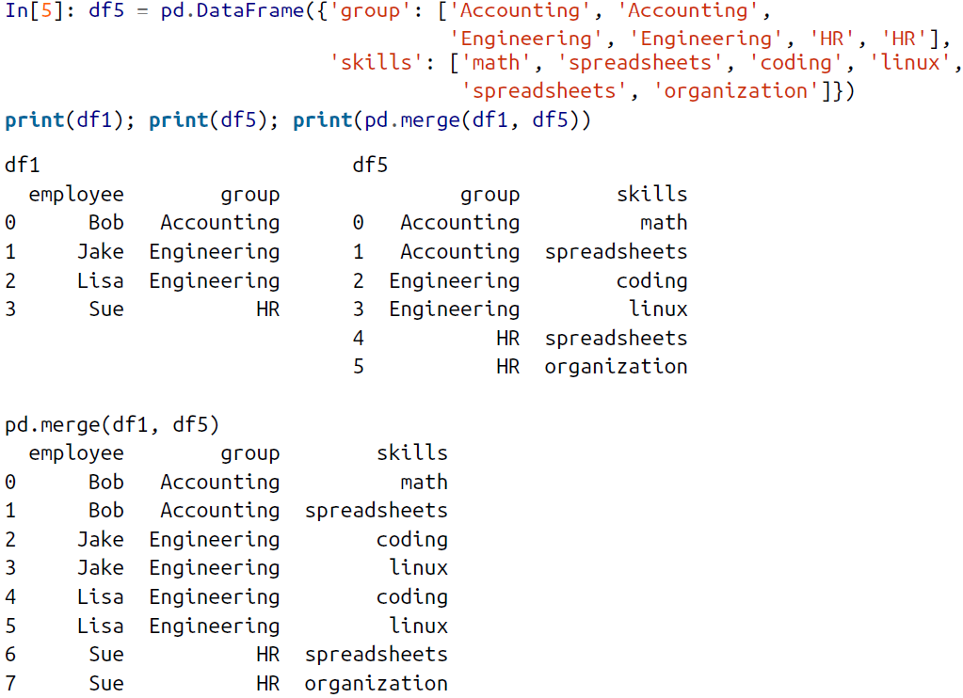

🡪These three types of joins can be used with other Pandas tools to implement a wide array of functionality.

**🡪But in practice, datasets are rarely as clean as the one we’re**

**working with here. In the following section, we’ll consider some of the options provided by pd.merge() that enable you to tune how the join operations work.**

**🡺Specification of the Merge Key**

🡪We’ve already seen the default behavior of pd.merge(): it looks for one or more matching column names between the two inputs, and uses this as the key. However, often the column names will not match so nicely, and pd.merge() provides a variety of options for handling this.

**🡺The on keyword**

🡪Most simply, you can explicitly specify the name of the key column using the on keyword, which takes a column name or a list of column names:

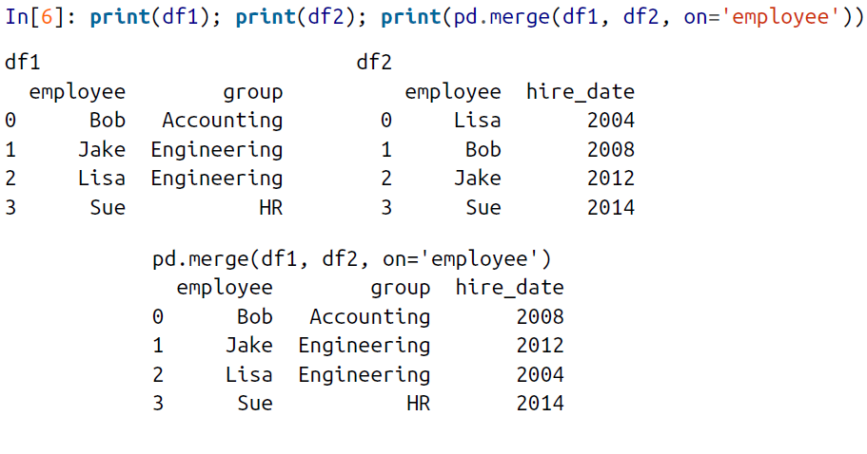

🡪This option works only if both the left and right DataFrames have the specified column name.

**🡺The left_on and right_on keywords**

🡪At times you may wish to merge two datasets with different column names; for example, we may have a dataset in which the employee name is labeled as “name” rather than “employee”. In this case, we can use the left_on and right_on keywords to specify the two column names:

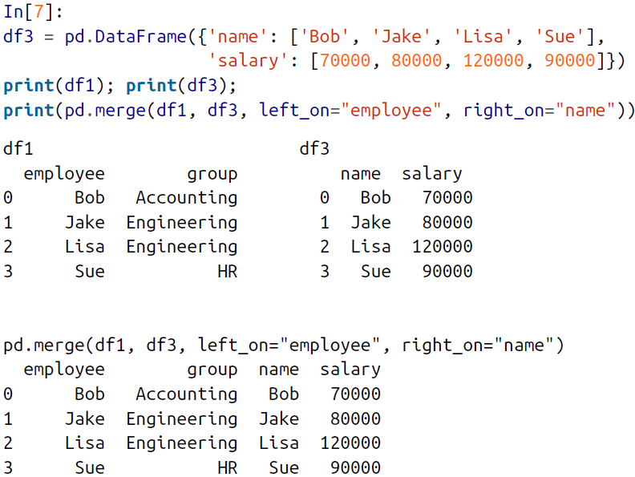

🡪The result has a redundant column that we can drop if desired—for example, by using the drop() method of DataFrames:

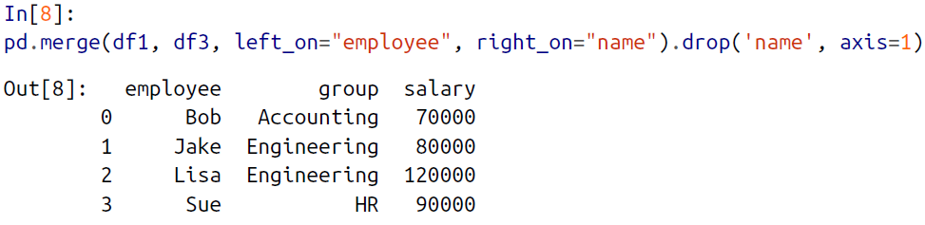

**🡺The left_index and right_index keywords**

🡪You can use the index as the key for merging by specifying the left_index and/or right_index flags in pd.merge():

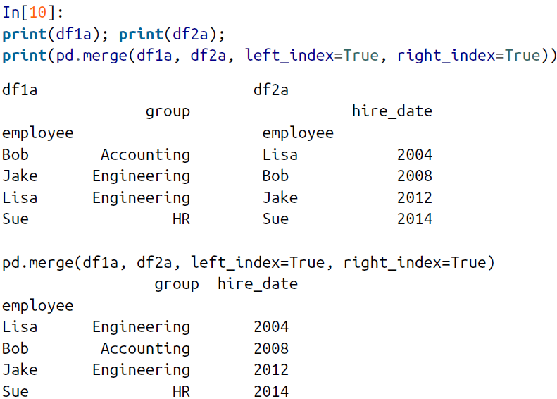

🡪For convenience, DataFrames implement the join() method, which performs a merge that defaults to joining on indices:

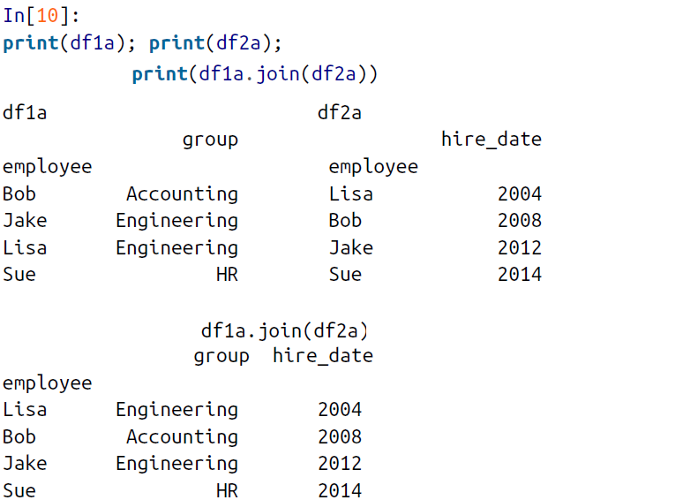

🡪If you’d like to mix indices and columns, you can combine left_index with right_on or left_on with right_index to get the desired behavior:

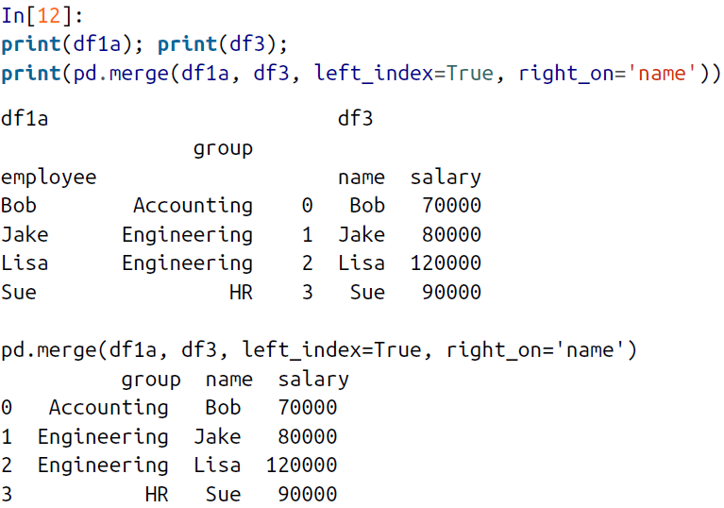

🡪All of these options also work with multiple indices and/or multiple columns; the interface for this behavior is very intuitive. For more information on this, see the “Merge, Join, and Concatenate” section of the Pandas documentation.

**🡺Specifying Set Arithmetic for Joins**

🡪In all the preceding examples we have glossed over one important consideration in performing a join: the type of set arithmetic used in the join. This comes up when a value appears in one key column but not the other. Consider this example:

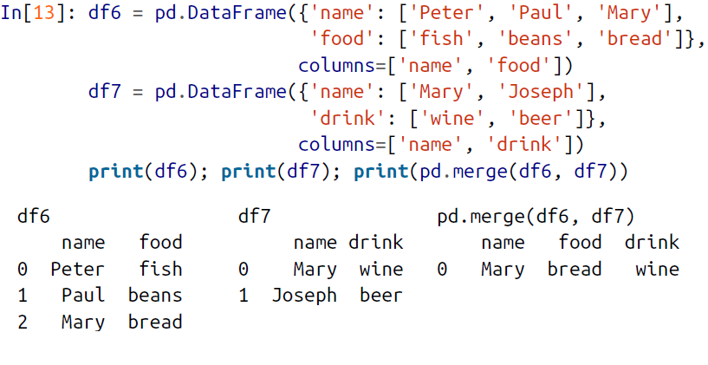

🡪Here we have merged two datasets that have only a single “name” entry in common: Mary. By default, the result contains the *intersection* of the two sets of inputs; this is what is known as an *inner join*. We can specify this explicitly using the how keyword, which defaults to 'inner':

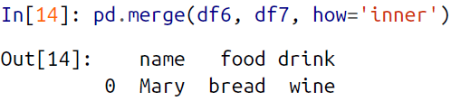

🡪Other options for the how keyword are 'outer', 'left', and 'right'. An *outer join* returns a join over the union of the input columns, and fills in all missing values withNAs:

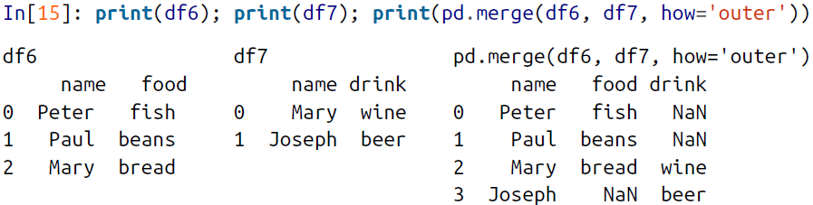

🡪The *left join* and *right join* return join over the left entries and right entries, respectively. For example:

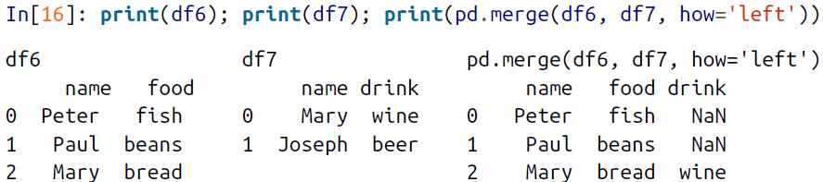

🡪The output rows now correspond to the entries in the left input. Using how='right' works in a similar manner.

🡪All of these options can be applied straightforwardly to any of the preceding join types.

🡺Overlapping Column Names: The suffixes Keyword

🡪Finally, you may end up in a case where your two input DataFrames have conflicting column names. Consider this example:

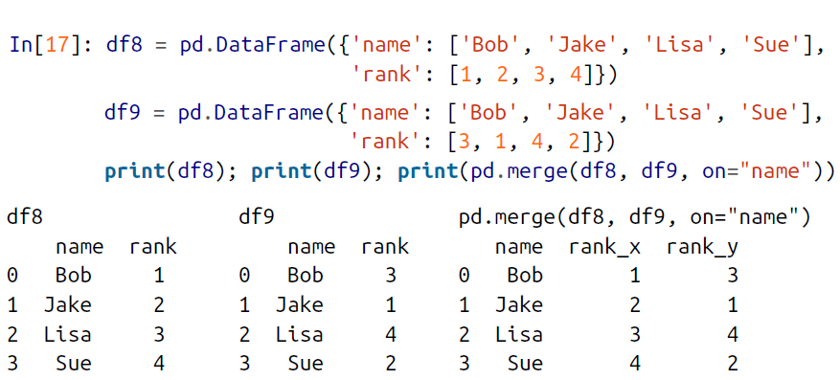

🡪Because the output would have two conflicting column names, the merge function automatically appends a suffix _x or _y to make the output columns unique. If these defaults are inappropriate, it is possible to specify a custom suffix using the suffixes keyword:

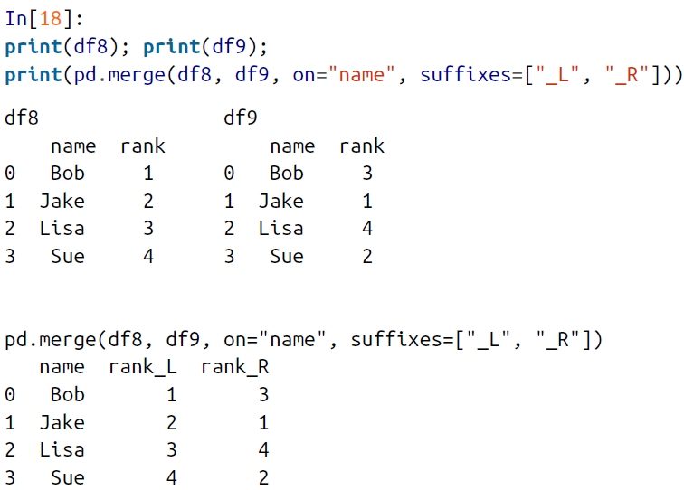

🡪These suffixes work in any of the possible join patterns, and work also if there are multiple overlapping columns.

1. Example: US States Data

🡪Merge and join operations come up most often when one is combining data from different sources. Here we will consider an example of some data about US states and their populations. The data files can be found at [*http://github.com/jakevdp/data-* *USstates/*](http://github.com/jakevdp/data-%20USstates/):

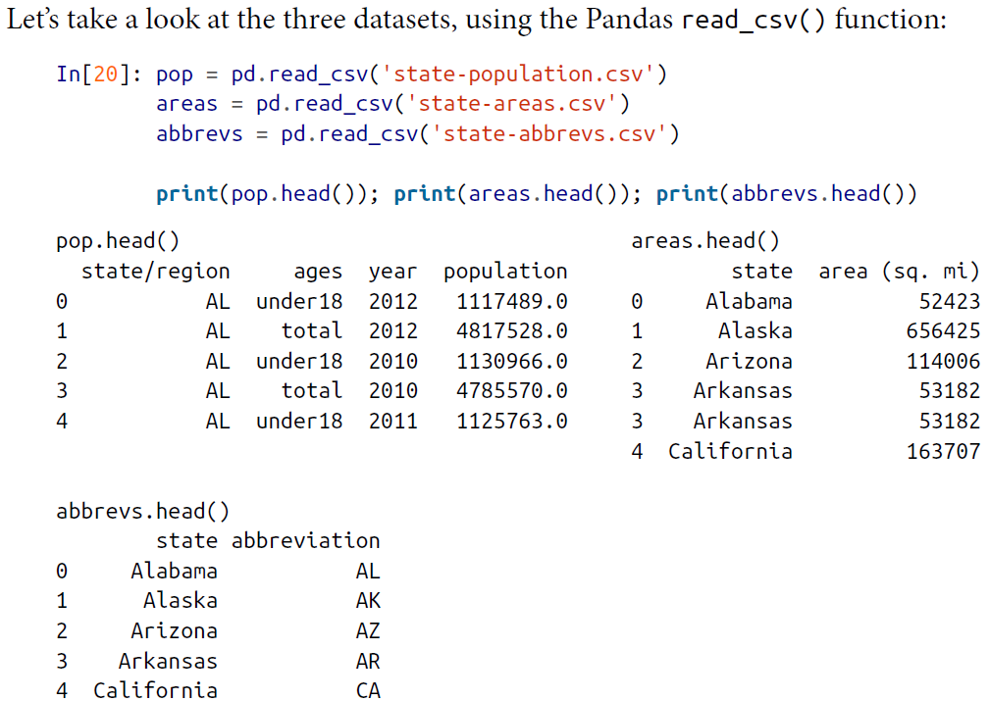

🡪Given this information, say we want to compute a relatively straightforward result: rank US states and territories by their 2010 population density. We clearly have the data here to find this result, but we’ll have to combine the datasets to get it.

🡪We’ll start with a many-to-one merge that will give us the full state name within the population DataFrame. We want to merge based on the state/region column of pop, and the abbreviation column of abbrevs. We’ll use how='outer' to make sure no data is thrown away due to mismatched labels.

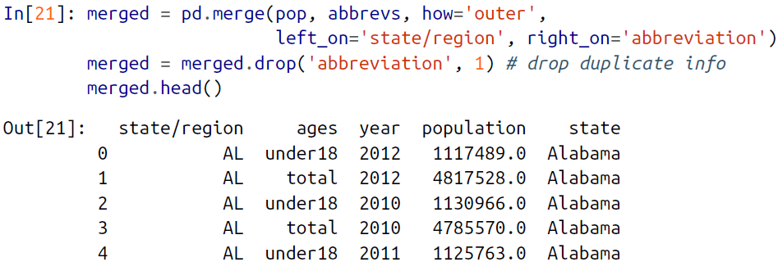

🡪Let’s double-check whether there were any mismatches here, which we can do by looking for rows with nulls:

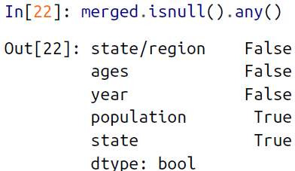

🡪Some of the population info is null; let’s figure out which these are!

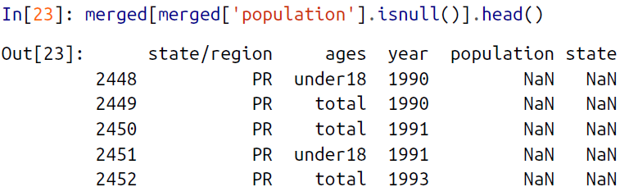

🡪It appears that all the null population values are from Puerto Rico prior to the year 2000; this is likely due to this data not being available from the original source.

🡪More importantly, we see also that some of the new state entries are also null, which means that there was no corresponding entry in the abbrevs key! Let’s figure out which regions lack this match:



🡪We can quickly infer the issue: our population data includes entries for Puerto Rico (PR) and the United States as a whole (USA), while these entries do not appear in the state abbreviation key. We can fix these quickly by filling in appropriate entries:

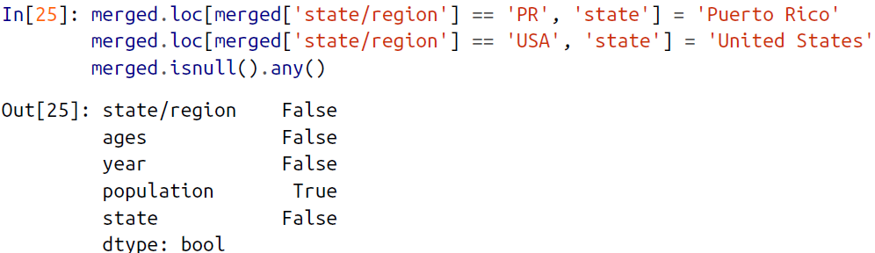

🡪No more nulls in the state column: we’re all set!

🡪Now we can merge the result with the area data using a similar procedure. Examining our results, we will want to join on the state column in both:

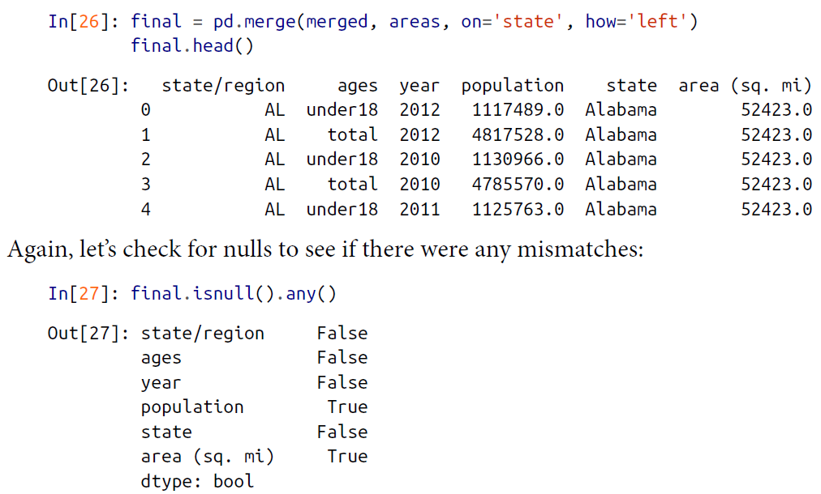

🡪There are nulls in the area column; we can take a look to see which regions were ignored here:



🡪We see that our areas DataFrame does not contain the area of the United States as a whole. We could insert the appropriate value (using the sum of all state areas, for instance), but in this case we’ll just drop the null values because the population density of the entire United States is not relevant to our current discussion:

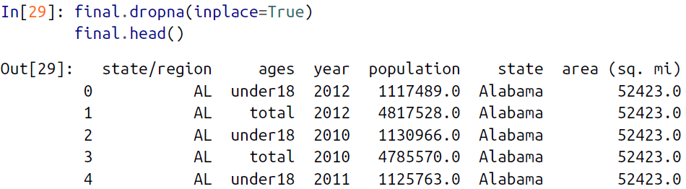

🡪Now we have all the data we need. To answer the question of interest, let’s first select the portion of the data corresponding with the year 2000, and the total population. We’ll use the query() function to do this quickly (this requires the numexpr package to be installed; see “High-Performance Pandas: eval() and query()”):

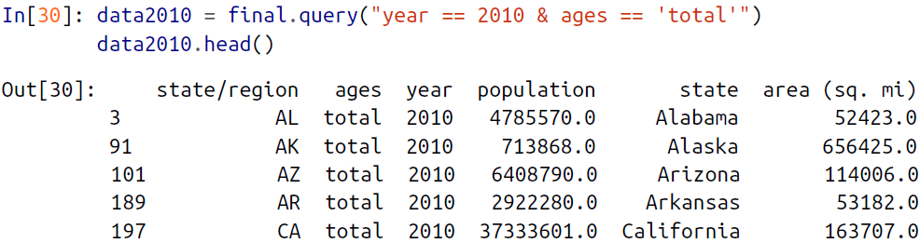

🡪Now let’s compute the population density and display it in order. We’ll start by reindexing our data on the state, and then compute the result:

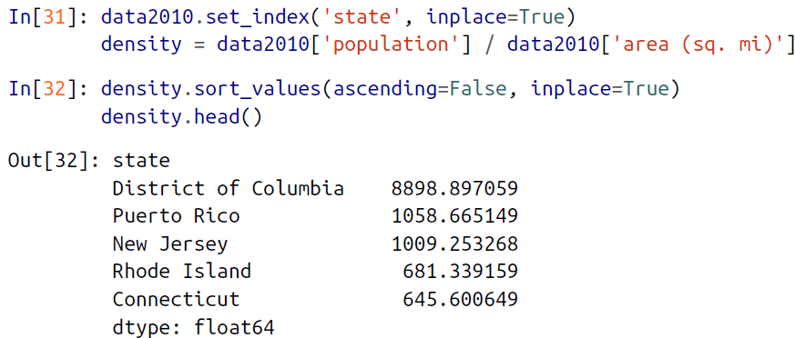

🡪The result is a ranking of US states plus Washington, DC, and Puerto Rico in order of their 2010 population density, in residents per square mile. We can see that by far the densest region in this dataset is Washington, DC (i.e., the District of Columbia); among states, the densest is New Jersey.

🡪We can also check the end of the list:

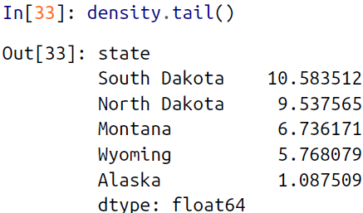

1. Aggregation and Grouping

🡪An essential piece of analysis of large data is efficient summarization: computing

aggregations like sum(), mean(), median(), min(), and max(), in which a single number

gives insight into the nature of a potentially large dataset. In this section, we’ll explore aggregations in Pandas, from simple operations akin to what we’ve seen on NumPy arrays, to more sophisticated operations based on the concept of a groupby.

**🡺Planets Data**

🡪Here we will use the Planets dataset, available via the Seaborn package. It gives information on planets that astronomers have discovered around other stars (known as *extrasolar planets* or *exoplanets* for short). It can be downloaded with a simple Seaborn command:

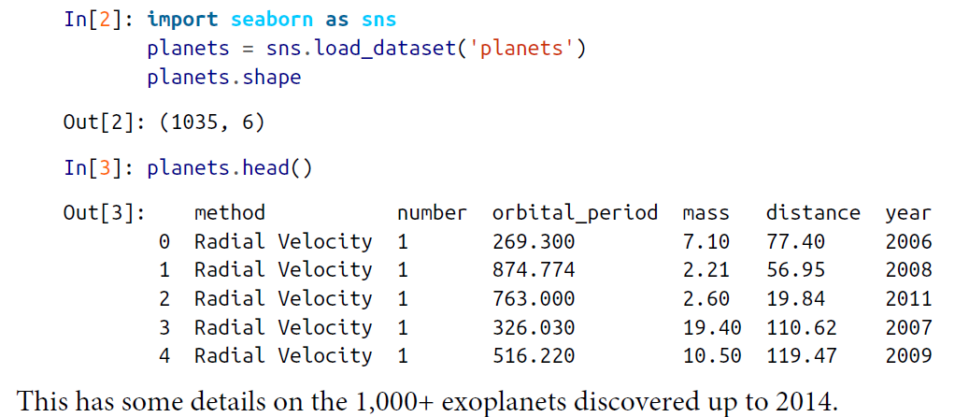

**🡺Simple Aggregation in pandas**

🡪Earlier we explored some of the data aggregations available for NumPy arrays (Like: Min, Max). As with a one-dimensional NumPy array, for a Pandas Series the aggregates return a single value:

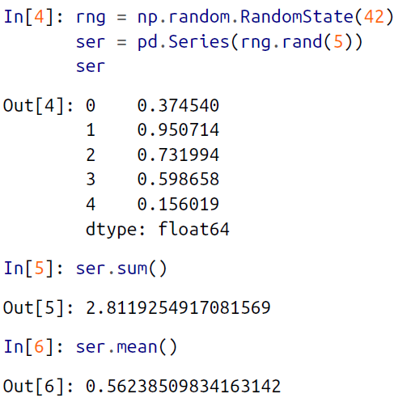

🡪For a DataFrame, by default the aggregates return results within each column:

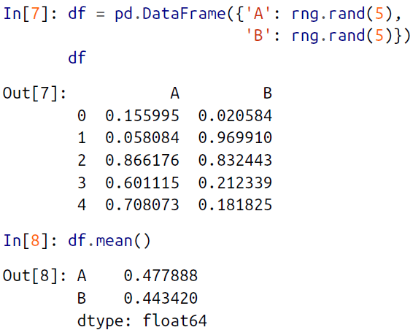

🡪By specifying the axis argument, you can instead aggregate within each row:

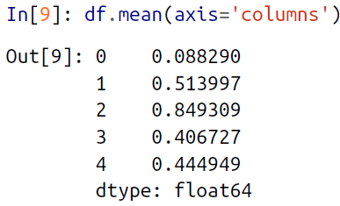

🡪List of pandas aggregation methods:

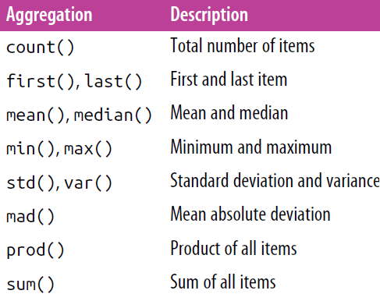

🡪To go deeper into the data, however, simple aggregates are often not enough. The

next level of data summarization is the groupby operation, which allows you to

quickly and efficiently compute aggregates on subsets of data.

**🡺GroupBy: Split, Apply, Combine**

🡪Simple aggregations can give you a flavor of your dataset, but often we would prefer to aggregate conditionally on some label or index: this is implemented in the so called groupby operation. The name “group by” comes from a command in the SQL

database language, but it is perhaps more illuminative to think of it in the terms first

coined by Hadley Wickham of Rstats fame: *split, apply, combine*.

**🡺Split, apply, combine**

🡪A canonical example of this split-apply-combine operation, where the “apply” is a summation aggregation, is illustrated in Figure

🡪Figure clears what the groupBy accomplishes:

1. The *split* step involves breaking up and grouping a DataFrame depending on the
2. The *apply* step involves computing some function, usually an aggregate, transformation, or filtering, within the individual groups.
3. The combine step merges the results of these operations into an output array

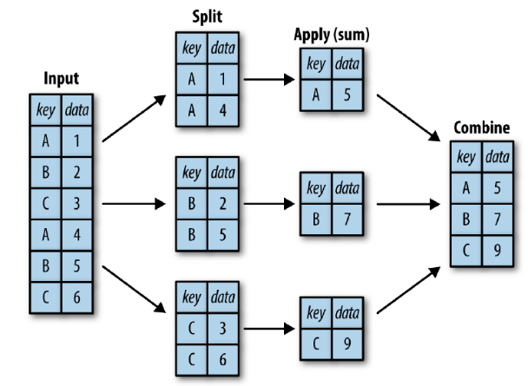

🡪 While we could certainly do this manually using some combination of the masking, aggregation, and merging commands covered earlier, it’s important to realize that *the* *intermediate splits do not need to be explicitly instantiated*. Rather, the GroupBy can (often) do this in a single pass over the data, updating the sum, mean, count, min, or other aggregate for each group along the way. The power of the GroupBy is that it abstracts away these steps: the user need not think about *how* the computation is done under the hood, but rather thinks about the *operation as a whole*.

🡪 As a concrete example, let’s take a look at using Pandas for the computation shown in figure

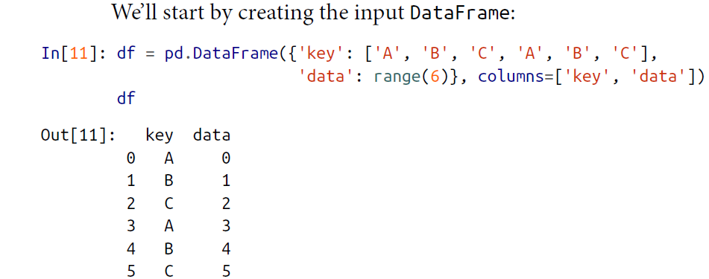

🡪 We can compute the most basic split-apply-combine operation with the groupby() method of DataFrames, passing the name of the desired key column:

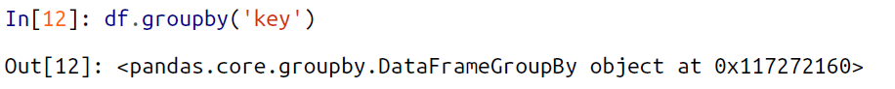

🡪 Notice that what is returned is not a set of DataFrames, but a DataFrameGroupBy object. This object is where the magic is: you can think of it as a special view of the DataFrame, which is poised to dig into the groups but does no actual computation until the aggregation is applied. This “lazy evaluation” approach means that common aggregates can be implemented very efficiently in a way that is almost transparent to the user.

🡪 To produce a result, we can apply an aggregate to this DataFrameGroupBy object, which will perform the appropriate apply/combine steps to produce the desired result:

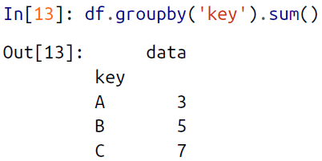

🡪 The sum() method is just one possibility here; you can apply virtually any common Pandas or NumPy aggregation function, as well as virtually any valid DataFrame operation, as we will see in the following discussion.

**🡺The GroupBy Object**

🡪 The GroupBy object is a very flexible abstraction. In many ways, you can simply treat it as if it’s a collection of DataFrames, and it does the difficult things under the hood. Let’s see some examples using the Planets data.

🡪 Perhaps the most important operations made available by a GroupBy are *aggregate*, *filter*, *transform*, and *apply*. We’ll discuss each of these more fully in “Aggregate, filter, transform, apply”, but before that let’s introduce some of the other functionality that can be used with the basic GroupBy operation.

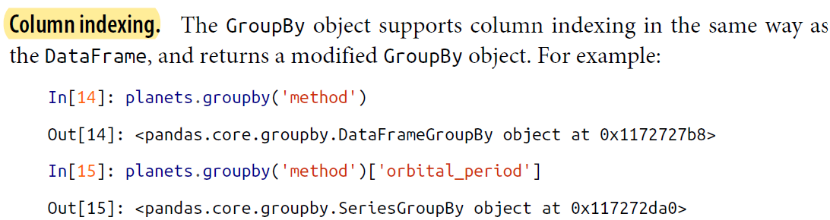

🡪 Here we’ve selected a particular Series group from the original DataFrame group by reference to its column name. As with the GroupBy object, no computation is done until we call some aggregate on the object:

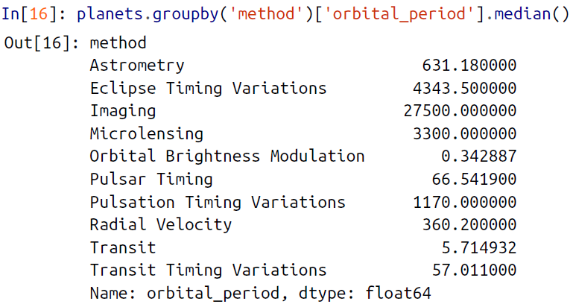

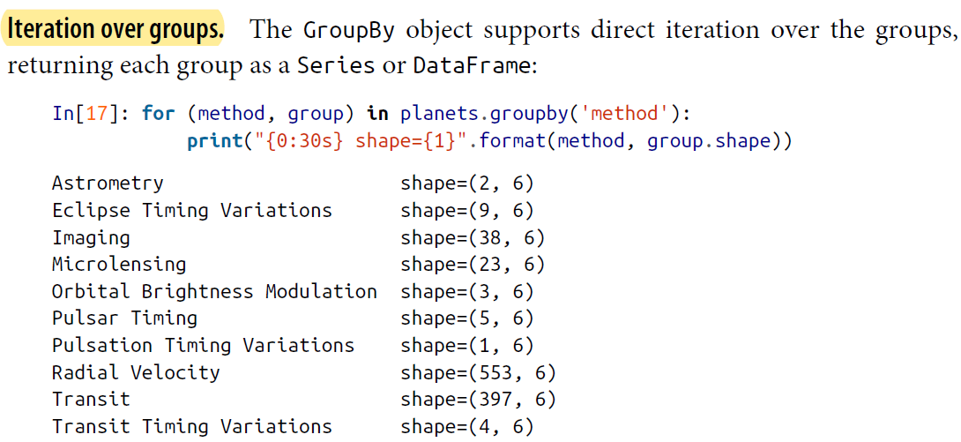

🡪 This can be useful for doing certain things manually, though it is often much faster to use the built-in apply functionality, which we will discuss momentarily.

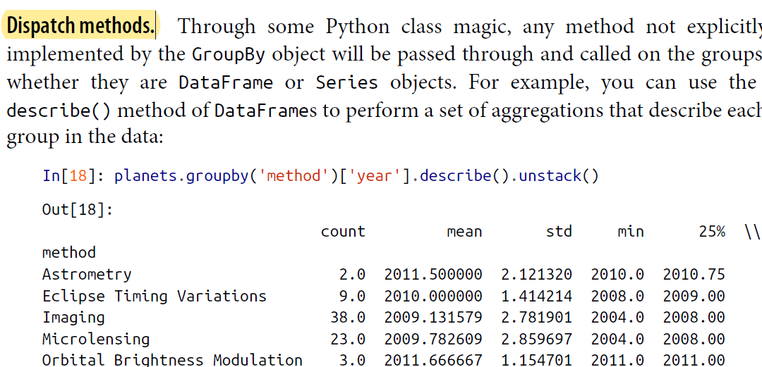

🡪 This is just one example of the utility of dispatch methods. Notice that they are applied *to each individual group*, and the results are then combined within GroupBy and returned. Again, any valid DataFrame/Series method can be used on the corresponding GroupBy object, which allows for some very flexible and powerful operations!

**🡺 Aggregate, filter, transform, apply**

🡪 The preceding discussion focused on aggregation for the combine operation, but there are more options available. In particular, GroupBy objects have aggregate(), filter(), transform(), and apply() methods that efficiently implement a variety of useful operations before combining the grouped data.

🡪 For the purpose of the following subsections, we’ll use this DataFrame:

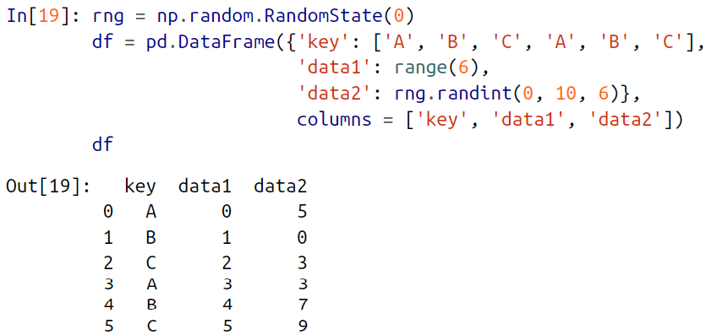

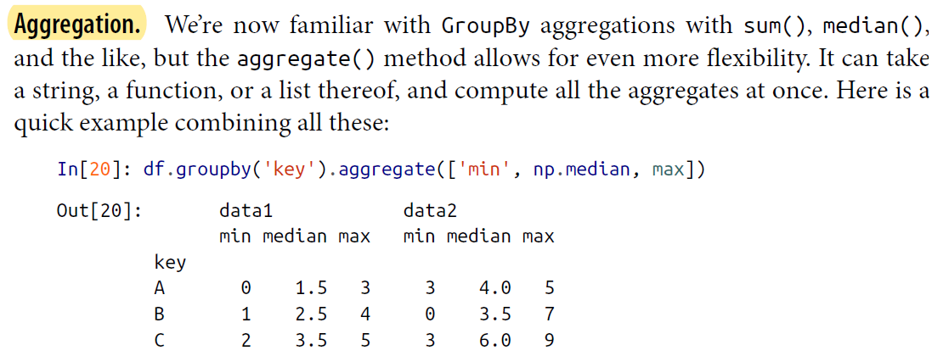

🡪 Another useful pattern is to pass a dictionary mapping column names to operations to be applied on that column:

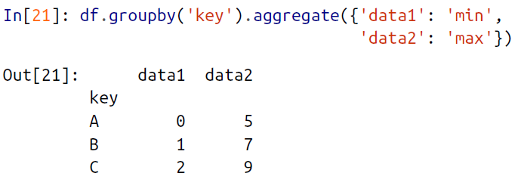

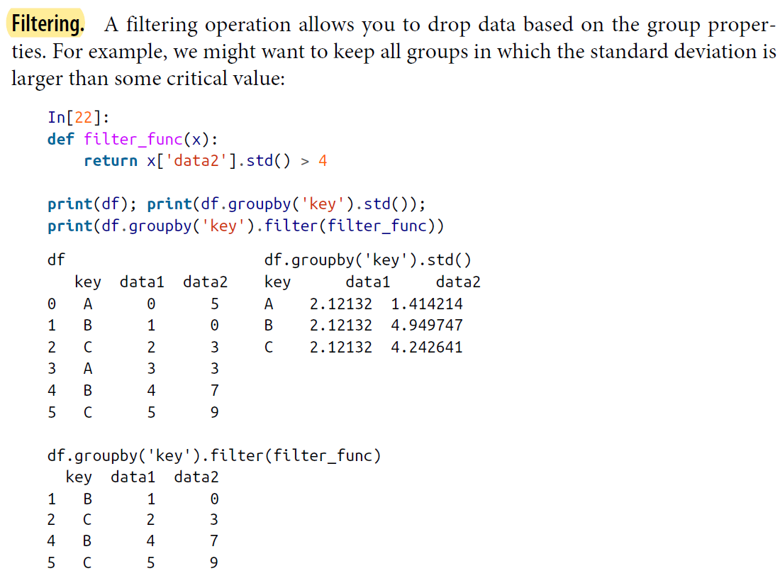

🡪 The filter() function should return a Boolean value specifying whether the group passes the filtering. Here because group A does not have a standard deviation greater than 4, it is dropped from the result.

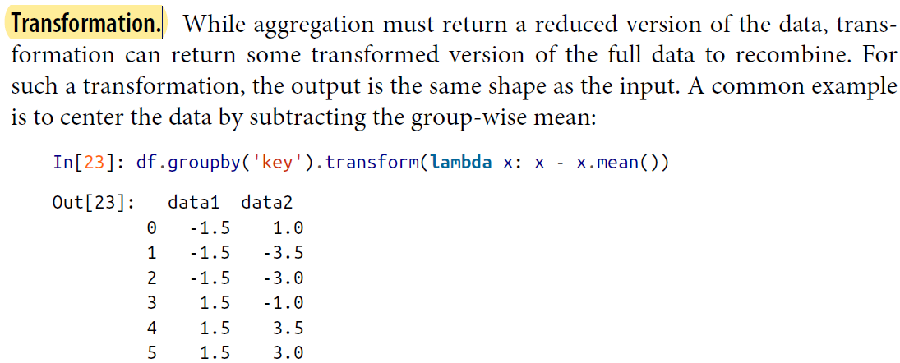

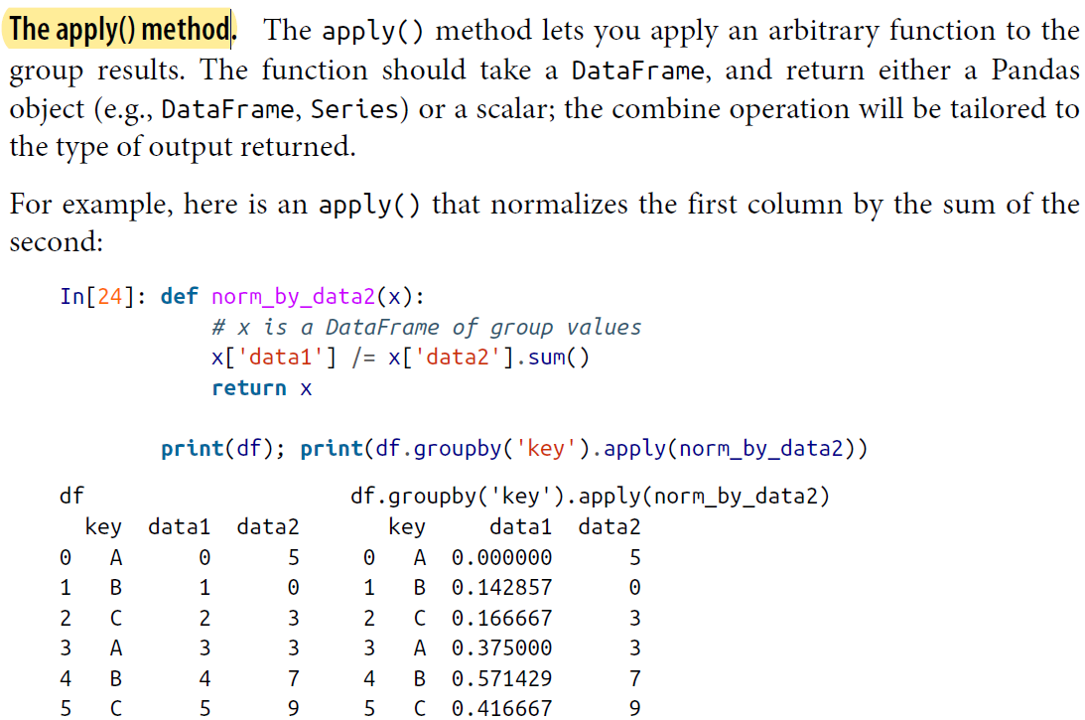

🡪 apply() within a GroupBy is quite flexible: the only criterion is that the function takes a DataFrame and returns a Pandas object or scalar; what you do in the middle is up to you!

**🡺Specifying the split key**

🡪 In the simple examples presented before, we split the DataFrame on a single column name. This is just one of many options by which the groups can be defined, and we’ll go through some other options for group specification here.

🡪 A list, array, series, or index providing the grouping keys. The key can be any series or list with a length matching that of the DataFrame. For example:

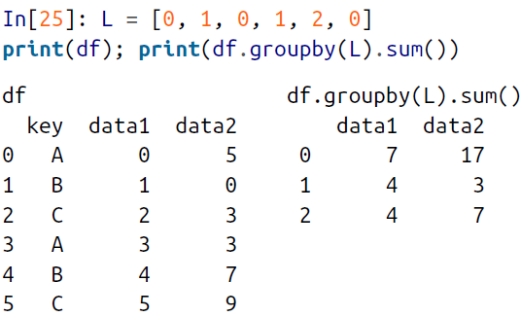

🡪 Of course, this means there’s another, more verbose way of accomplishing the df.groupby('key') from before:

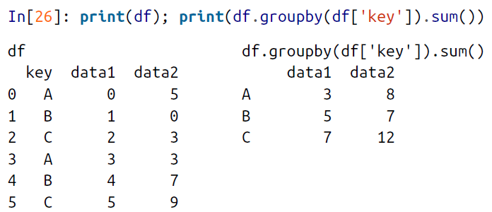

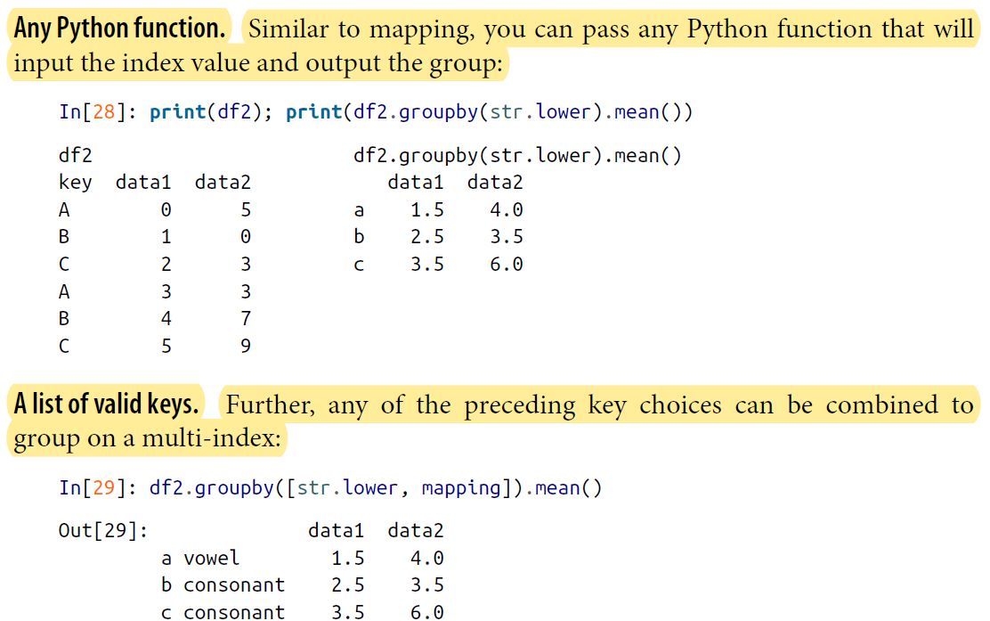

1. Pivot Tables

🡪We have seen how the GroupBy abstraction lets us explore relationships within a dataset. A *pivot table* is a similar operation that is commonly seen in spreadsheets and other programs that operate on tabular data. The pivot table takes simple columnwise data as input, and groups the entries into a two-dimensional table that provides a multidimensional summarization of the data. The difference between pivot tables and GroupBy can sometimes cause confusion; it helps me to think of pivot tables as essentially a *multidimensional* version of GroupBy aggregation. That is, you splitapply- combine, but both the split and the combine happen across not a onedimensional index, but across a two-dimensional grid.

**🡺Motivating Pivot tables**

🡪For the examples in this section, we’ll use the database of passengers on the *Titanic*, available through the Seaborn library

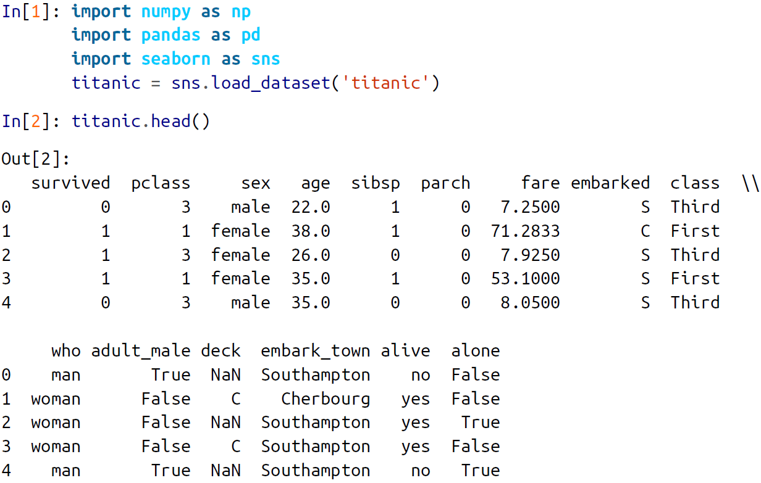

🡪This contains a wealth of information on each passenger of that ill-fated voyage, including gender, age, class, fare paid, and much more.

**🡺Pivot tables by hand**

🡪To start learning more about this data, we might begin by grouping it according to gender, survival status, or some combination thereof. If you have read the previous section, you might be tempted to apply a GroupBy operation—for example, let’s look at survival rate by gender:

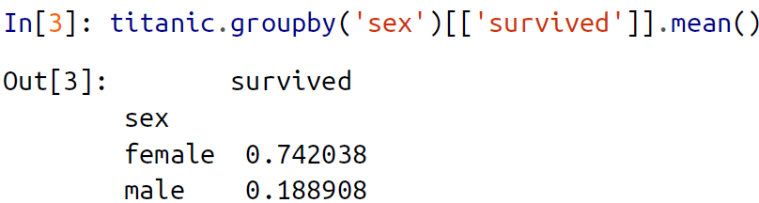

🡪This immediately gives us some insight: overall, three of every four females on board survived, while only one in five males survived!

🡪This is useful, but we might like to go one step deeper and look at survival by both sex and, say, class. Using the vocabulary of GroupBy, we might proceed using something like this: we *group by* class and gender, *select* survival, *apply* a mean aggregate, *combine* the resulting groups, and then *unstack* the hierarchical index to reveal the hidden

multidimensionality. In code:

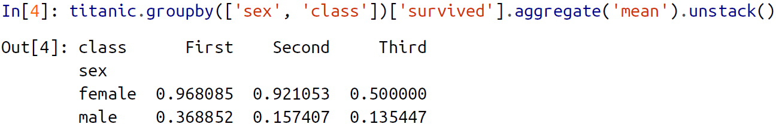

🡪This gives us a better idea of how both gender and class affected survival, but the code is starting to look a bit garbled. While each step of this pipeline makes sense in light of the tools we’ve previously discussed, the long string of code is not particularly easy to read or use. This two-dimensional GroupBy is common enough that Pandas includes a convenience routine, pivot_table, which succinctly handles this type of multidimensional aggregation.

**🡺Pivot Table Syntax**

🡪Here is the equivalent to the preceding operation using the pivot_table method of DataFrames:

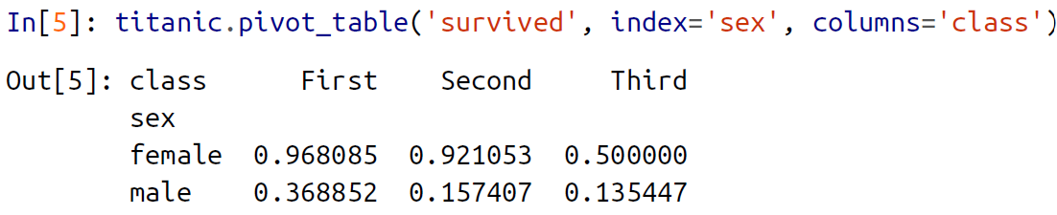

🡪This is eminently readable than the GroupBy approach, and produces the same result.

**🡺Multilevel pivot tables**

🡪Just as in the GroupBy, the grouping in pivot tables can be specified with multiple levels, and via a number of options. For example, we might be interested in looking at

age as a third dimension. We’ll bin the age using the pd.cut function:

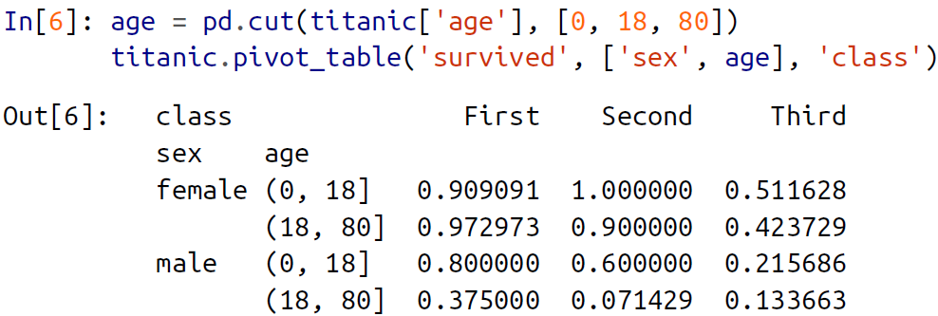

🡪We can apply this same strategy when working with the columns as well; let’s add info on the fare paid using pd.qcut to automatically compute quantiles:

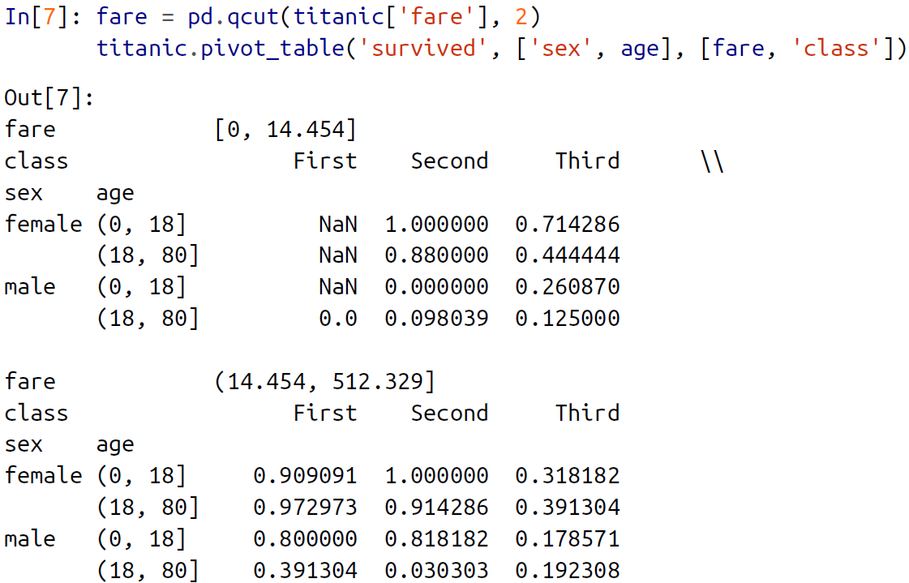

*Here, the pandas.qcut is quantile-based discretization function. It discretize variable into equal sized quantities. For example 1000 values for 10 quantiles.

🡪The result is four dimensional aggregation with hierarchical indices

**🡺Additional pivot table options**

🡪The full call signature of the pivot_table method of DataFrames is as follows:

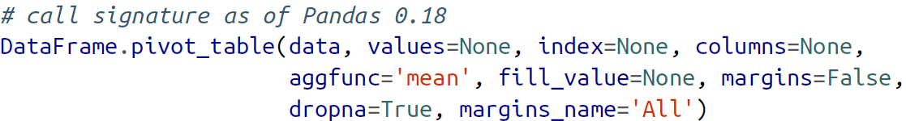

🡪We’ve already seen examples of the first three arguments; here we’ll take a quick look at the remaining ones. Two of the options, fill_value and dropna, have to do with missing data and are fairly straightforward; we will not show examples of them here.

🡪The aggfunc keyword controls what type of aggregation is applied, which is a mean by default. As in the GroupBy, the aggregation specification can be a string representing one of several common choices ('sum', 'mean', 'count', 'min', 'max', etc.) or a function that implements an aggregation (np.sum(), min(), sum(), etc.). Additionally, it can be specified as a dictionary mapping a column to any of the above desired options:

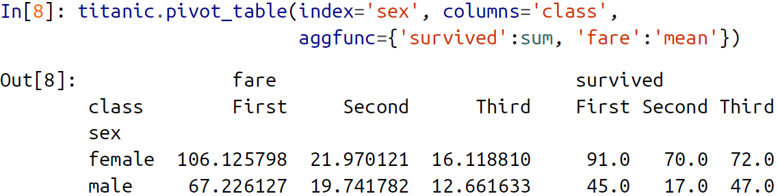  
🡪Notice also here that we’ve omitted the values keyword; when you’re specifying a mapping for aggfunc, this is determined automatically.

🡪**At times it’s useful to compute totals along each grouping. This can be done via the margins keyword:**

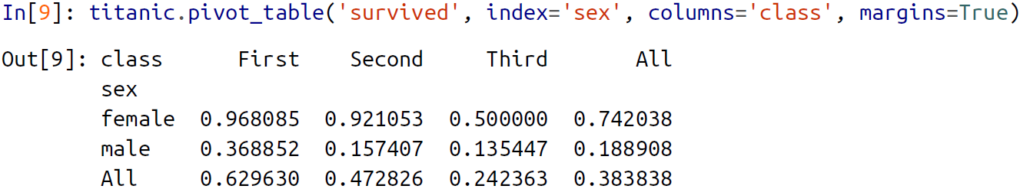

🡪Here this automatically gives us information about the class-agnostic survival rate by gender, the gender-agnostic survival rate by class, and the overall survival rate of 38%. The margin label can be specified with the margins_name keyword, which defaults to

"All".

**🡺Example: Birth rate Data**

🡪As a more interesting example, let’s take a look at the freely available data on births in the United States, provided by the Centers for Disease Control (CDC). This data can be found at *https://raw.githubusercontent.com/jakevdp/data-CDCbirths/master/*

*births.csv*

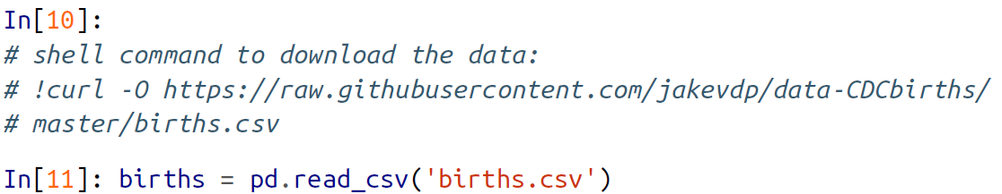

🡪Taking a look at the data, we see that it’s relatively simple—it contains the number ofbirths grouped by date and gender:

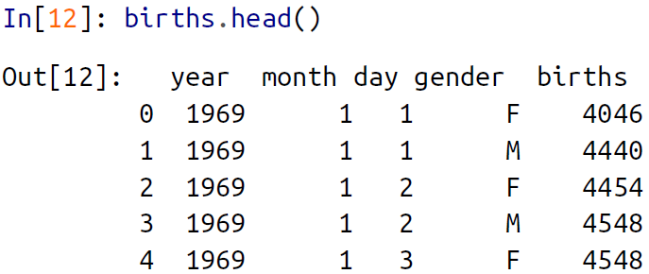

🡪We can start to understand this data a bit more by using a pivot table. Let’s add a decade column, and take a look at male and female births as a function of decade:

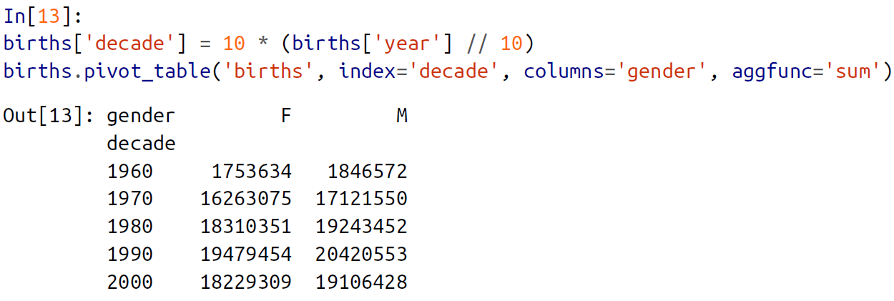

🡪We immediately see that male births outnumber female births in every decade. To see this trend a bit more clearly, we can use the built-in plotting tools in Pandas to visualize the total number of births by year

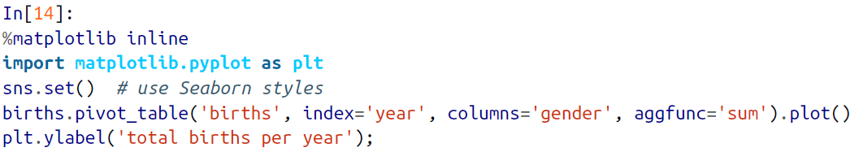

🡪Graph of total numbers of US births by year and gender

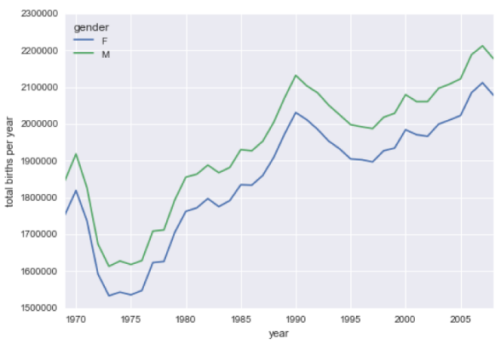

🡪With a simple pivot table and plot() method, we can immediately see the annual trend in births by gender. By eye, it appears that over the past 50 years male births have outnumbered female births by around 5%.

1. Vectorized String Operations

🡪One strength of Python is its relative ease in handling and manipulating string data.

Pandas builds on this and provides a comprehensive set of *vectorized string operations* that become an essential piece of the type of munging required when one is workingwith (read: cleaning up) real-world data. In this section, we’ll walk through some ofthe Pandas string operations, and then take a look at using them to partially clean upa very messy dataset of recipes collected from the Internet.

**🡺Introducing Pandas String Operations**

🡪We saw in previous sections how tools like NumPy and Pandas generalize arithmetic operations so that we can easily and quickly perform the same operation on many array elements. For example:

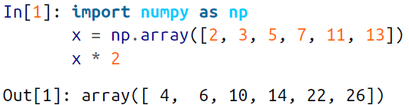

🡪This *vectorization* of operations simplifies the syntax of operating on arrays of data: we no longer have to worry about the size or shape of the array, but just about what operation we want done. For arrays of strings, NumPy does not provide such simple access, and thus you’re stuck using a more verbose loop syntax:

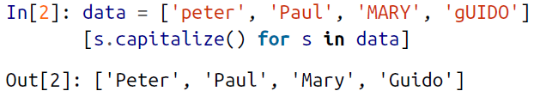

🡪This is perhaps sufficient to work with some data, but it will break if there are any missing values. For example:

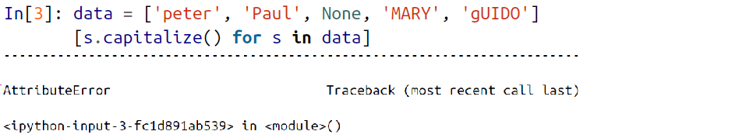

🡪Pandas includes features to address both this need for vectorized string operations and for correctly handling missing data via the str attribute of Pandas Series and Index objects containing strings. So, for example, suppose we create a Pandas Series with this data:

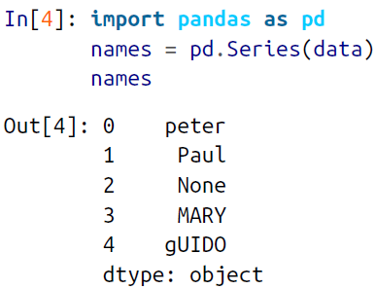

**🡪We can now call a single method that will capitalize all the entries, while skipping over any missing values:**

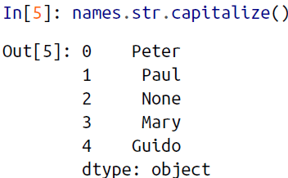

🡪Using tab completion on this str attribute will list all the vectorized string methods available to Pandas.

🡺**Tables of pandas String methods:**

🡪If you have a good understanding of string manipulation in Python, most of Pandas’ string syntax is intuitive enough that it’s probably sufficient to just list a table of available methods; we will start with that here, before diving deeper into a few of the subtleties. The examples in this section use the following series of names:



🡺**Methods similar to Python string methods**

🡪Nearly all Python’s built-in string methods are mirrored by a Pandas vectorized string method. Here is a list of Pandas str methods that mirror Python string methods:

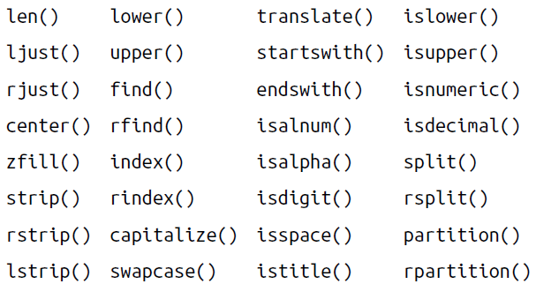

🡪Notice that these have various return values. Some, like lower(), return a series of strings:

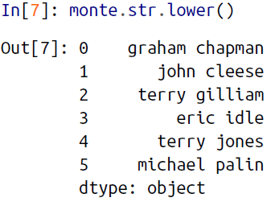

🡪But some others return numbers:

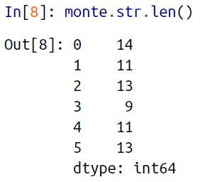

🡪Or Boolean values:

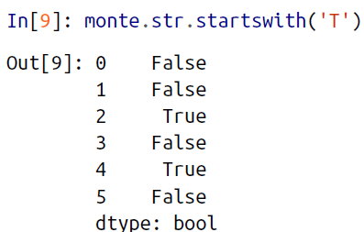

🡪Still others return lists or other compound values for each element:

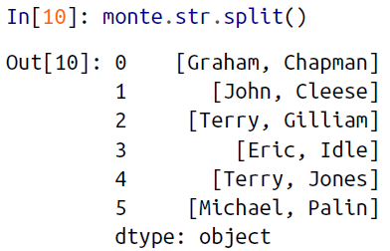

🡪We’ll see further manipulations of this kind of series-of-lists object as we continue our discussion.

**🡺Methods using regular expressions**

🡪In addition, there are several methods that accept regular expressions to examine the content of each string element, and follow some of the API conventions of Python’s built-in re module

🡪Mapping between pandas methods and functions in python’s re module

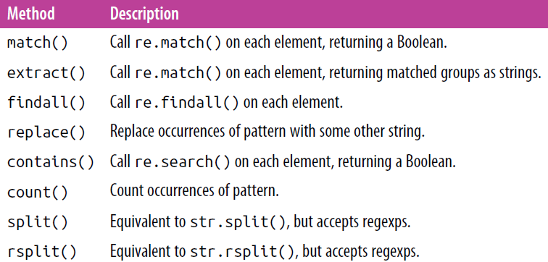

🡪With these, you can do a wide range of interesting operations. For example, we can extract the first name from each by asking for a contiguous group of characters at the beginning of each element:

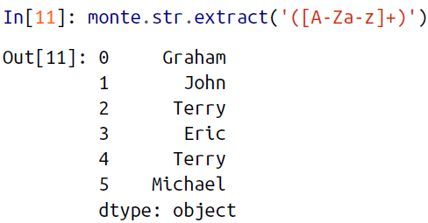

🡪Or we can do something more complicated, like finding all names that start and end with a consonant, making use of the start-of-string (^) and end-of-string ($) regular expression characters:

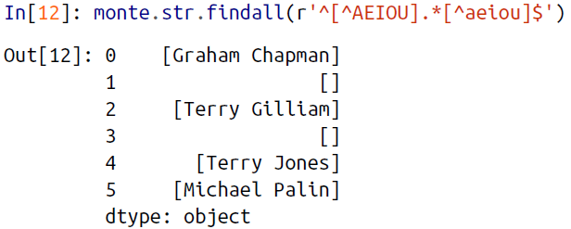

🡪The ability to concisely apply regular expressions across Series or DataFrame entries opens up many possibilities for analysis and cleaning of data.

**🡺Miscellaneous methods**

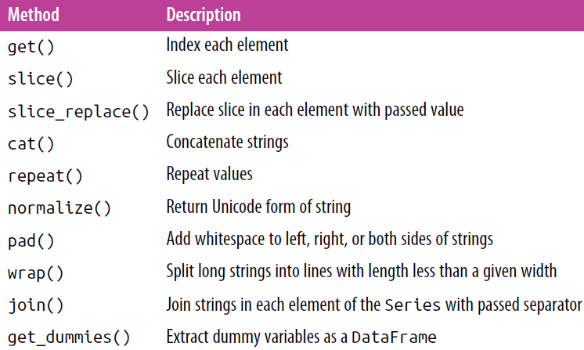

🡪Vectorized item access and slicing. The get() and slice() operations, in particular, enable vectorized element access from each array. For example, we can get a slice of the first three characters of each array using str.slice(0, 3). Note that this behavior is also available through Python’s normal indexing syntax—for example, df.str.slice(0, 3) is equivalent to df.str[0:3]:

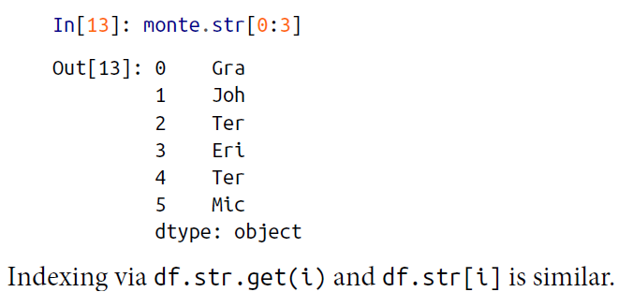

🡪These get() and slice() methods also let you access elements of arrays returned by split(). For example, to extract the last name of each entry, we can combine split() and get():

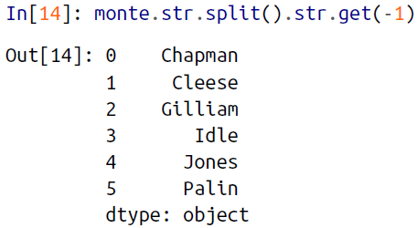

🡪Indicator variables. Another method that requires a bit of extra explanation is the get_dummies() method. This is useful when your data has a column containing some sort of coded indicator. For example, we might have a dataset that contains information in the form of codes, such as A=“born in America,” B=“born in the United Kingdom,” C=“likes cheese,” D=“likes spam :

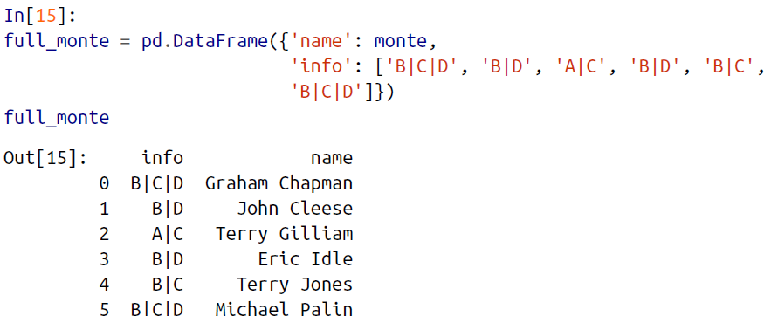

🡪The get_dummies() routine lets you quickly split out these indicator variables into a DataFrame:

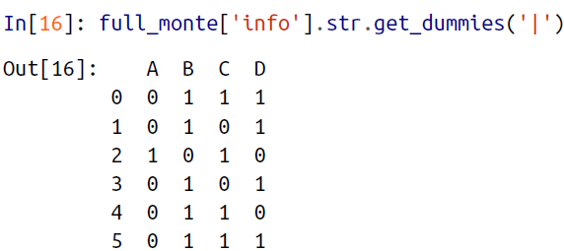

🡪With these operations as building blocks, you can construct an endless range of string processing procedures when cleaning your data.

🡪We won’t dive further into these methods here, but I encourage you to read through “Working with Text Data” in the pandas online documentation

🡺**Example: Recipe Database**

🡪These vectorized string operations become most useful in the process of cleaning up messy, real-world data. Here I’ll walk through an example of that, using an open recipe database compiled from various sources on the Web. Our goal will be to parse the recipe data into ingredient lists, so we can quickly find a recipe based on some ingredients we have on hand.

🡪The scripts used to compile this can be found at *https://github.com/fictivekin/openrecipes*, and the link to the current version of the database is found there as well.

🡪The database is in JSON format, so we will try pd.read_json to read it:

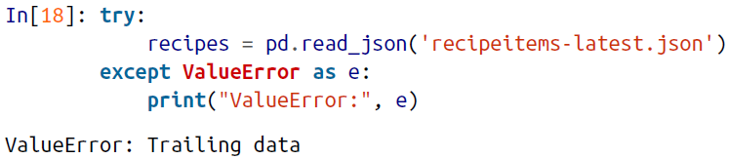

🡪Oops! We get a ValueError mentioning that there is “trailing data.” Searching for this error on the Internet, it seems that it’s due to using a file in which *each line* is itself a valid JSON, but the full file is not. Let’s check if this interpretation is true:

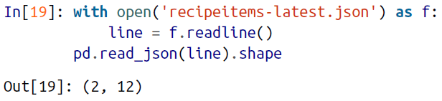

🡪Yes, apparently each line is a valid JSON, so we’ll need to string them together. One way we can do this is to actually construct a string representation containing all these JSON entries, and then load the whole thing with pd.read_json:

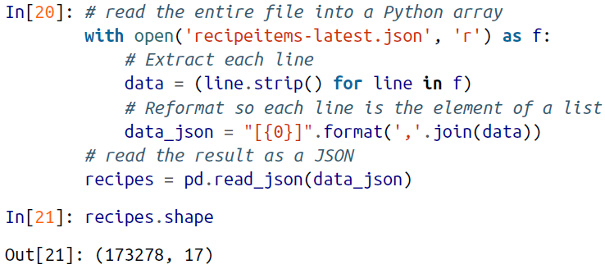

🡪We see there are nearly 200,000 recipes, and 17 columns. Let’s take a look at one row to see what we have:

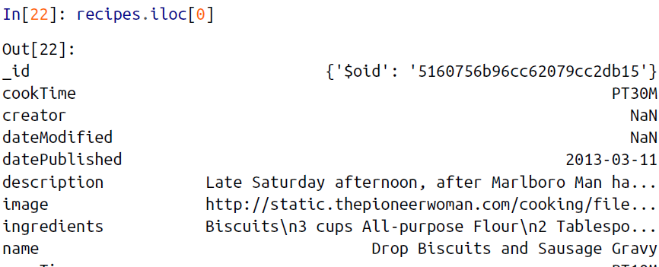

🡪There is a lot of information there, but much of it is in a very messy form, as is typical of data scraped from the Web. In particular, the ingredient list is in string format; we’re going to have to carefully extract the information we’re interested in. Let’s start by taking a closer look at the ingredients:



🡪The ingredient lists average 250 characters long, with a minimum of 0 and a maximum of nearly 10,000 characters!

🡪Just out of curiosity, let’s see which recipe has the longest ingredient list:

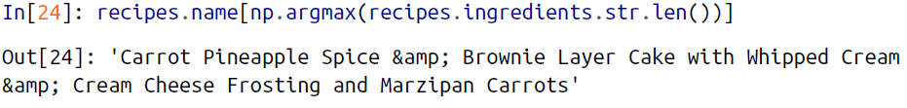

🡪We can do other aggregate explorations; for example, let’s see how many of the recipes are for breakfast food:

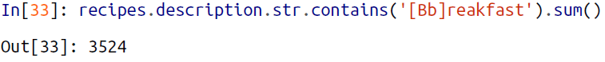

🡪Or how many of the recipes list cinnamon as an ingredient:



🡪This is the type of essential data exploration that is possible with Pandas string tools. It is data munging like this that Python really excels at.

**🡺A simple recipe recommender**

🡪Let’s go a bit further, and start working on a simple recipe recommendation system: given a list of ingredients, find a recipe that uses all those ingredients. While conceptually straightforward, the task is complicated by the heterogeneity of the data: there is no easy operation, for example, to extract a clean list of ingredients from each row. So we will cheat a bit: we’ll start with a list of common ingredients, and simply search to see whether they are in each recipe’s ingredient list. For simplicity, let’s just stick with herbs and spices for the time being:



🡪We can then build a Boolean DataFrame consisting of True and False values, indicating whether this ingredient appears in the list:

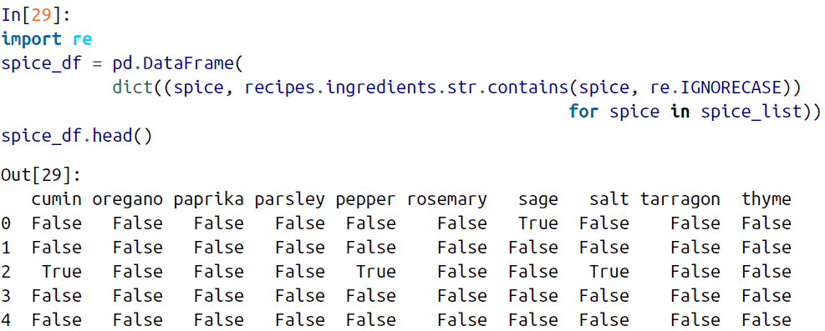

🡪Now, as an example, let’s say we’d like to find a recipe that uses parsley, paprika, and tarragon. We can compute this very quickly using the query() method of Data Frames, discussed in “High-Performance Pandas: eval() and query()”

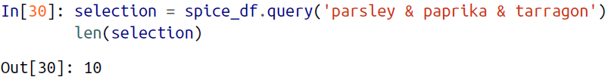

🡪We find only 10 recipes with this combination; let’s use the index returned by this selection to discover the names of the recipes that have this combination:

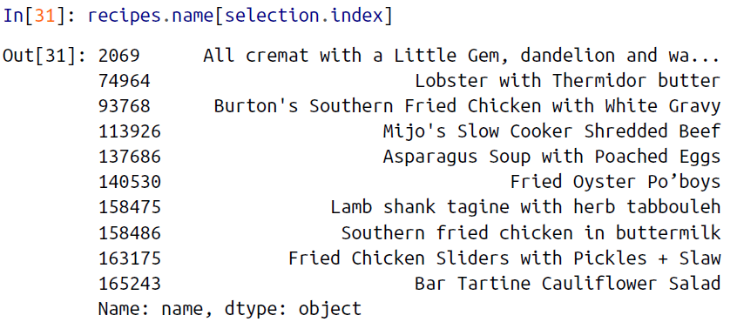

🡪Now that we have narrowed down our recipe selection by a factor of almost 20,000, we are in a position to make a more informed decision about what we’d like to cook for dinner.

1. Working with Time Series

🡪Pandas was developed in the context of financial modeling, so as you might expect, it contains a fairly extensive set of tools for working with dates, times, and time indexed data. Date and time data comes in a few flavors, which we will discuss here:

🡪In this section, we will introduce how to work with each of these types of date/time

data in Pandas. This short section is by no means a complete guide to the time series

tools available in Python or Pandas, but instead is intended as a broad overview of

how you as a user should approach working with time series.

**🡺Dates and Times in python**

🡪The Python world has a number of available representations of dates, times, deltas,

and timespans. While the time series tools provided by Pandas tend to be the most

useful for data science applications, it is helpful to see their relationship to other

packages used in Python.

**🡺Native python dates and times: datetime and dateutil**

🡪Python’s basic objects for working with dates and times reside in the built-in date time module. Along with the third-party dateutil module, you can use it to quickly perform a host of useful functionalities on dates and times. For example, you can manually build a date using the datetime type:

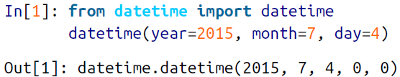

🡪Or, using the dateutil module, you can parse dates from a variety of string formats:

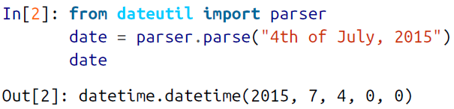

🡪Once you have a datetime object, you can do things like printing the day of the week:

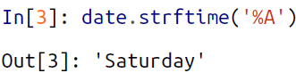

🡪In the final line, we’ve used one of the standard string format codes for printing dates ("%A"), which you can read about in the strftime section of Python’s datetime documentation. Documentation of other useful date utilities can be found in dateutil’s online documentation. A related package to be aware of is pytz, which contains tools for working with the most migraine-inducing piece of time series data: time zones.

🡪The power of datetime and dateutil lies in their flexibility and easy syntax: you can use these objects and their built-in methods to easily perform nearly any operation you might be interested in. Where they break down is when you wish to work with large arrays of dates and times: just as lists of Python numerical variables are suboptimal compared to NumPy-style typed numerical arrays, lists of Python datetime objects are suboptimal compared to typed arrays of encoded dates.

**🡺Typed arrays of times: NumPy’s datetime64**

🡪The weaknesses of Python’s datetime format inspired the NumPy team to add a set of native time series data type to NumPy. The datetime64 dtype encodes dates as 64-bit integers, and thus allows arrays of dates to be represented very compactly. The datetime64 requires a very specific input format:

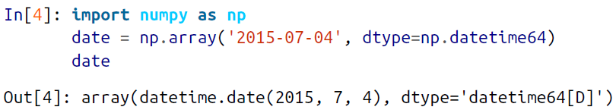

🡪Once we have this date formatted, however, we can quickly do vectorized operations on it:

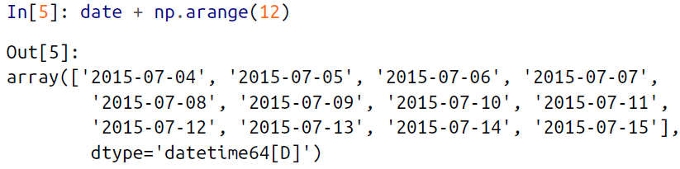

🡪Because of the uniform type in NumPy datetime64 arrays, this type of operation can be accomplished much more quickly than if we were working directly with Python’s datetime objects, especially as arrays get large

🡪One detail of the datetime64 and timedelta64 objects is that they are built on a *fundamental time unit*. Because the datetime64 object is limited to 64-bit precision, therange of encodable times is 264 times this fundamental unit. In other words, datetime64 imposes a trade-off between *time resolution* and *maximum time span*.

🡪For example, if you want a time resolution of one nanosecond, you only have enough information to encode a range of 264 nanoseconds, or just under 600 years. NumPy will infer the desired unit from the input; for example, here is a day-based datetime:

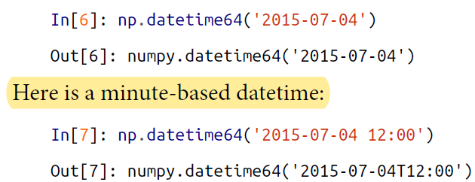

🡪Notice that the time zone is automatically set to the local time on the computer executing the code. You can force any desired fundamental unit using one of many format codes; for example, here we’ll force a nanosecond-based time:

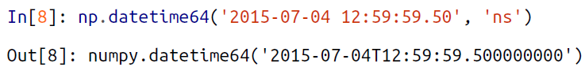

🡪Table, drawn below, lists the available format codes along with the relative and absolute timespans that they can encode.

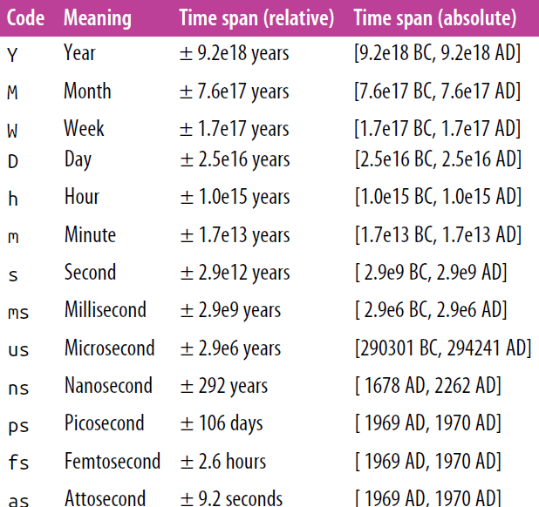

**🡺Dates and times in Pandas: Best of both worlds**

🡪Pandas builds upon all the tools just discussed to provide a Timestamp object, which combines the ease of use of datetime and dateutil with the efficient storage and vectorized interface of numpy.datetime64. From a group of these Timestamp objects, andas can construct a DatetimeIndex that can be used to index data in a Series or DataFrame; we’ll see many examples of this below.

🡪For example, we can use Pandas tools to repeat the demonstration from above. We can parse a flexibly formatted string date, and use format codes to output the day of the week:

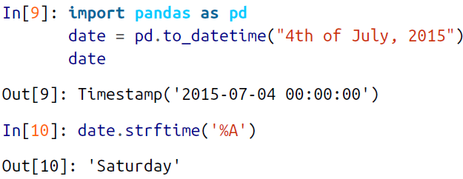

🡪Additionally, we can do NumPy-style vectorized operations directly on this same object:

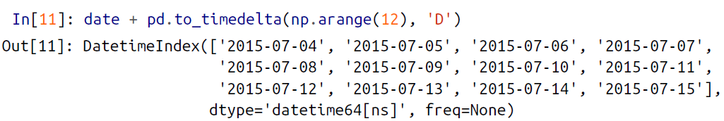

🡪In the next section, we will take a closer look at manipulating time series data with the tools provided by Pandas.

**🡺Pandas Time: Series: Indexing by Time**

**🡪**Where the Pandas time series tools really become useful is when you begin to *index data by timestamps*. For example, we can construct a Series object that has time indexeddata:

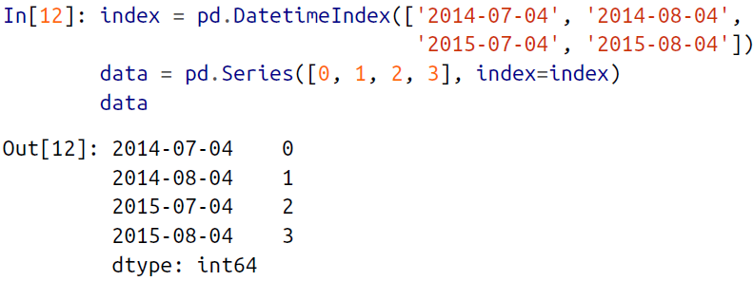

🡪Now that we have this data in a Series, we can make use of any of the Series indexing patterns we discussed in previous sections, passing values that can be coerced into dates:

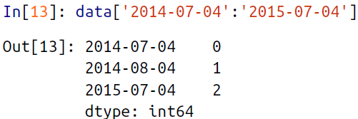

🡪There are additional special date-only indexing operations, such as passing a year to obtain a slice of all data from that year:

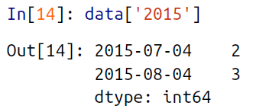

🡪Later, we will see additional examples of the convenience of dates-as-indices. But first, let’s take a closer look at the available time series data structures.

**🡺Pandas Time Series Data Structure**

**🡪**This section will introduce the fundamental Pandas data structures for working with time series data.

🡪The most fundamental of these date/time objects are the Timestamp and DatetimeIndex objects. While these class objects can be invoked directly, it is more common to use the pd.to_datetime() function, which can parse a wide variety of formats. Passing a single date to pd.to_datetime() yields a Timestamp; passing a series of dates by default yields a DatetimeIndex:

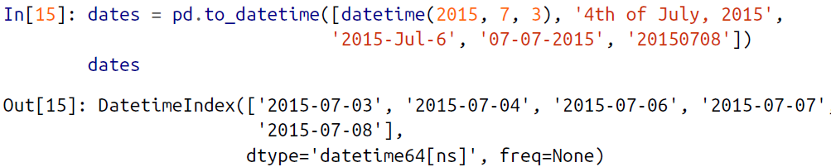

🡪Any DatetimeIndex can be converted to a PeriodIndex with the to_period() function with the addition of a frequency code; here we’ll use 'D' to indicate daily frequency:

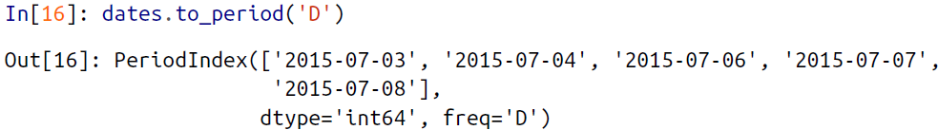

🡪A TimedeltaIndex is created, for example, when one date is subtracted from another:

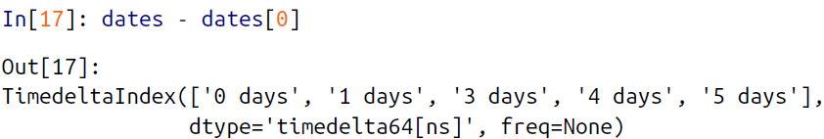

**🡺Regular sequences: pd.date_range()**

🡪To make the creation of regular date sequences more convenient, Pandas offers a few functions for this purpose: pd.date_range() for timestamps, pd.period_range() for periods, and pd.timedelta_range() for time deltas. We’ve seen that Python’s range() and NumPy’s np.arange() turn a startpoint, endpoint, and optional stepsize into a sequence. Similarly, pd.date_range() accepts a start date, an end date, and an optional frequency code to create a regular sequence of dates. By default, the frequency is one day:  
 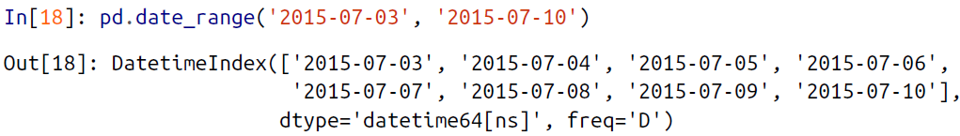

🡪Alternatively, the date range can be specified not with a start- and endpoint, but with a startpoint and a number of periods:

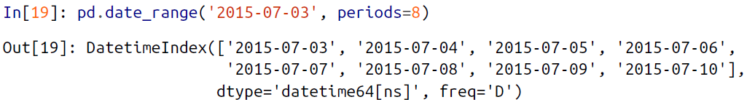

🡪You can modify the spacing by altering the freq argument, which defaults to D. For example, here we will construct a range of hourly timestamps:

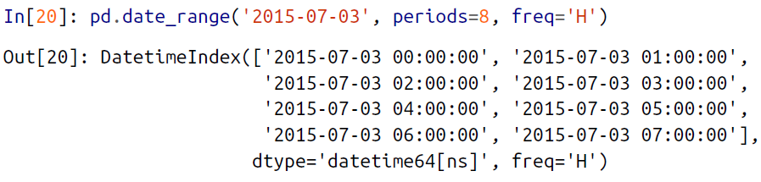

🡪To create regular sequences of period or time delta values, the very similar

pd.period_range() and pd.timedelta_range() functions are useful. Here are some

monthly periods:

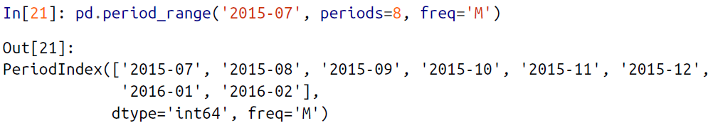

🡪And a sequence of durations increasing by an hour:

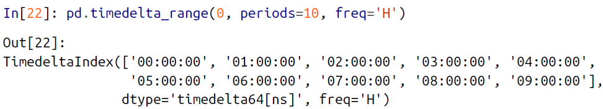

🡪All of these require an understanding of Pandas frequency codes, which we’ll summarize in the next section.

**🡺Frequencies and Offsets**

🡪Fundamental to these Pandas time series tools is the concept of a frequency or date offset. Just as we saw the D (day) and H (hour) codes previously, we can use such codes to specify any desired frequency spacing

🡪Listing of pandas frequency codes:

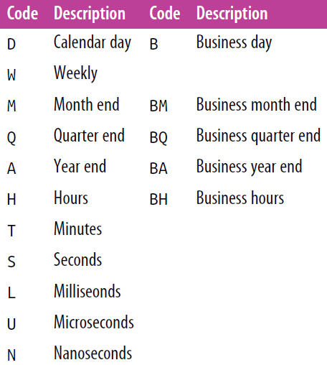

🡪The monthly, quarterly, and annual frequencies are all marked at the end of the specified period. Adding an S suffix to any of these marks it instead at the beginning

🡪Listing of start-indexed frequency codes

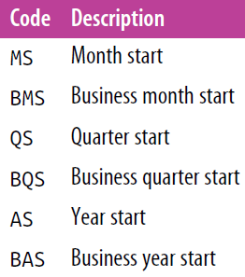

🡪Additionally, you can change the month used to mark any quarterly or annual code by adding a three-letter month code as a suffix:

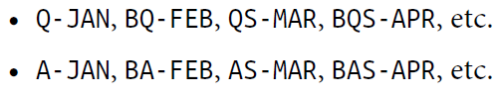

🡪In the same way, you can modify the split-point of the weekly frequency by adding a three-letter weekday code:



**🡪On top of this, codes can be combined with numbers to specify other frequencies**. For example, for a frequency of 2 hours 30 minutes, we can combine the hour (H) and minute (T) codes as follows:

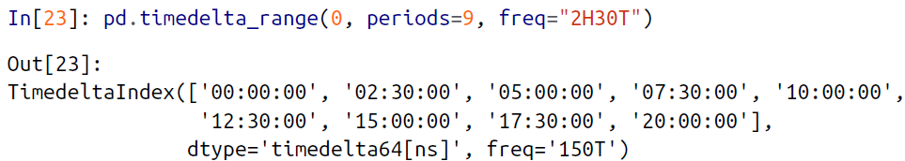

**🡪All of these short codes refer to specific instances of Pandas time series offsets, which can be found in the pd.tseries.offsets module. For example, we can create a business day offset directly as follows:**

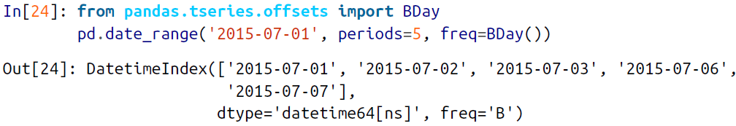

🡪For more discussion of the use of frequencies and offsets, see the “DateOffset objects” section of the Pandas online documentation.

**🡺Resampling, Shifting, and Windowing**

🡪The ability to use dates and times as indices to intuitively organize and access data is an important piece of the Pandas time series tools. The benefits of indexed data in general (automatic alignment during operations, intuitive data slicing and access, etc.) still apply, and Pandas provides several additional time series–specific operations.

🡪We will take a look at a few of those here, using some stock price data as an example. Because Pandas was developed largely in a finance context, it includes some very specific tools for financial data. For example, the accompanying pandas-datareader package (installable via conda install pandas-datareader) knows how to import financial data from a number of available sources, including Yahoo finance, Google Finance, and others. Here we will load Google’s closing price history:

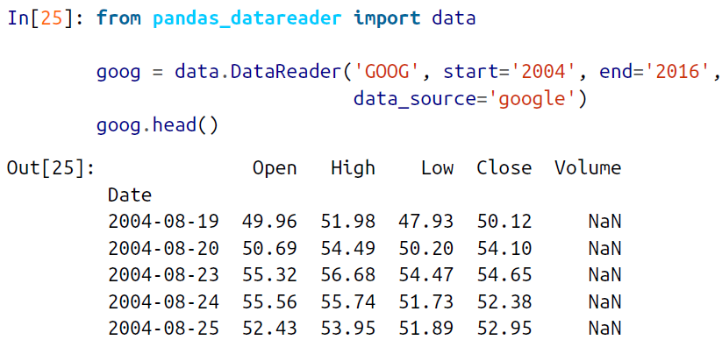

🡪For simplicity, we’ll use just the closing price:



🡪We can visualize this using the plot() method, after the normal Matplotlib setup Boilerplate

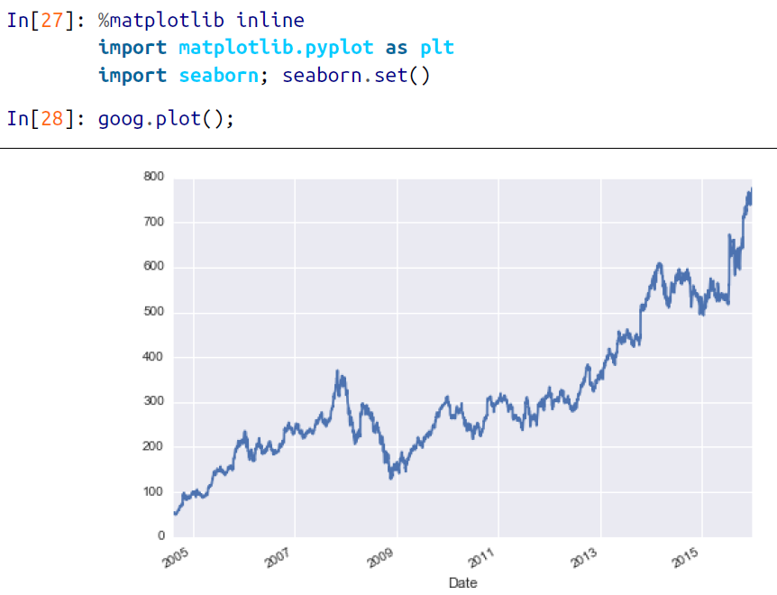

**🡺Resampling and converting frequencies**

🡪One common need for time series data is resampling at a higher or lower frequency. You can do this using the resample() method, or the much simpler asfreq() method. The primary difference between the two is that resample() is fundamentally a *data aggregation*, while asfreq() is fundamentally a *data selection*.

🡪Taking a look at the Google closing price, let’s compare what the two return when we down-sample the data. Here we will resample the data at the end of business year

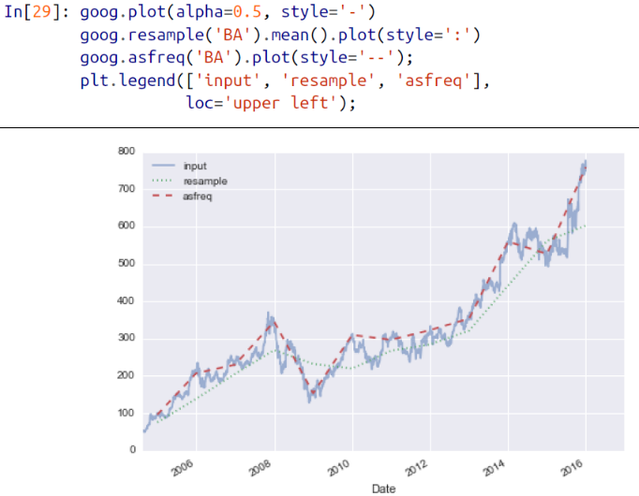

**🡪Notice the difference: at each point, resample reports the *average of the previous year*, while asfreq reports the *value at the end of the year*.**

🡪For up-sampling, resample() and asfreq() are largely equivalent, though resample has many more options available. In this case, the default for both methods is to leave the up-sampled points empty—that is, filled with NA values. Just as with the pd.fillna() function discussed previously, asfreq() accepts a method argument to specify how values are imputed. Here, we will resample the business day data at a daily frequency (i.e., including weekends); see

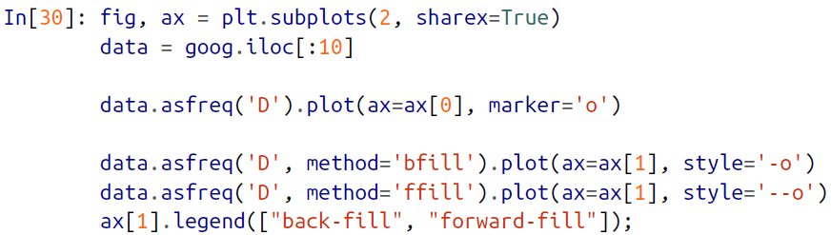

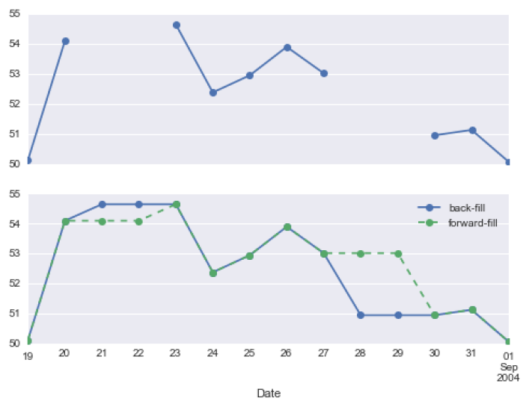

🡪The top panel is the default: non-business days are left as NA values and do not appear on the plot. The bottom panel shows the differences between two strategies for filling the gaps: forward-filling and backward-filling.

**🡺Time-shifts**

🡪Another common time series–specific operation is shifting of data in time. Pandas has two closely related methods for computing this: shift() and tshift(). In short, the difference between them is that shift() *shifts the data*, while tshift() *shifts the* *index*. In both cases, the shift is specified in multiples of the frequency.

🡪Here we will both shift() and tshift() by 900 days

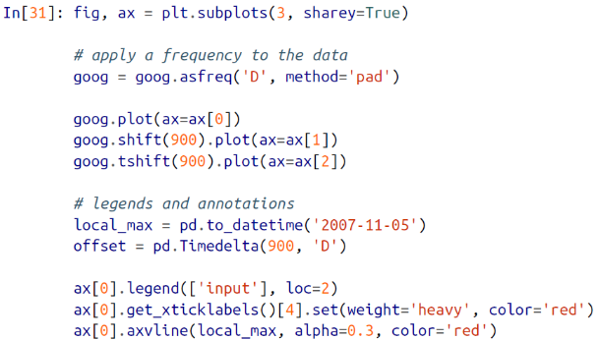

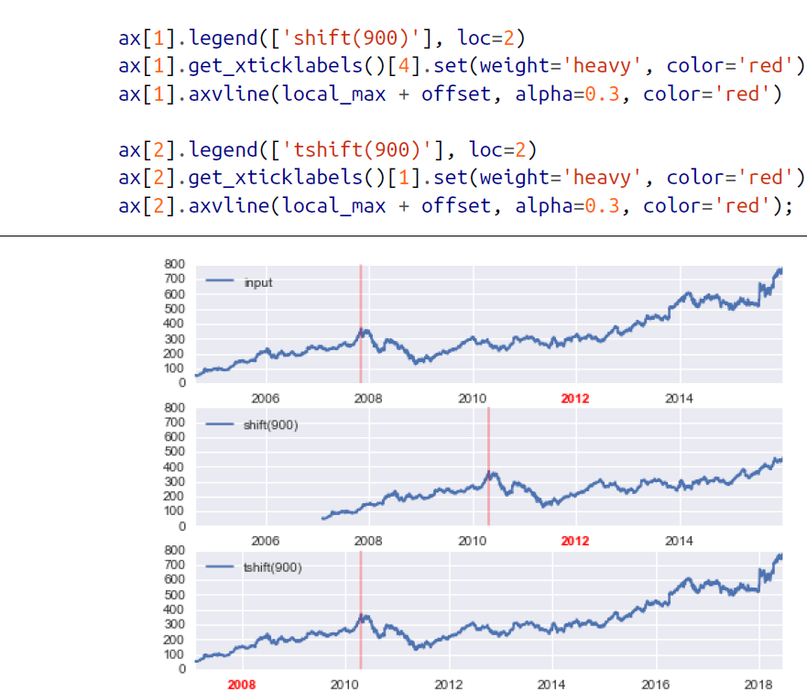

🡪We see here that shift(900) shifts the *data* by 900 days, pushing some of it off the end of the graph (and leaving NA values at the other end), while tshift(900) shifts the *index values* by 900 days.

🡪A common context for this type of shift is computing differences over time. For example, we use shifted values to compute the one-year return on investment for Google stock over the course of the dataset  
 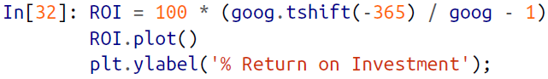

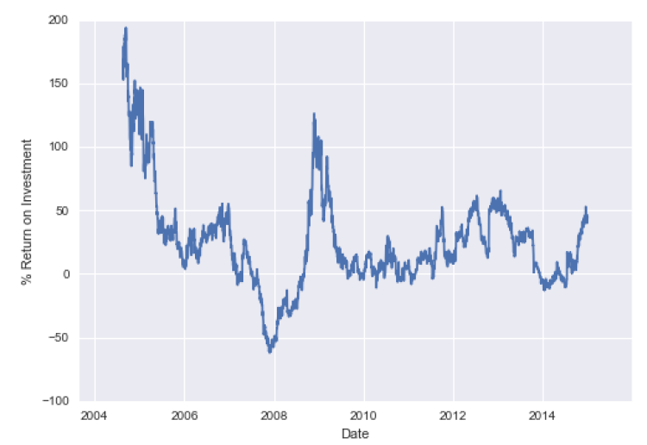

🡪This helps us to see the overall trend in Google stock: thus far, the most profitable times to invest in Google have been (unsurprisingly, in retrospect) shortly after its IPO, and in the middle of the 2009 recession.

**🡺Rolling Windows**

🡪Rolling statistics are a third type of time series–specific operation implemented by Pandas. These can be accomplished via the rolling() attribute of Series and Data Frame objects, which returns a view similar to what we saw with the groupby operation. This rolling view makes available a number of aggregation operations by default.

🡪For example, here is the one-year centered rolling mean and standard deviation of the Google stock prices

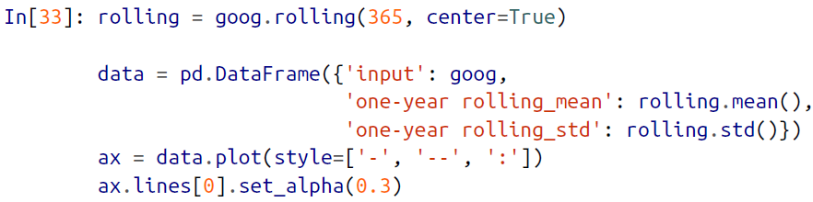

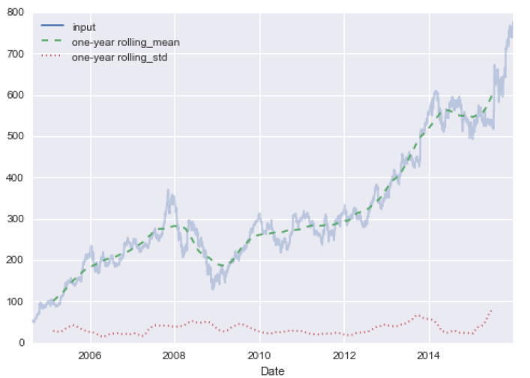

🡪As with groupby operations, the aggregate() and apply() methods can be used for custom rolling computations.

1. Example: Visualizing Seattle Bicycle Counts

🡪As a more involved example of working with some time series data, let’s take a look at bicycle counts on Seattle’s Fremont Bridge. This data comes from an automated bicycle counter, installed in late 2012, which has inductive sensors on the east and west sidewalks of the bridge. The hourly bicycle counts can be downloaded from *http://data.seattle.gov/;*

🡪Once this dataset is downloaded, we can use Pandas to read the CSV output into a

DataFrame. We will specify that we want the Date as an index, and we want these

dates to be automatically parsed:

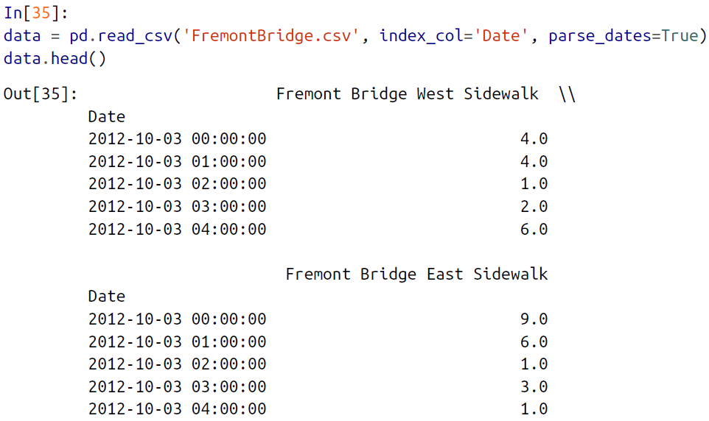

🡪For convenience, we’ll further process this dataset by shortening the column names and adding a “Total” column:

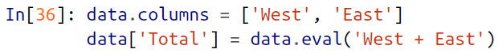

🡪Now let’s take a look at the summary statistics for this data:

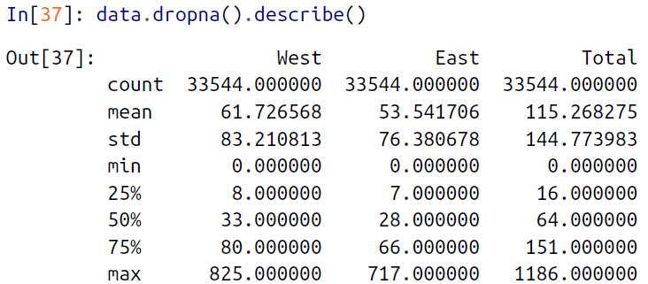

**🡺Visualizing the data**

🡪We can gain some insight into the dataset by visualizing it. Let’s start by plotting the raw data

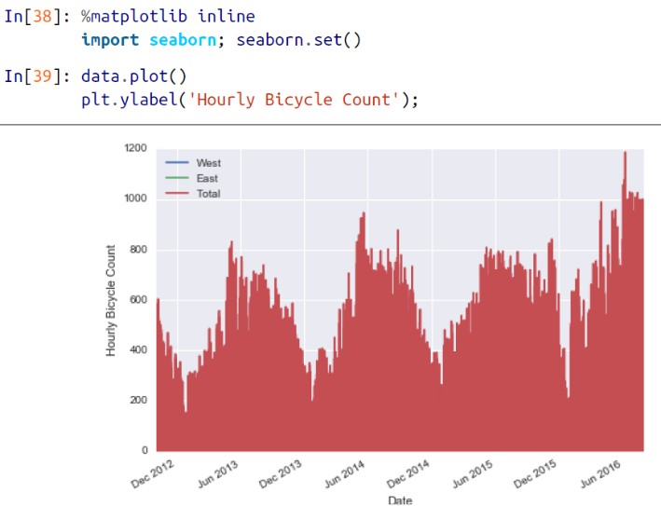

🡪The ~25,000 hourly samples are far too dense for us to make much sense of. We can gain more insight by resampling the data to a coarser grid. Let’s resample by week

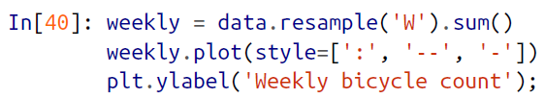

🡪This shows us some interesting seasonal trends: as you might expect, people bicycle more in the summer than in the winter, and even within a particular season the bicycle use varies from week to week

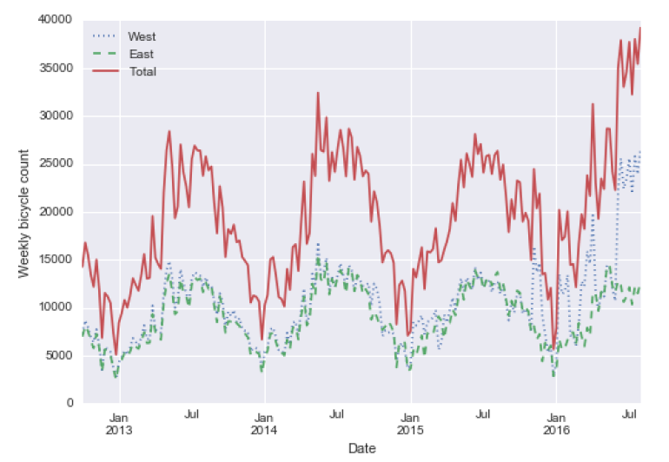

🡪Another way that comes in handy for aggregating the data is to use a rolling mean, utilizing the pd.rolling_mean() function. Here we’ll do a 30-day rolling mean of our data, making sure to center the window

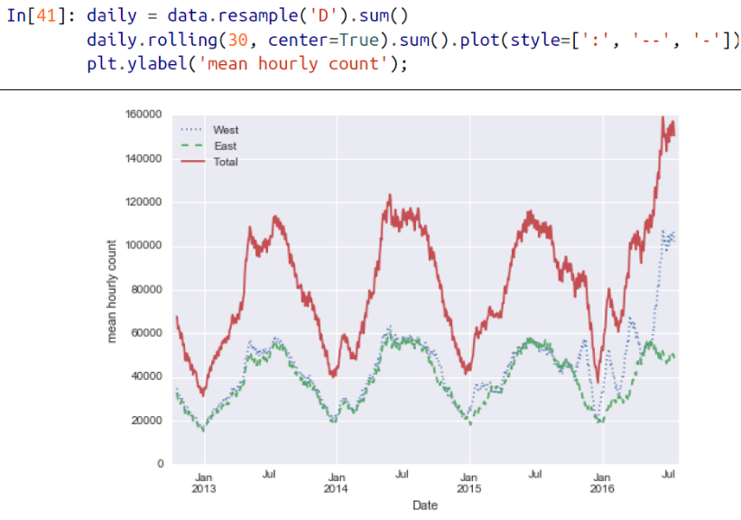

🡪The jaggedness of the result is due to the hard cutoff of the window. We can get a smoother version of a rolling mean using a window function—for example, a Gaussian window. The following code (visualized in Figure 3-14) specifies both the width of the window (we chose 50 days) and the width of the Gaussian within the window (we chose 10 days):

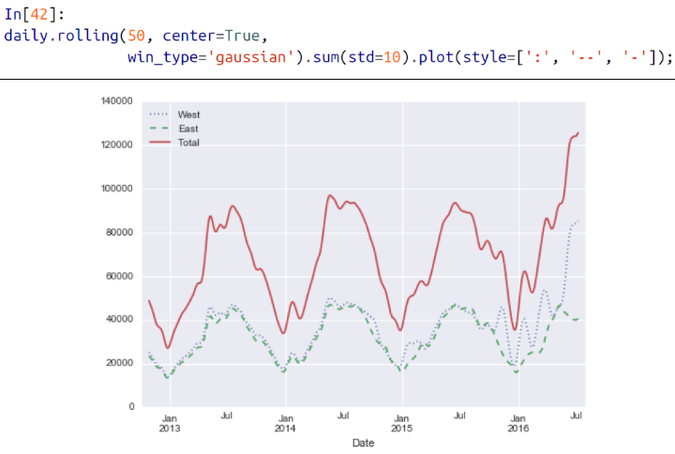

🡺Digging into the data

🡪While the smoothed data views in Figure 3-14 are useful to get an idea of the general trend in the data, they hide much of the interesting structure. For example, we might want to look at the average traffic as a function of the time of day. We can do this using the GroupBy functionality

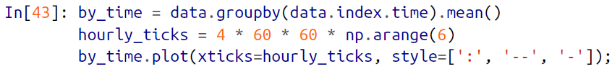

🡪The hourly traffic is a strongly bimodal distribution, with peaks around 8:00 in the

morning and 5:00 in the evening. This is likely evidence of a strong component of

commuter traffic crossing the bridge. This is further evidenced by the differences

between the western sidewalk (generally used going toward downtown Seattle),

which peaks more strongly in the morning, and the eastern sidewalk (generally used going away from downtown Seattle), which peaks more strongly in the evening.

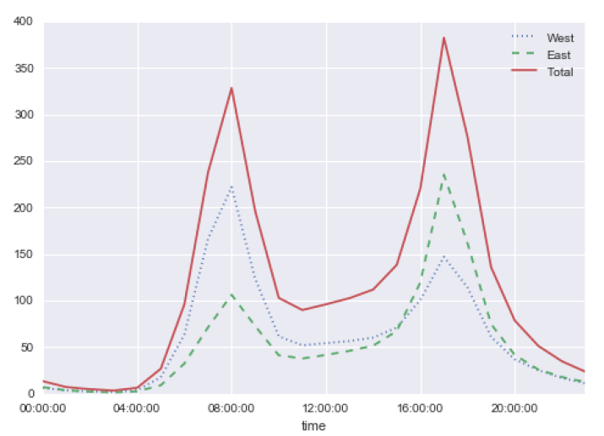

🡪We also might be curious about how things change based on the day of the week.

Again, we can do this with a simple groupby (Figure 3-16):

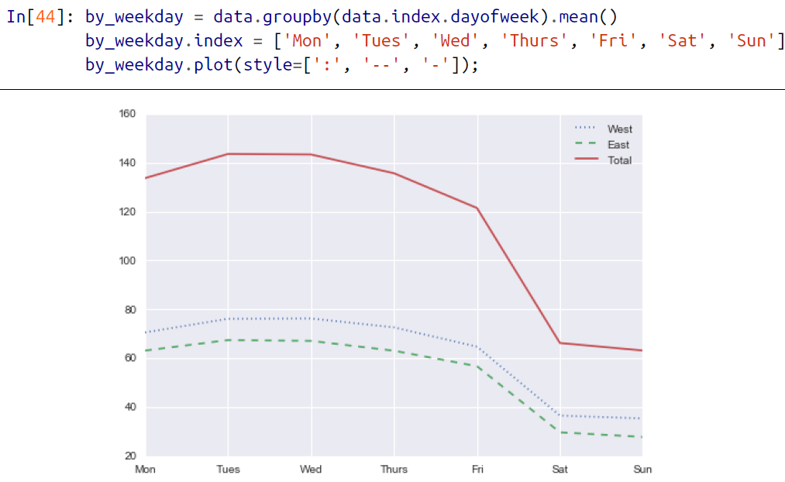

🡪This shows a strong distinction between weekday and weekend totals, with around

twice as many average riders crossing the bridge on Monday through Friday than on

Saturday and Sunday.

🡪With this in mind, let’s do a compound groupby and look at the hourly trend on

weekdays versus weekends. We’ll start by grouping by both a flag marking the weekend, and the time of day:



🡪Now we’ll use some of the Matplotlib tools

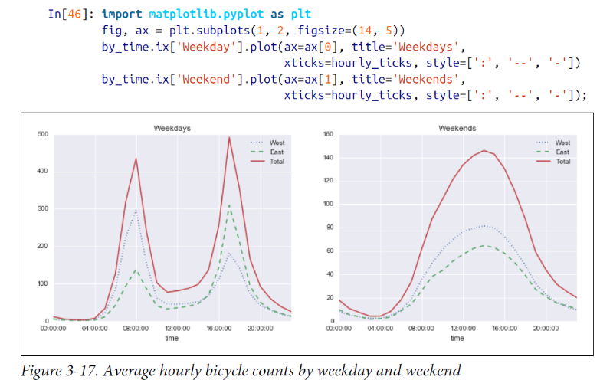

🡪The result is very interesting: we see a bimodal commute pattern during the work

week, and a unimodal recreational pattern during the weekends. It would be interesting to dig through this data in more detail, and examine the effect of weather, temperature, time of year, and other factors on people’s commuting patterns.

1. High-Performance Pandas: eval() and query()

🡪As we’ve already seen in previous chapters, the power of the PyData stack is built

upon the ability of NumPy and Pandas to push basic operations into C via an intuitive

syntax: examples are vectorized/broadcasted operations in NumPy, and

grouping-type operations in Pandas. While these abstractions are efficient and effctive for many common use cases, they often rely on the creation of temporary intermediate objects, which can cause undue overhead in computational time and

memory use.

🡪Pandas includes some experimental tools that allow you to directly access C-speed operations without costly allocation of intermediate arrays. These are the eval() and query() functions, which rely on the Numexpr package. In this notebook we will walk through their use and give some rules of thumb about when you might think about using them.

**🡺Motivating query()and eval(): Compound Expressions**

🡪We’ve seen previously that NumPy and Pandas support fast vectorized operations; for example, when you are adding the elements of two arrays:

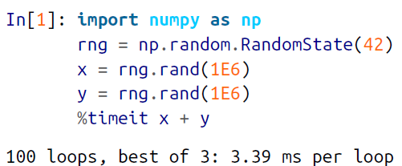

🡪This is much faster than doing the addition via a Python loop or comprehension:

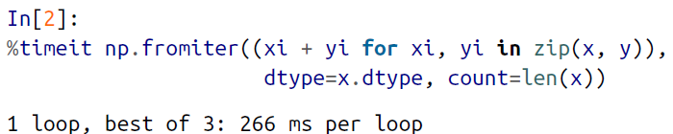

🡪But this abstraction can become less efficient when you are computing compound expressions. For example, consider the following expression:



🡪Because NumPy evaluates each subexpression, this is roughly equivalent to the following:

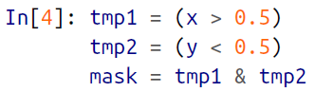

🡪In other words, *every intermediate step is explicitly allocated in memory*. If the x and y arrays are very large, this can lead to significant memory and computational overhead. The Numexpr library gives you the ability to compute this type of compound expression element by element, without the need to allocate full intermediate arrays. The Numexpr documentation has more details, but for the time being it is sufficient to say that the library accepts a *string* giving the NumPy-style expression you’d like to compute:

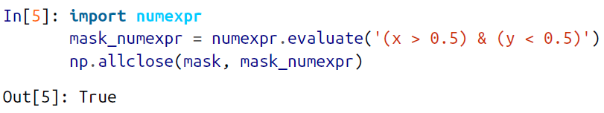

🡪The benefit here is that Numexpr evaluates the expression in a way that does not use full-sized temporary arrays, and thus can be much more efficient than NumPy, especially for large arrays. The Pandas eval() and query() tools that we will discuss here are conceptually similar, and depend on the Numexpr package.

**🡺Pandas.eval() for Efficient Operations**

🡪The eval() function in Pandas uses string expressions to efficiently compute operations using DataFrames. For example, consider the following DataFrames:

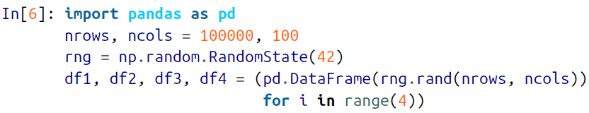

🡪To compute the sum of all four DataFrames using the typical Pandas approach, we can just write the sum:

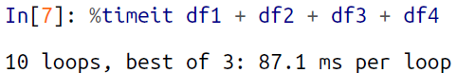

🡪We can compute the same result via pd.eval by constructing the expression as a string:

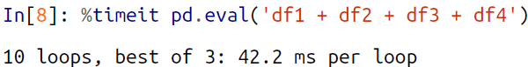

🡪The eval() version of this expression is about 50% faster (and uses much less memory), while giving the same result:

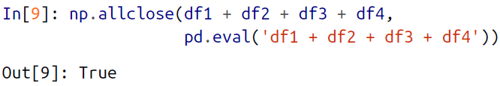

**🡺Operations supported by pd.eval()**

🡪As of Pandas v0.16, pd.eval() supports a wide range of operations. To demonstrate these, we’ll use the following integer DataFrames:



🡪Arithmetic operators. pd.eval() supports all arithmetic operators. For example:

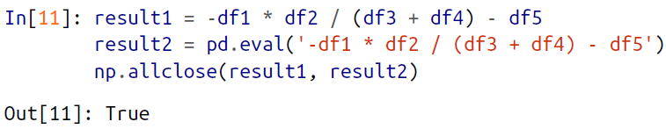

🡪Comparison operators. pd.eval() supports all comparison operators, including

chained expressions:

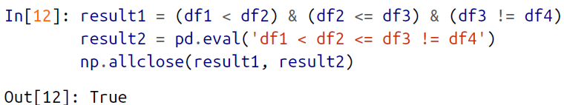

🡪Bitwise operators. pd.eval() supports the & and | bitwise operators:

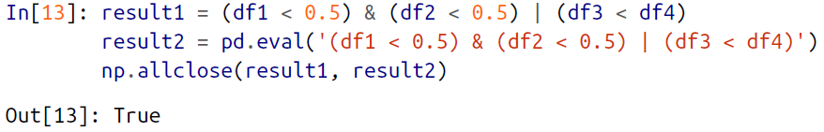

🡪In addition, it supports the use of the literal and and or in Boolean expressions:

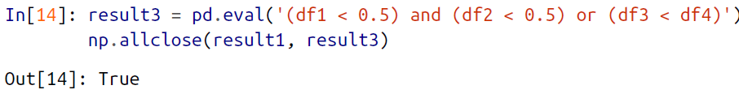

🡪Object attributes and indices. pd.eval() supports access to object attributes via the obj.attr syntax, and indexes via the obj[index] syntax:

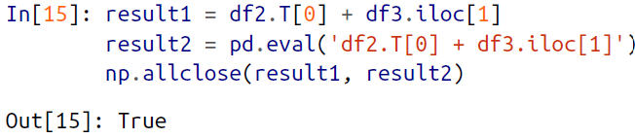

🡪Other operations. Other operations, such as function calls, conditional statements, loops, and other more involved constructs, are currently *not* implemented in pd.eval(). If you’d like to execute these more complicated types of expressions, you can use the Numexpr library itself.

**🡺DataFrame.eval() for Column-wise Operations**

🡪Just as Pandas has a top-level pd.eval() function, DataFrames have an eval()

method that works in similar ways. The benefit of the eval() method is that columns can be referred to *by name*. We’ll use this labeled array as an example:

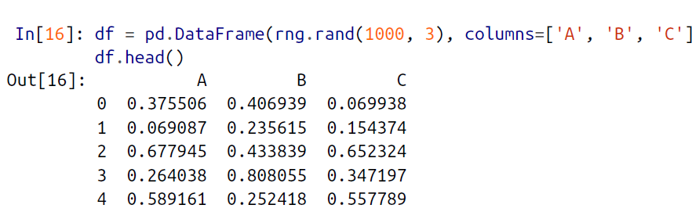

🡪Using pd.eval() as above, we can compute expressions with the three columns like this:

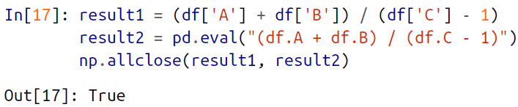

🡪The DataFrame.eval() method allows much more succinct evaluation of expressions with the columns:

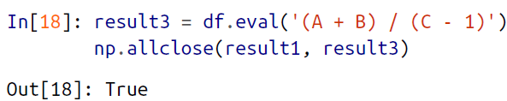

🡪Notice here that we treat *column names as variables* within the evaluated expression, and the result is what we would wish.

**🡺Assignment in DataFrame.eval()**

🡪In addition to the options just discussed, DataFrame.eval() also allows assignment to any column. Let’s use the DataFrame from before, which has columns 'A', 'B', and 'C':

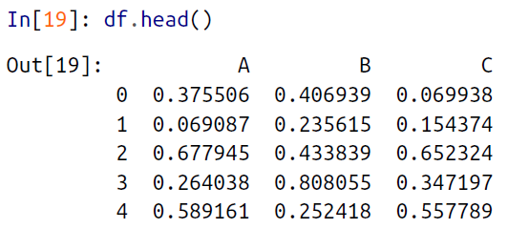

🡪We can use df.eval() to create a new column 'D' and assign to it a value computed from the other columns:

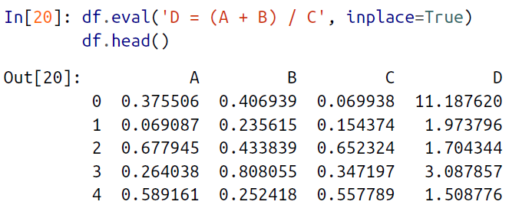

🡪In the same way, any existing column can be modified:

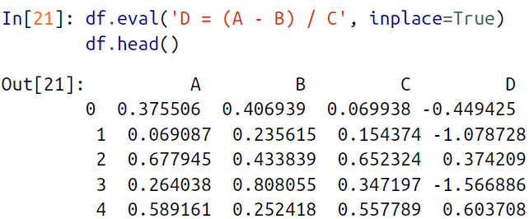

**🡺Local variables in DataFrame.eval()**

🡪The DataFrame.eval() method supports an additional syntax that lets it work with local Python variables. Consider the following:

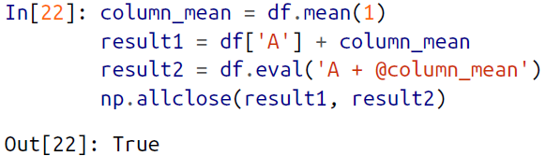

**🡪The @ character here marks a *variable name* rather than a *column name*, and lets you efficiently evaluate expressions involving the two “namespaces”: the namespace of columns, and the namespace of Python objects. Notice that this @ character is only supported by the DataFrame.eval() *method*, not by the pandas.eval() *function*, because the pandas.eval() function only has access to the one (Python) namespace.**

**🡺DataFrame.query() method**

🡪The DataFrame has another method based on evaluated strings, called the query() method. Consider the following:

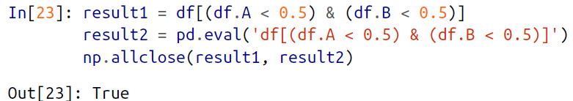

🡪As with the example used in our discussion of DataFrame.eval(), this is an expression involving columns of the DataFrame. It cannot be expressed using the Data Frame.eval() syntax, however! Instead, for this type of filtering operation, you can use the query() method:

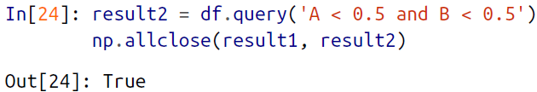

🡪In addition to being a more efficient computation, compared to the masking expression this is much easier to read and understand. Note that the query() method also accepts the @ flag to mark local variables:

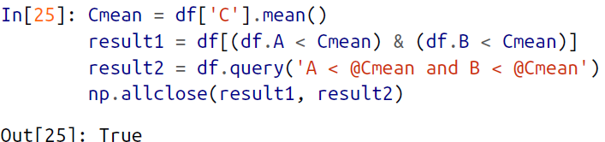

**🡺Performance: When to use these functions**

🡪When considering whether to use these functions, there are two considerations: *computation time* and *memory use*. Memory use is the most predictable aspect. As alreadymentioned, every compound expression involving NumPy arrays or Pandas DataFrames will result in implicit creation of temporary arrays: For example, this:

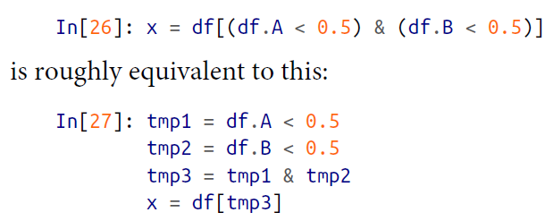

🡪**If the size of the temporary DataFrames is significant compared to your available system memory (typically several gigabytes), then it’s a good idea to use an eval() or query() expression**. You can check the approximate size of your array in bytes usingthis:

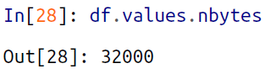

🡪On the performance side, eval() can be faster even when you are not maxing out your system memory. The issue is how your temporary DataFrames compare to the size of the L1 or L2 CPU cache on your system (typically a few megabytes in 2016); if they are much bigger, then eval() can avoid some potentially slow movement of values between the different memory caches. In practice, I find that the difference in computation time between the traditional methods and the eval/query method is usually not significant—if anything, the traditional method is faster for smaller arrays! The benefit of eval/query is mainly in the saved memory, and the sometimes cleaner syntax they offer.

🡪We’ve covered most of the details of eval() and query() here; for more information on these, you can refer to the Pandas documentation. In particular, different parsers and engines can be specified for running these queries; for details on this, see the discussion within the “Enhancing Performance” section.